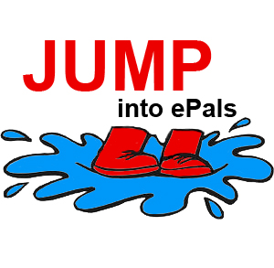

Jump into ePals Introductory Project
Suggested Timeline for Classroom Tasks
 | Monday | Tuesday | Wednesday | Thursday | Friday
Week 1  Introductions | Review Assmt 1 | Email Roster |  |  | All forum posts must be completed
Week 2  Communication | Review Assmt 2  Try in-class email | Moderate in class email | Class A send: email 1 |  | Class B reply: Email 1
Week 3  Learning Center | Review Assmt 3 | Class A send: Email 2 |  | Class B: reply Email 2 | All Learning Center work should be completed
Week 4  Collaboration | Review Assmt 4 | Class A send: Email 3 |  | Class B: reply Email 2 | All Wiki work should be completed

