HELP A FRIEND GET HEALTHY

CULMINATING ACTIVITY GRADE 10

Statistics
Canada, like many nations, is in the midst of an epidemic of overweight and obesity. Currently, 59% of adult Canadians are either overweight or obese¹. Cities in Alberta, Saskatchewan, Ontario, New Brunswick, and Nova Scotia were significantly higher in overweight/obesity population than the national average for adults².
There has also been a dramatic increase in unhealthy weights in children. In 1978, only 15% of children were overweight or obese. By 2007, Statistics Canada found that 29% of adolescents had unhealthy weights². Most adolescents do not outgrow this problem and in fact, many continue to gain excess weight³. If current trends continue, by 2040, up to 70% of adults aged 40 years will be either overweight or obese⁴.
Adults who have unhealthy weights are at increased risk of heart disease⁵, cancer⁶, strokes and type 2 diabetes⁷. In 2005, the total cost of obesity to Canadians was $4.3 billion; $1.8 billion in indirect healthcare costs, and $2.5 billion in indirect costs⁸. Affected adults may die up to 3 to 7 years earlier than counterparts with a healthy weight⁹.
The resultant toll in dollar's cost and lives list is a call for action. Obesity is difficult to reverse and public health measures must include effective prevention beginning in childhood as well as treatment.
¹Tjepkema M. Measured Obesity: Adult obesity in Canada: Measured height and weight. Statistics Canada Catalogue no. 82-620-MVE2005001
²Statistics Canada, Canadian Community Health Survey, 2009, 2010.
³Singh AS, Mulder C, Twisk JWR. (2008) Tracking of childhood overweight into adulthood: a systematic review of the literature. Obesity Reviews 9. 474 - 488.
⁴Le Petit C, Berthelot JM. Obesity: A Growing Issue. Statistics Canada catalogue no 82-618-MWE2005003
⁵Zalesin K, Franklin BA, Miller WM, Petersen ED. Impact of Obesity on Cardiovascular Disease - Endocrinology Metabolism Clinics North America - 01-SEP-2008;37(3): 663 - 84
⁶Danaei G, et al. (2005) Causes of Cancer in the world: comparitive risk assessment of nine behavioural and environmental risk factors. Lancet,: 366, 1786 - 1793
⁷Smith SC. Multiple Risk Factors for Cardiovascular Disease and Diabetes Mellitus. (2007) American Journal of Medicine., Vol 120 (3A)
⁸Janssen I, Diener A. (2005) Economic Burden of Obesity in Canada
⁹Peeters A, et al. (2003) Obesity in adulthood and its consequences for life expectancy: A life table analysis. Annals of Internal Medicine, 138, 24 – 32

Statistics about Screen Time
“In 2004, over a third of children aged 6-11 logged more than 2 hours of screen time each day” (Canadian Children):
http://www.statcan.gc.ca/pub/82-003-x/2005003/article/9277-eng.pdf
“Currently children and youth average close to 8 hours of screen time per day with only 19% of kids aged 10 to 16 meeting the 2-hour guideline”
http://www.bcmj.org/council-health-promotion/promoting-physical-activity-0
“Of 51 922 Canadian youth in grades 6 to 12, 50.9% spent more than 2 hours per day in screen-based behaviours. The average daily screen time was 7.8 (± 2.3) hours”
http://www.phac-aspc.gc.ca/publicat/cdic-mcbc/31-4/assets/pdf/cdic-mcbc-31-4-ar-01-eng.pdf
INTRODUCTION
The lack of physical activity among North Americans of all ages is critical, it is considered to be a major health risk factor. The cornerstone for physical activity throughout life is and can be physical education programs. Schools offer the best opportunity to reach all children and teach them the skills and knowledge needed to establish and sustain an active lifestyle. Children learn the habits that they will practice throughout their lifetime in school. It is important that students learn the importance of eating well and exercising. These same children as adults will know how to maintain a healthy weight and healthy body. Knowledge of safe sexual practices, drugs, smoking and alcohol go hand in hand with learning to live and maintain a healthy lifestyle.
Background Information
Your friend, go ahead give her a name, is overweight and needs a lifestyle change. She is a big fan of fast foot, unhealthy snacks, TV, internet and she smokes. She has also been known to drink alcohol. She rarely mixes in healthy food and is not good at making healthy lifestyle choices at all! Her ideal workout is clicking the remote control and getting up to walk to the refrigerator. You need to help your friend as she is on the fast track to heart disease and possibly diabetes.
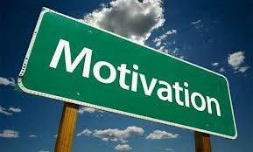

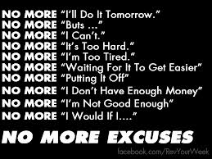
TASK
- Your task is to become her personal trainer and help to develop a sample eating plan for 3 days and an exercise routine for one week. It should be something that she can follow and be able to understand and implement. Include a brief description of your made up person. (Name, age, weight, goals etc.) Also using the BMR formula calculate their calories they would need for a day. Keep in mind one of the goals is some weight loss.
- You will work with a partner on this assignment. One person will act as the fitness expert and one will be the nutritionist.
- The fitness expert will provide an outline of the activity routine for a week. You must include the FITT principle (Frequency, Intensity, Type, and Time) when planning the activities. It is not enough to say jog for 30 minutes. When planning the activities be creative and detailed and make it fun!
- The nutritionist will design a three day meal plan that will help your friend eat in a more healthy way. When making a meal plan you must include the portion sizes for each item. The plan should be made up using the Food Guide Pyramid. Each day your friend should eat six meals, 3 of those meals are snacks. When choosing your meals be creative and detailed. Make it yummy!
PROCESS
- Decide who will be the Nutritionist - , the Trainer -
- Both individuals must research the following topics
- Both individuals, using information from the researched topics, must answer the following questions on a sheet of paper. The answers must be well written and typed
RESEARCHED TOPICS – Food Guide Pyramid, Overweigh and Obesity Facts, Exercise suggestions, FITT Principle, Teen Health.
QUESTIONS:
- What is the healthiest way to lose weight?
- What diseases can be caused by obesity and being overweight?
- How many days a week should a person exercise?
- How long should a teen/adult exercise?
- How many days a week should a person do aerobic endurance exercises?
- How many days should a person do muscular strength exercises?
- How many days should a person do flexibility exercises?
- Write down the name of the food groups on the Food Pyramid and how many servings of each should be eaten each day.

NAME:
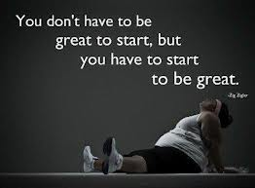
ANSWERS
1.

2.

3.

4.

5.

6.

7.

8.

THE TRAINER
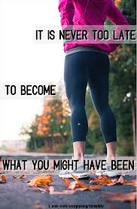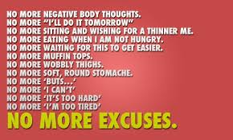
WORKOUT SCHEDULE
DAY & LOCATION | EXERCISE | TIME | INTENSITY
You do not have to use this chart but it can serve as an organizing tool. If you want to use it you can but your workouts have to include details so you may need more space.

THE NUTRITIONIST

THREE DAY MEAL PLAN
Remember when planning the meal plan that you must include 3 meals (breakfast, lunch, dinner) and 3 snacks.
MEAL PLAN
DAY 1 | Breakfast | Snack | Lunch | Snack | Dinner | Snack
DAY 2
DAY 3
This is just a sample you can change it if you want. You also have the option of using it if you would like.
Brief Biography of your Friend. (Don’t be afraid to be creative)
NAME: AGE: HGT: WGT:
DETAILS:

BMR FORMULA

Remember this is only for 1 week so your friend may have an overall weight loss and activity goal but this is just a “snapshot” of what the long term program could be.

