
HEALTH AND PHYSICAL EDUCATION MENU
TOPIC: Promoting and participating in physical activities that encourage lifelong
participation.

APPETIZER: Students MUST complete this part of the assignment.

List your top 10 favourite physical activities. They can be from activities that we have done in class or activities that you have done outside of school. You must explain why you consider each of them to be valuable. Also answer the question, which one of the 10 do you see you doing in the future and why? Answer with one to two paragraphs on the sheet provided.



ENTRÉE: Choose ONE of the following assignments.
- Create an activity/game with a fitness component that maximizes participation
- Create a Bitstrip, Poster, pamphlet, power point, or Prezi on the computer that focuses on one of the health topics we have covered or a sport/activity that we have done in class.
- Create a Power Point, Prezi, poster or pamphlet on promoting a sport or activity in your school encouraging fun and skill development
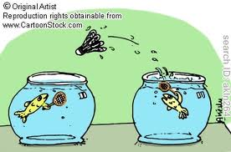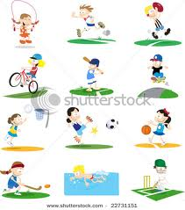
DESSERT: Students MUST complete this assignment.
Write a newspaper article to the editor of the paper discussing the importance of lifelong participation in physical activities and fitness.

MY TOP TEN PHYSICAL ACTIVITIES
WHY ARE THEY VALUABLE TO YOU?
1.

2.

3.

4.

5.

6.

7.

8.

9.

10.



HOW DO I SEE MYSELF BEING PHYSICALLY ACTIVE IN THE FUTURE?



