CULMINATING ACTIVITY
PPL4O1F

OBJECTIVE: CREATE A CHILDREN’S STORY THAT EXPLAINS OR HIGHLIGHTS THE IMPORTANCE OF PHYSICAL ACTIVITY FOR YOUNG CHILDREN AND YOUNG ADULTS.

STEPS TO WRITING YOUR STORY

- Choose the topic of your story. Something new that they would be interested or curious about.
- Think of a main character and develop him/her. Start with the name or personality.
- Make a list of possible problems or situations that can be included throughout your story and pick the best idea.
- Figure out how your problem can be solved. Research the topic and try to include something educational and interesting.
- Make a quick plan or storyboard of your story. Plan the beginning, build up to the problem, introduce the problem, climax, problem solved and the ending. This should be your Rough Draft.
- Write (type) up the story. Vary sentence length and keep the readers interested.
- Read through, edit story.
- Think of a title for your story that will interest both the children and adults reading the story.
- Illustrate the book
- Add the title and your name to the cover.

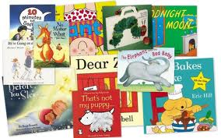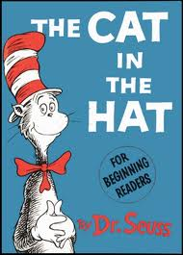

Rough/Planning Notes

BRAINSTORM TOPICS
- Make a list of at least 10 different things that you might want to write your book about. Then pick one.

MAIN CHARACTER
- Start with the name and then develop the character

BRAINSTORM PROBLEMS/SITUATIONS
- Make a list of at least 5 problems/situations that could be included and pick one.

SOLVE THE PROBLEM/SITUATIONS
- Make a list of solutions make it educational and interesting



QUICK PLAN/STORYBOARD

If you need more space just copy and paste another one. If you are doing it by hand I will have extra copies.
WRITE/TYPE THE STORY ROUGH NOTES

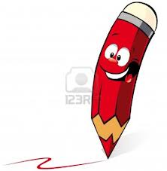

Now that you have all the rough work done it is time to put the book together. You can either write and illustrate your book on the computer or by hand. Your choice.
COVER FOR THE BOOK
(Remember you need a fun and interesting title)

CULMINATING ACTIVITY PPL4O1F

CHILDREN’S STORYBOOK

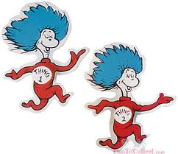

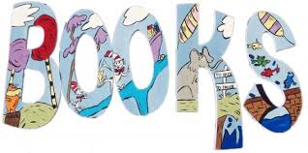
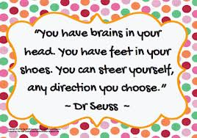

NAME:
DUE DATE:

