.

Month of May 2016
Sunday | Monday | Tuesday | Wednesday | Thursday | Friday | Saturday
1 | 2 (2)  Gym  Bring running shoes | 3 (3)  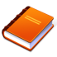  Library  Reading Buddies | 4 (4)    Music | 5 (5)  Music | 6 (1)  Gym  Bring running shoes  Fitness | 7
8 | 9 (2)  Gym  Bring running shoes | 10 (3)  Library  Reading Buddies | 11 (4)  Music | 12 (5)  Music | 13 (1)  Gym  Bring running shoes  Fitness | 14
15 | 16 (2)  Gym  Bring running shoes | 17 (3)  Library  Reading Buddies | 18 (4)  Music  Toys from home day | 19 (5)  Music | 20 (1)  Gym  Bring running shoes  Fitness | 21
22 | 23  Victoria Day  No school  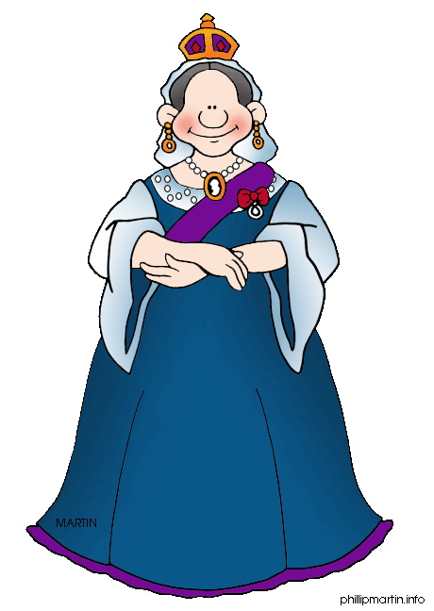 | 24 (2)  Gym  Bring running shoes | 25 (3)  Library  Reading Buddies | 26 (4)  Music | 27 (5)  Music  Fitness | 28
29 | 30 (1)  Gym  Bring running shoes | 31 (2)  Gym  Bring running shoes

