Ma famille
- Match each phrase to the correct picture.
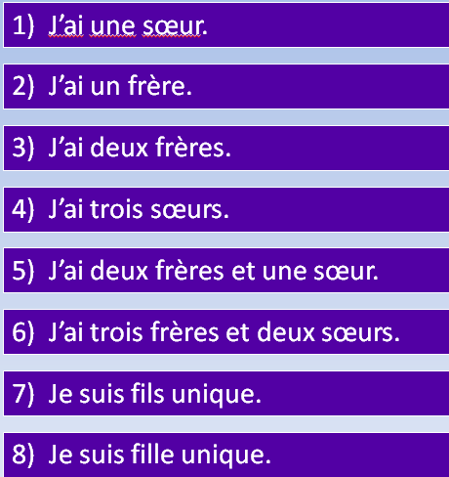
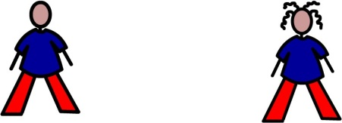
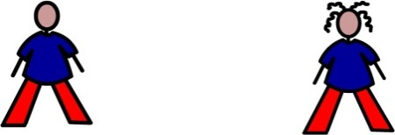

A
B
C
D
F
G

- Draw symbols to represent each family.

Patrice:
Aurélie:
Jeanne:
Olivier:
Étienne:
Magali:
- Write a sentence for each person
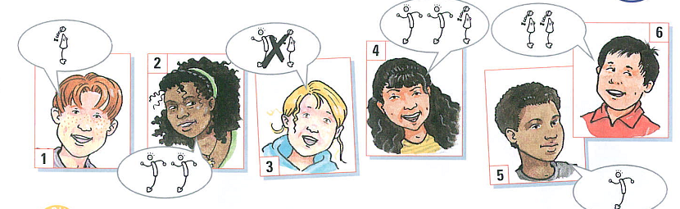
1.
2.
3.
4.
5.
6.
Some example sentences:
J’ai un frère qui s’appelle Alex - I’ve got a brother who is called Alex.
J’ai deux soeurs qui s’appellent Anisa et Ruth - I’ve got 2 sisters who are called Anisa and Ruth.
Practice
1.
2.
3.
4.
5.
6.

