Winona Gives Back 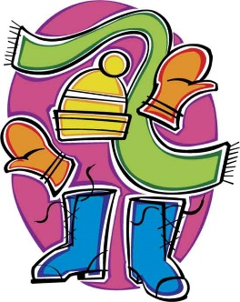

Winter Clothing Drive
Please donate winter clothes from
December 7th to 11th
^{We are collecting} COATS, HATS, MITTS, GLOVES, Snow pants AND BOOTS
ALL CLOTHING WILL BE GIVEN TO WINONA FAMILIES IN NEED AND OTHER SCHOOLS IN OUR COMMUNITY
All ITEMS WILL BE PICKED UP from the CLASSROOMS FIRST BREAK, all week!

