Khaled Hosseini, 1965-
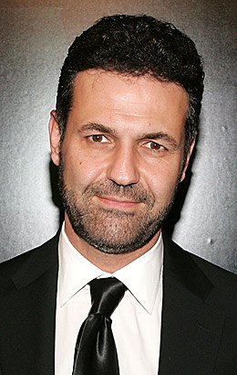 | - Born in Kabul, Afghanistan  - Father was a diplomat  - Mother taught Farsi and History at a high school  - Family was relocated to Paris in 1976  - Were ready to return in 1980 but communist groups had taken over  - Granted political asylum in U.S. – moved to San Jose California  - Earned a B.S. in biology at Santa Clara University  - Earned a medical degree at the University of California  - Began writing his first novel, The Kite Runner, while he was studying medicine  - Named a Goodwill Envoy to the United Nations Refugee Agency in2006  - Established The Khaled Hosseini Foundation, a nonprofit, that provides humanitarian aid to citizens in Afghanistan  - The Kite Runner (2003) sold in at least 70 countries and spent more than 100 weeks on the New York Times bestseller list. Adapted into a graphic novel in 2011  - A Thousand Splendid Suns (2007) debuted at #1 on the New York Times bestseller list and remained at #1 for 15 weeks and nearly an entire year on the list. Set in Afghanistan, this novel focuses on two very different women who are brought together by war, loss, and fate.  - And the Mountains Echoed (2013) – explores how families interact with each other with settings spanning from Kabul to Paris to San Francisco and the Greek island of Tinos

