November 2014
What’s growing in this Kinder Garden?? Room 149
FRIENDLY REMINDERS
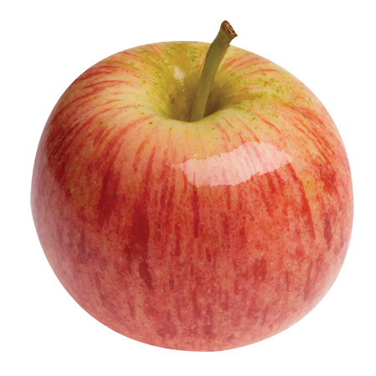
Lunch & Snack
Please send enough food
for your child to have both
a healthy snack and lunch while at school.
Change of Clothing
It would be very helpful to have a change of clothing
in your child’s back pack just in case!
Weather
As the weather is changing please make sure students are coming with appropriate clothing for outdoor play activities. We go outside EVERY day!
Picture Retake Day
Reminder that Picture Re-take day is coming up on Nov 13th –
Labelling Items
As the year goes on we are having students leave lots of items at school. It would be helpful to label everything you send to school with your child to avoid mix ups. ( tupperware, clothing, shoes, lunch bags etc)

Gym Clothes

A reminder to send your child with running shoes, on the days that we have phys ed. The days are marked on the monthly calendar.
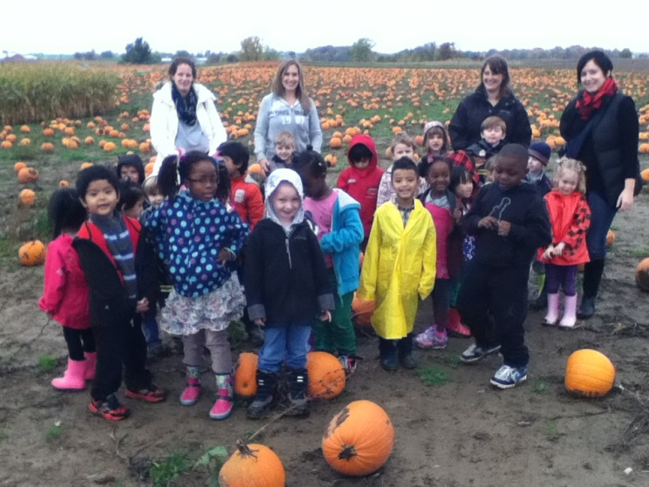
A trip to Dyments was fitting in the month of October. It opened up many learning opportunities. We we’re able to do so many Literacy, Math and Science lessons with pumpkins as well as lots of different Halloween crafts. A special thank you to our parent volunteers Mrs. Fritz and Ms. Upper.

In reading, and writing:
We have been focusing on our popcorn words and learning how to stretch out our words using the letters and their sounds, and then putting the word back together. Using different books, and doing picture walks we have learned that looking at the pictures can really help us figure out what we are reading and what a word might be.
In Math we have been learning all about graphing and ordinal numbers, Our classroom pumpkins dinosaurs and spiders raced and we decided who came in first, second and third place. We have been graphing our question of the day and deciding what answer has the most votes by looking at the graphs we have made. We have also continued patterning with different materials around the classroom.
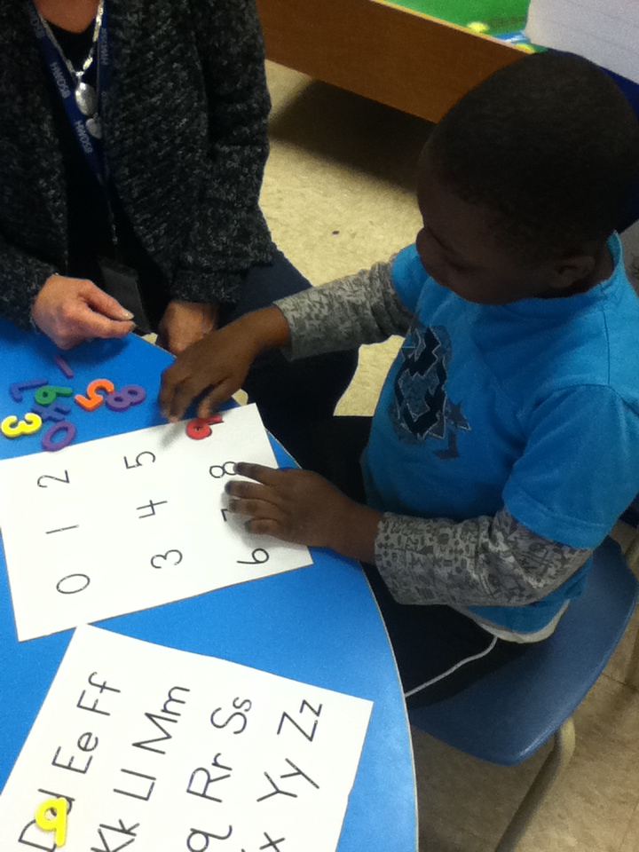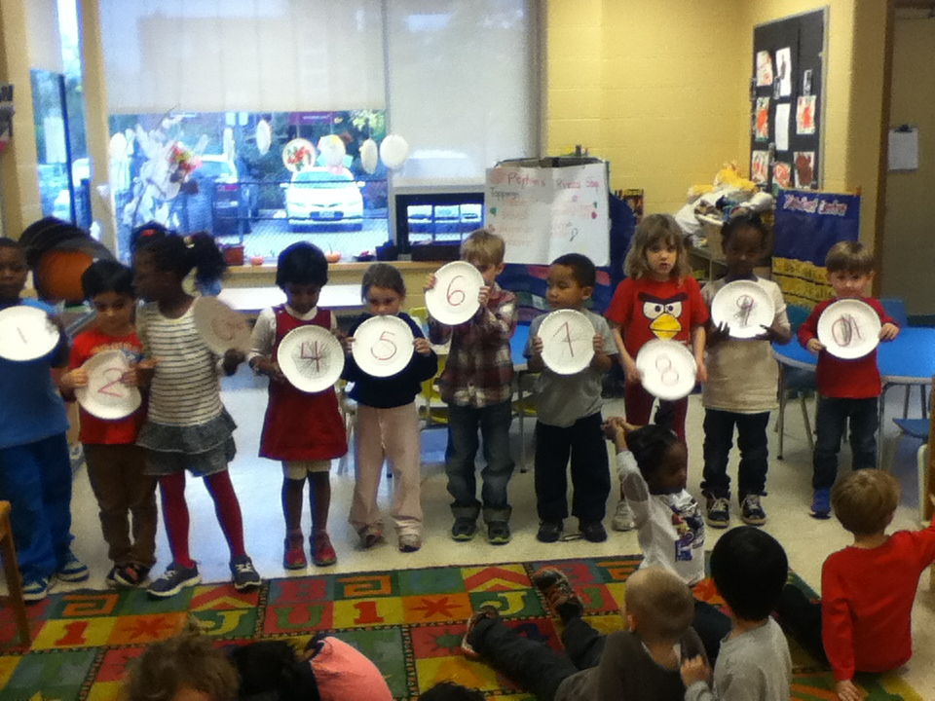
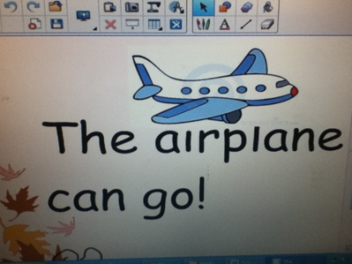
At home:
-Review popcorn words
-Practice correct formation of #s 1-10
- ordinal numbers 1st- 10th
- Practice printing of first name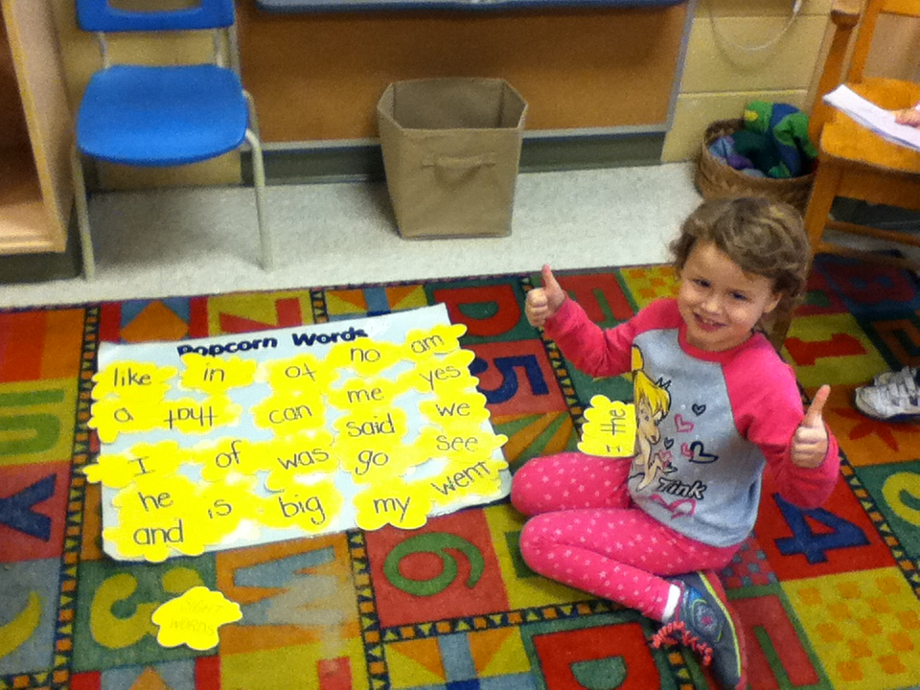

CLASSROOM BLOG- Check out what is happening in our classroom every single day! Visit
misskindergarten.commons.hwdsb.on.ca
Don’t forget to leave comments and watch for important announcements and updates. This will eventually take the place of our newsletter!

[Date]

