MFM2P FINAL EXAM REVIEW

1. Solve the following equations.
a) 5x + 20 = 60 b) -3 + 4a = 30 – 3a – 4a c) 4x - 8 = 9x + 2

- Find the slope and y-intercept of the following lines:
- y = x + 1 b) y = x + 3
m = m =
b = b =

- Determine the slope, y-intercept, and equation of the line shown in each graph.
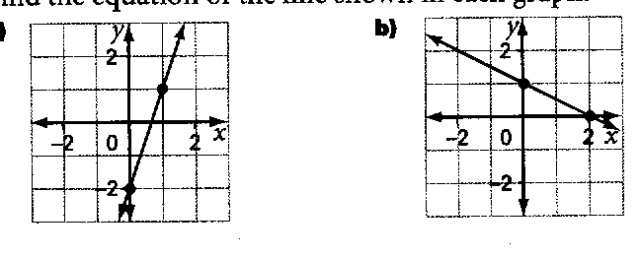
a) b)

Slope = _____ Slope = _____
y-intercept = _____ y-intercept = _____
Equation of the line: Equation of the line:

- Solve the following system of equations by method of graphing.
(Hint: use table of values, slope y – intercept, and/or x-y–intercepts methods.)
- y = x + 5 b)
y = -2x – 4
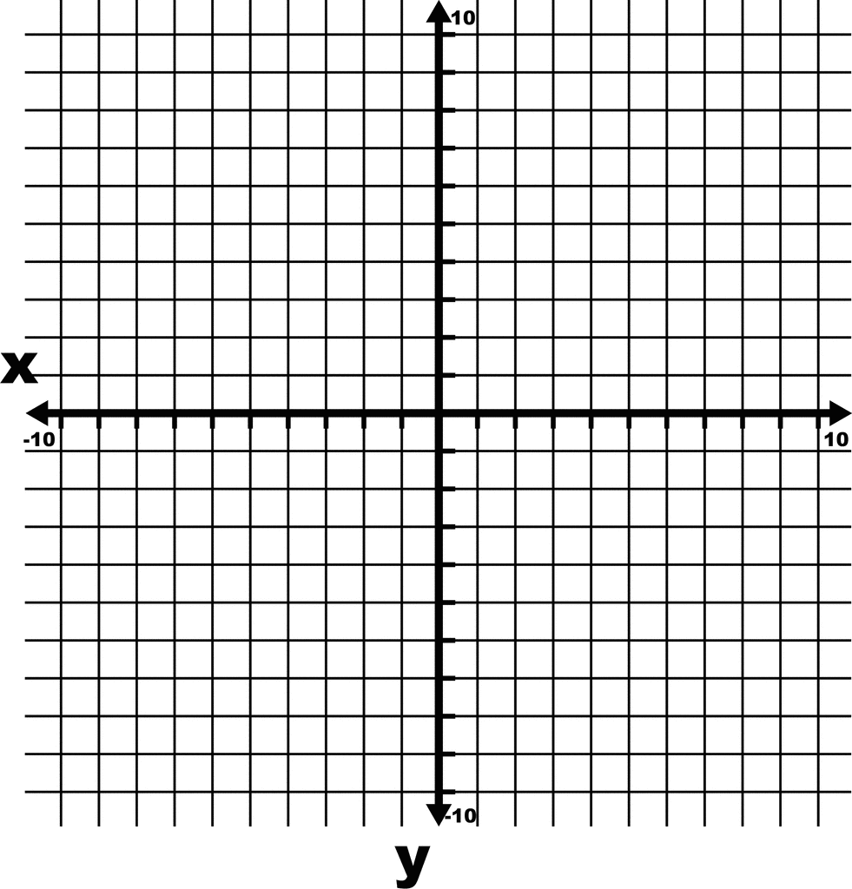
POI is: ( , ) POI is: ( , )

- Solve the following system of linear equations by either substitution OR elimination.
- -2x + y = -5 b) 4x – 4y = 4
3x + y = -10 3x + y = 3

- The school council is trying to determine which banquet hall to hold the Jr. Formal. The Algebra Ballroom charges a $60 per person plus an $800 flat fee. The Geometry Hall charges $55 per person plus an $1000 flat fee. The cost, C dollars, for n number of people.
Algebra Ballroom: C = 60n + 800
Geometry Hall: C = 55n + 1000
- What number of people attending the Junior Formal would result in the same cost at each banquet hall? Give a full algebraic solution.

- If 200 people attend the Jr. Formal, which banquet hall would you choose? Explain?

- The yearbook club is considering two different companies to print the yearbook. The Descartes Publishing charges $4.50 per book plus a flat fee of $475. School Memories charges $4.25 per book plus a flat fee of $550. The cost, C dollars, for n number of yearbooks printed.
Descartes Publishing: C = 4.50n + 475
School Memories: C = 4.25n + 550

- How many yearbooks would need to be printed for the cost to be the same at both companies? Show a full algebraic solution. Answer: 300 books

- Which company would you use if you needed 600 yearbooks printed?

- Expand and simplify the following:
a) (x + 3)(x + 5) b) (x – 2) (x + 4) c) (2x – 3)²

- Common factor each of the following.
a) 2x + 6 b) 9x² – 12x

- Factor the following quadratic expressions:
a) x² – 16 b) x² – 4x – 45

- x² – 10x + 16 d) x² – 3x – 10

e) x² + 11x + 24 f) x² – 49

- For the following parabola, state the value of the key features in the table below.

Parabola Graph | 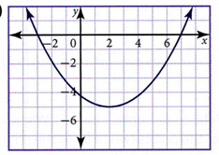
Vertex
Max/Min Value
Axis of Symmetry
Zeroes
Direction of Opening
y – intercept

- Calculate the first and second differences (if necessary) by completing the table.
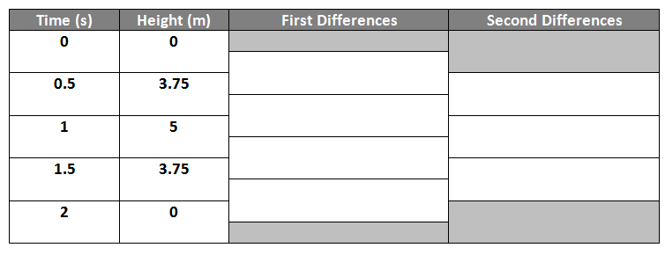

Is it linear, quadratic, or neither? _____________________
Height (m)
Explain your reason: __________________________________________________________

- Use the Pythagorean Theorem to find the unknown. Round answers to one decimal place.
x
- b)
x
8 m
6 cm
10 m
4 cm

- Similar Triangles: Two students take measurements as shown to determine the width of the river. Find the width of the river. Round answer to one decimal place. [4 marks]

- Find the missing side length.
- b)
x
25 m
60º
40 cm
x
41º

- A doorway is player is 350 cm tall. Express this height in metres.

- A marathon is 26 miles; convert to km. (Hint: 1 mile = 1.609 km)

- The fish tank measures 12 feet by 4 feet by 2 feet. How many cubic feet of water can it hold?

- Lance is going to paint baskets. Below is what one of them looks like:
- How much paint will he need to paint the outside of ONE basket in squared cm?
Open top
12 cm
10 cm
10 cm

- If one quart of paint is enough to paint 1 m², how many quarts will Lance need to buy in order to paint his 30 baskets? (Recall: 1 cm² = 0.0001 m²)

