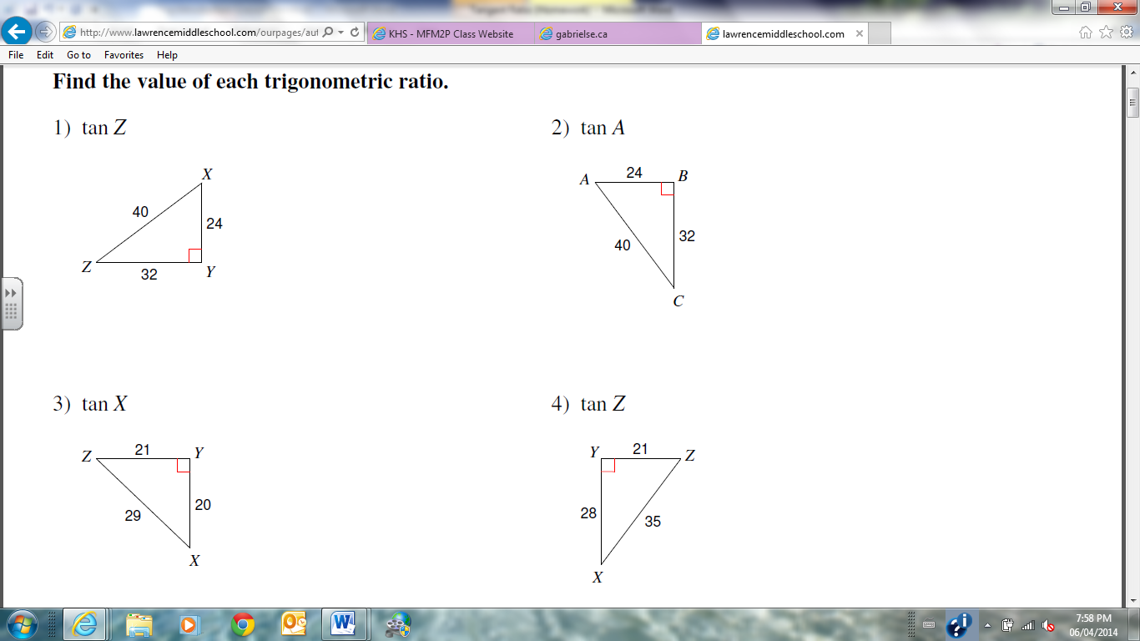
- Find the value of each tangent ratio:
- tan Z b) tan A c) tan X

- Use your calculator to find each value to four decimal places.
- tan 28º b) tan 36º c) tan 45º d) tan 72º

- Find the length of the unknown side. Round to 1 decimal.
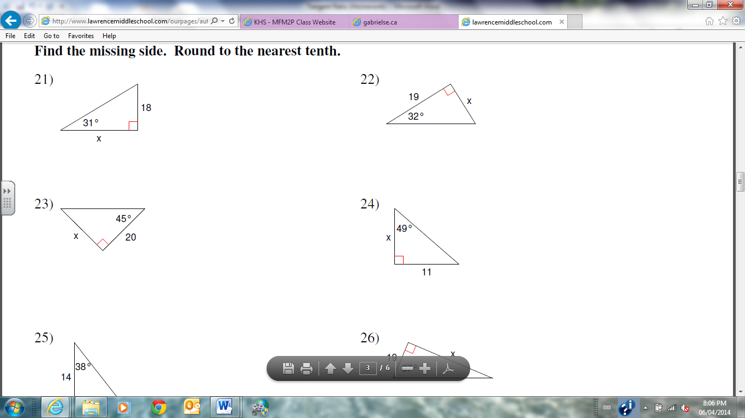

Round all answers to 1 decimal place.
- A helicopter H is hovering over a landing pad P 100 meters from where Grant is standing at G. The helicopter’s angle of elevation with the ground is 12°. What is the altitude of the helicopter?
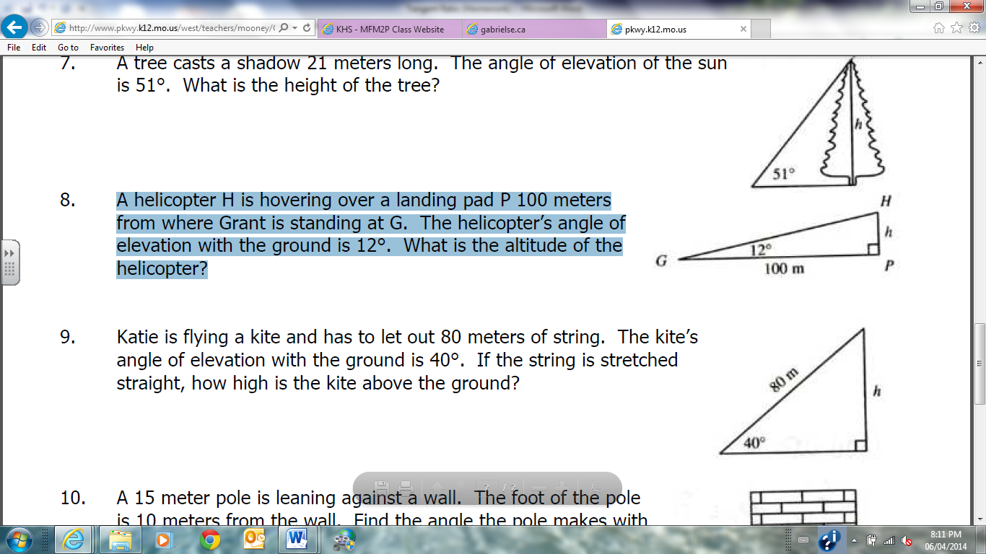

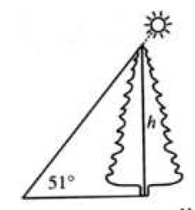
- A tree casts a shadow 21 meters long. The angle of elevation of the sun is 51°. What is the height of the tree?

21 m

