For the following parabolas:
- Graph the parabola and the axis of symmetry
- ON THE GRAPH, label the vertex, x-intercepts, y-intercept, the maximum or minimum value.
- Complete the key features of the quadratic relationship in the table provided.
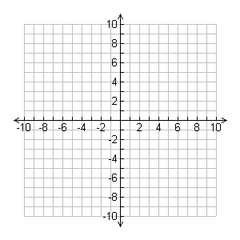
- Graph the parabola y = (x + 3)² – 4
The coordinates of the vertex
The equation of the axis of symmetry
Does the parabola open up or down?
The maximum or the minimum value
The y-intercept
The x-intercepts (zeros)

- How did you know the direction of the opening by looking at the equation only?

- How did you know the vertex of the parabola by looking at the equation only?

The coordinates of the vertex
The equation of the axis of symmetry
Does the parabola open up or down?
The maximum or the minimum value
The y-intercept
The x-intercepts (zeros)
- Graph y = -(x – 2)² – 1

- How did you know the direction of the opening by looking at the equation only?

- How did you know the vertex of the parabola by looking at the equation only?

- Graph y = (x + 1)² – 9
The coordinates of the vertex
The equation of the axis of symmetry
Does the parabola open up or down?
The maximum or the minimum value
The y-intercept
The x-intercepts (zeros)

The coordinates of the vertex
The equation of the axis of symmetry
Does the parabola open up or down?
The maximum or the minimum value
The y-intercept
The x-intercepts (zeros)

- Graph y = - (x + 2)² + 7

The coordinates of the vertex
The equation of the axis of symmetry
Does the parabola open up or down?
The maximum or the minimum value
The y-intercept
The x-intercepts (zeros)
- Graph y = (x - 2)² + 3

