Complete the following information and GRAPH each equation in Standard Form.
- y = x² – 8x + 7
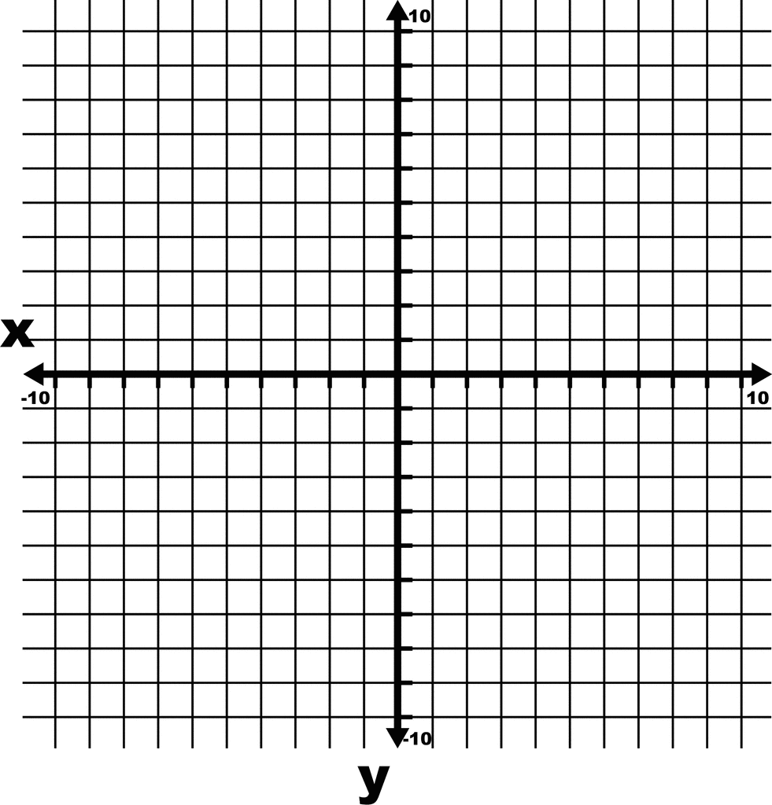
- y-intercept

- zeros

- axis of symmetry

- vertex

- direction of opening
- max/min value

- y = -x² + 2x + 3
- y-intercept

- zeros

- axis of symmetry

- vertex

- direction of opening
- max/min value

Complete the following information WITHOUT using a graph.
- y = 4x² + 24x – 28
- y-intercept

- zeros

- axis of symmetry
- vertex

- direction of opening

- max/min value

- y = –2x² + 162
- y-intercept

- zeros

- axis of symmetry

- vertex

- direction of opening
- max/min value

