- Name the corresponding angles and sides for each pair of similar triangles.
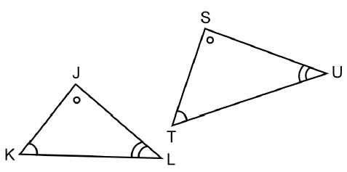

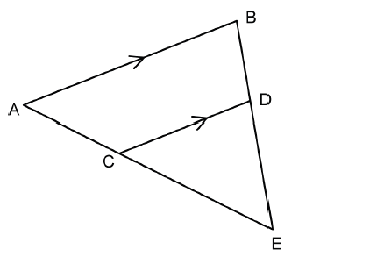

- If ABC ~ XYZ, find the corresponding angles and sides for the triangle.
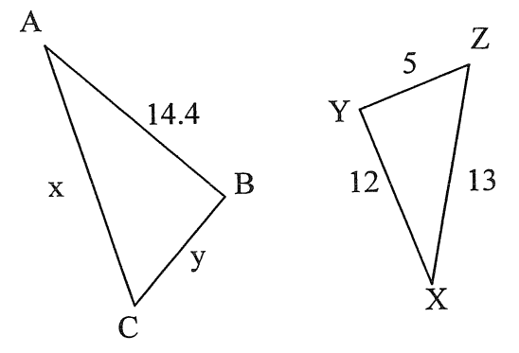

.

- Given the following triangles are similar, find all the missing angles.
R
B
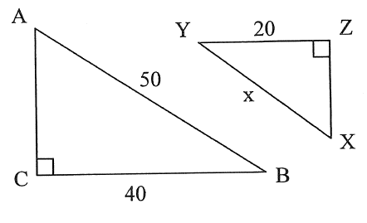
- b)
Q
60º
60º
30º
45º
60º
S
C
A
75º

- Given the following triangles in each pair are similar. Find the length of the missing sides.
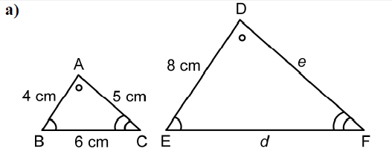
Find the length of e and d.

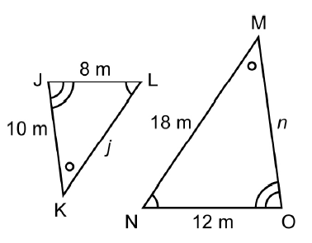
b) Find the length of j and n.

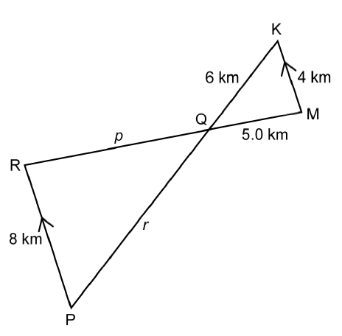
c) Find the length of p and r.
x

x

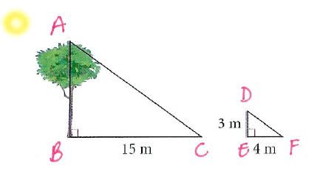
- A pole 3m tall casts a shadow of 4m long. A nearby tree casts a shadow 15m long. What is the height of the tree? (Remember to label the height with a variable)

