- The force of gravity on Mars is less than half that on Earth. A ball thrown upward can be modelled using h = -2t² + 4t + 6 where h is the height in feet and t is the time in seconds.
- What is the maximum height of the ball?
12
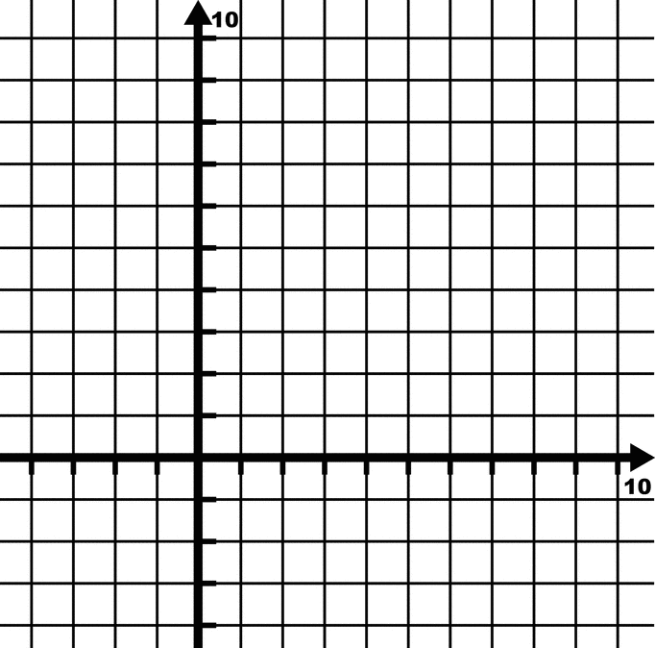
10
4
2
Height (ft)
8

6

2
4
6
8

Time (Seconds)

- When does the ball reach its maximum height?

- When does the ball hit the ground?
Height (m)
20
- The path of a firework is given by h = -5t² + 20t, where h is the height in metres and t is the time in seconds.
18
- Find the maximum height of the firework.
14

10

6
2
8
6
4
2

Time (Seconds)

- After how many seconds does the firework reach its maximum height?

- What is the height of the model rocket after 3 seconds?

