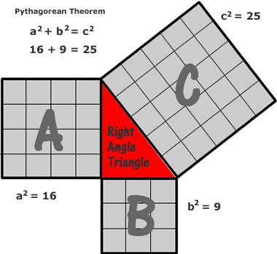
RELATION:
For any ________________________________, the area of a square placed on the _____________ ______________of the triangle is _____________ ___________________________ of the squares placed on the ____________________________.

Area of C = __________________________

___ is the _______________ side of a right angled triangle.
It is called the ______________________ and is
_____________________of the right angle.
The other two sides are called ________ and labeled __________

PYTHAGOREAN THEOREM FORMULA
_______________________________
This ONLY works for right angled triangles.

EXAMPLES:
- Calculate the unknown side for each right angled triangle.
- Step 1: Label your sides starting with c, then a and b
c
3
4
Step 2: Substitute your values into the formula (c² = a² + b²)
Step 3: Rearrange the formula to solve the unknown side

13
b
5

15
x
14
7
y

- a = 3, b = √4, c = ?

