- Determine whether the following are LINEAR, QUADRATIC, or NEITHER. Only complete S.D. if necessary!
a)
x | y | F.D | S.D
-4 | 5
-2 | 2
0 | 1
2 | 2
4 | 5
6 | 10
b)
x | y
0 | 600
1 | 700
2 | 800
3 | 900
4 | 1000
5 | 1100

x  c) | y
0 | 7
1 | 21
2 | 63
3 | 189
4 | 567

- Determine whether the following equations are linear, quadratic, or neither, and explain why.
- y = x + 3 __________________________ Why? ___________________________
- y = $x^{\frac{1}{3}}$ + 5 __________________________ Why? ___________________________
- y = x² – 2x + 5 __________________________ Why? ___________________________
- 3x – y = 5 __________________________ Why? ___________________________
- 5 - x² = 89 __________________________ Why? ___________________________
- x⁴ + x² + 1 = 0 _________________________ Why? ___________________________

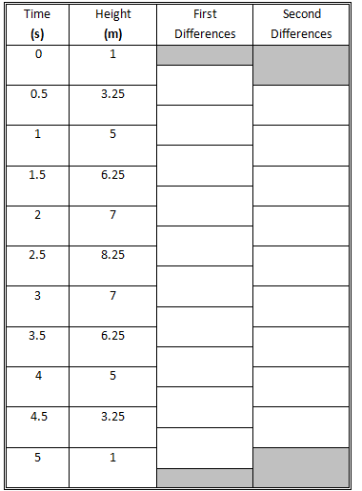
- The observations for the height of a paper airplane at different times are as follows. The airplane was thrown starting at a height of 1m above ground.

- Determine the first difference and second differences. Record your answers in the table to the right.
- What type of function does this data represent? (Linear/quadratic/neither) ______________________

Give a reason for your choice.

- Complete the scatter plot below by plotting time(s) on the horizontal axis and height (m) on the vertical axis.

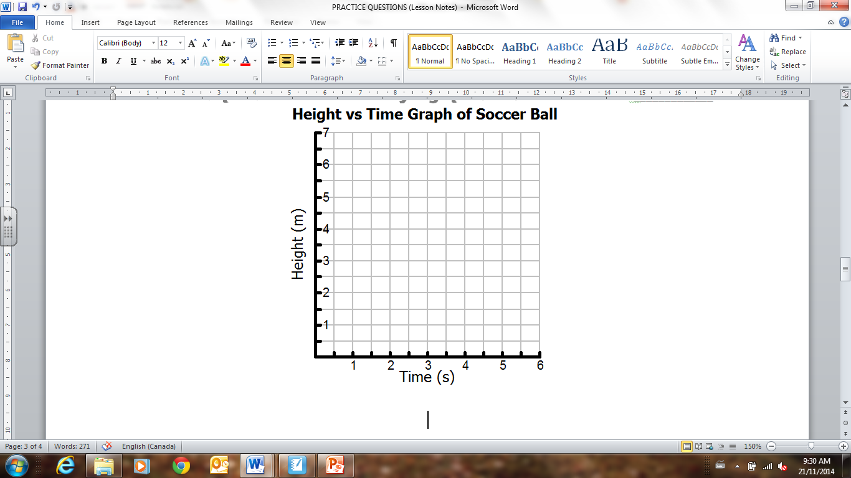
8
- For how long was the airplane in the air
before it was caught at 1m?
7

- After how many seconds did the airplane reach the maximum height?

- What is the height of the airplane after 4.5 s?

