ASSIGNMENT REVIEW - Characteristics of Quadratics

- Are the following quadratic equations in standard, factored, or vertex form?

- y = 19x² + 4x + 1 _______________ b) y = 4 (x -2 )² + 1________________

c) y = (x – 3)(x + 8) _______________ d) y = x² + 5x - 92________________

- For the following parabolas, state the key features:

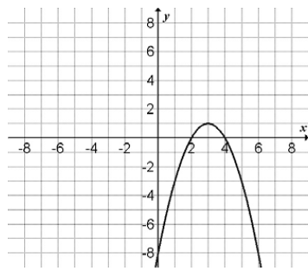
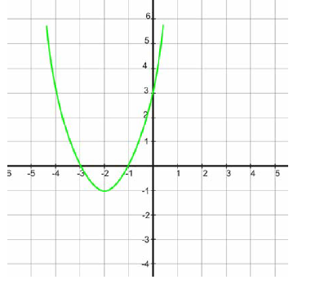

- Vertex a) Vertex

- Min/max value b) Min/max value

- Axis of symmetry c) Axis of symmetry

- Zeros d) Zeros

- Direction of opening e) Direction of opening

- y-intercept f) y-intercept

- Find the zeros of the following quadratic equations.
a) y = x² – 8x – 33 b) y = 3x² – 48 c) y = 2x² +6x – 80

- The path of a killer whale in the water can be given by the function d = t² - 8t + 7. Where d is the depth in metres (y-value) below the water surface and t is the time in seconds (x-value). Complete the following information below and sketch a graph.
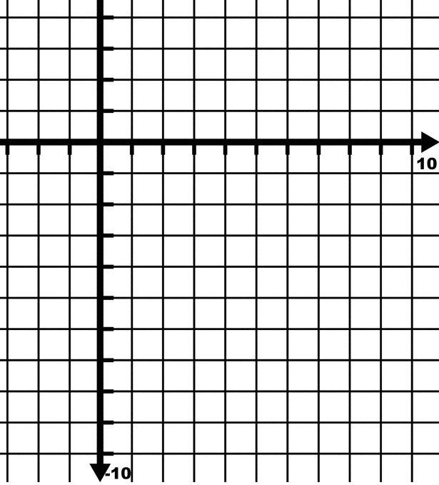
- y-intercept ____________

- Zeros
Depth (m)

- Axis of symmetry

Time (s)
- Vertex

- Draw the graph on the grid provided using the information you have gathered.

- Direction of opening ____________

- What is the maximum/minimum depth the whale reaches? _________________

- Label each equation as either: linear, quadratic or neither.
d) 19x – 4y + 1 = 0 _________________

e) y = 11x³ + 8 _________________

f) y = 4x⁵ + 6x _________________

a) y = 6x – 1 ____________________

b) y = 3x² + 10x ___________________

c) y = 9x² – 4x + 100 __________________

- The observations for a kicked football at different times are shown below.
Time (s) | Height (m) | First Differences | Second Differences
0 | 0
0.5 | 8.75
1 | 15
1.5 | 18.75
2 | 20
2.5 | 18.75
3 | 15
3.5 | 8.75
4 | 0
- Calculate the first and second differences (if necessary) by completing the above table.
Height (m)
Height (m)
- Is it linear, quadratic, or neither? _____________________
Height (m)
Explain your reason: __________________________________________________________
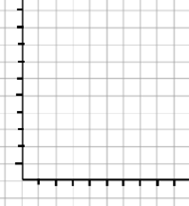
- Use the points from the table and complete the scatter plot on the graph to the right by plotting time(s) on the horizontal axis and height (m) on the vertical axis.
18
14
20
16
12
Height (m)
- How long was the ball in the air for? _______________________________
10
6
8
Height (m)
- After how many seconds did the ball reach its maximum height? ______________
2
4
- What was the height of the ball after 3.5 seconds? ______________
Time (s)
4
3
2
1
0

