Solving Linear Systems – Review
INSTRUCTIONS:
Complete the questions below using your lesson notes to help you. SHOW ALL YOUR WORK and CHECK YOUR ANSWERS. If you don’t have enough space, write your solutions on a separate piece of paper.
- Solve the following linear systems by GRAPHING.
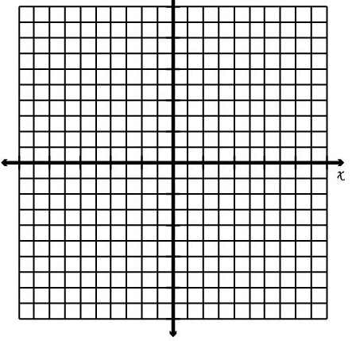
(Hint: Graph each line and find where the lines cross!)
- b)

y = x + 3 y = x + 5
y = -3x - 1 y = 2x + 2
POI = _____________ POI = _____________

Answer: (-1, 2) Answer: (3,8)

- Solve the following linear systems by SUBSTITUTION. Check ONE solution (LS = RS).
(Hint: If one of the equations doesn’t have y or x by itself, rearrange the equation first!)

- 3x + 2y – 1 = 0 Answer: POI is (-5, 8)
y = -x + 3

Question #2 Continued….Solve the following linear systems by SUBSTITUTION.
- x = -2y + 7 Answer: POI is (9, -1) c) 3x – y = 4 Answer: POI is (3, 5)
x + 4y = 5 x + y = 8

- Solve the following linear systems by ELIMINATION. Check ONE solution (LS = RS).
(Hint: You may need to multiply one or both equations by a number first)

- 3x – 4y = 14 Answer: POI is (2, -2) b) x + 2y = 9 Answer: POI is (1, 4)
3x + 7y = -8 4x – 2y = -4

Question #3 Continued….Solve the following linear systems by ELIMINATION.
c) -4x + 9y = 9 Answer: POI is (9, 5) d) 6x + 2y = 6 Answer: POI is (1, 0)
x – 3y = -6 4x – 4y = 4

- Solve the following linear systems using SUBSTITUTION OR ELIMINATION.
- 2x – 2y = 14 Answer: POI is (5, -2) b) 3x + y = -1 Answer: POI is (2, -7)
x + 2y = 1 y = 2x – 11

CHALLENGE QUESTIONS – SEE IF YOU CAN FIGURE THEM OUT
- After ticket sales at a volleyball game, a cash box contains 87 coins in loonies and toonies. If the total value of the money is $161, how much of each kind of coin is there? The situation can be represented by the following linear system:
l + t = 87
l + 2t = 161
where l represents the number of loonies and t represents the number toonies.
- Solve the system of equations by substitution or elimination. (Hint: Pretend the l is x and t is y) Answer: (74, 13)

- How many loonies are in the cash box? (Hint: What is the l value?)
- How many toonies are in the cash box? (Hint: What is the t value?)

- At a sale, each DVD is one price and each CD is another price. Three DVDs and two CDs cost $67. One DVD and three CDs cost $48. This situation can be described by the following linear system:
3d + 2c = 67
d + 3c = 48
where d represents the price of a DVD in dollars and c represents the price of a CD in dollars.
- Solve the system of equations by substitution or elimination. (Hint: Pretend the d is x and c is y) Answer: (15, 11)

- How much does one DVD cost? (Hint: What is the d value?)
- How much does one CD cost? (Hint: What is the c value?)

