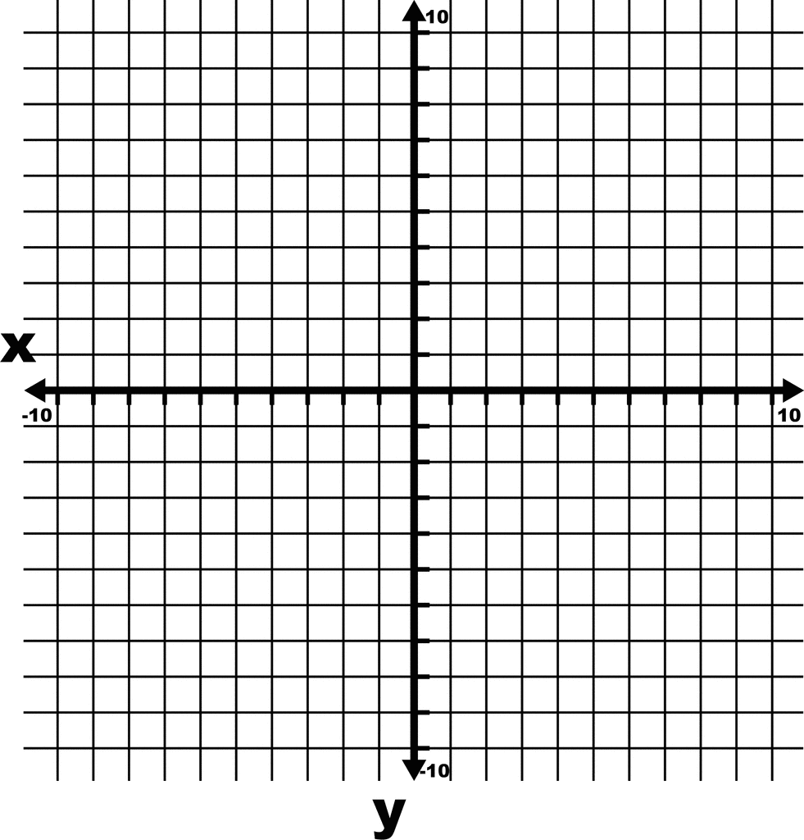
Investigation A:
- Enter the equation y = x². Sketch and label this graph on the grid provided below.
- On the same graph, enter the equation y = 2x². Sketch and label this graph on the grid provided.
Findings:
How are these graphs different?

Investigation B:
- Delete all previous graphs.
- Enter the equation y = x². Sketch and label this graph on the grid provided below.
- On the same graph, enter the equation y = $\frac{1}{2}$x² or y = 0.5x². Sketch and label this graph on the grid provided.
Findings:
How are these graphs different?

Investigation C:
- Delete all previous graphs.
- Enter the following equations:
y = $\sqrt{x}$, y = $3\sqrt{x}$, y =$\frac{1}{3}\sqrt{x}$ or y = 0.33$\sqrt{x}$
- Sketch and label these graphs on the grid provided below.
Findings:
What can you conclude from these graphs?

SUMMARY OF VERTICAL STRETCHES AND COMPRESSIONS:
- The function af(x) will be ______________________________________________________________
- The function af(x) will be ______________________________________________________________

Investigation D:
- Delete all previous graphs.
- Enter the following equations:
y = x², y = $(\frac{1}{2}x)$² or y = (0.5x)², y = (2x)²
- Sketch and label these graphs on the grid provided below.

Findings:
Which of the functions stretches y = x² horizontally?

Which of the functions compresses y = x² horizontally?

SUMMARY OF HORIZTONAL COMPRESSIONS AND STRETCHES:
- For the function y = f(kx), if ____________________________________________________________
- If -1 < k < 1, _________________________________________________________________________

