The xy-plane is known as the Cartesian Plan.
horizontal axis x-axis
vertical axis y-axis
The intersection point of these two is called the origin with coordinates (0,0).
The x and y axis are divided into four regions called quadrants.
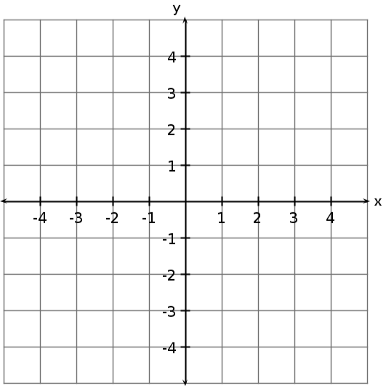
The coordinates of a point on the Cartesian Plane form what is called an ordered pair (x,y).
Quadrant 1
( + , + )
Quadrant 2
( - , + )

Quadrant 3
( - , - )
Quadrant 4
( + , - )

Plot the following points:
A (4,1) | B (-2,3) | C (-4,-2) | D (3,-1)
E (0,-1) | F (0,3) | G (-2,0)

