#2
#1
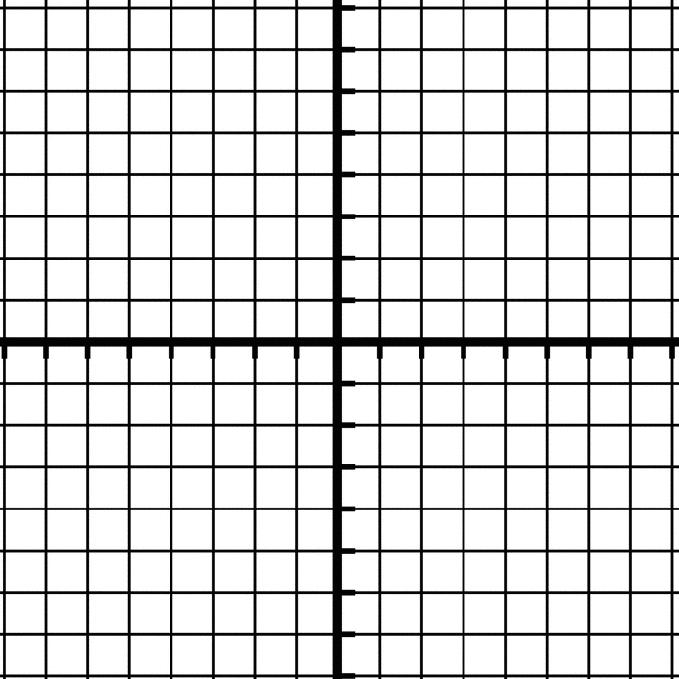
Parallel Lines
- Two lines that never cross each other
- The distance between the lines stays the same

Slope of Line #1: _______
y-intercept of Line #1: _______
Equation of Line #1: _______________________

Slope of Line #2: ________
y-intercept of Line #2: ________
Equation of Line #2: _______________________

FINDINGS:
What do we notice about the slopes and y-intercepts of these parallel lines?
The slopes are the SAME. (Ex. Both slopes are __________)
The y-intercepts are DIFFERENT (Ex. Line #1 y- intercept is ___ and Line #2 y-intercept is ___)

TASK:
a) Write two equations that are parallel to the line y = 3x + 1
Equation #1: __________________
Equation #2: __________________

b) Graph all three equations.

Perpendicular Lines
- Two lines that intersect (cross) each other at a 90º angle.

Slope of Line #1: _______
y-intercept of Line #1: _______
Equation of Line #1: _______________________

Slope of Line #2: ________
y-intercept of Line #2: ________
Equation of Line #2: _______________________

FINDINGS:
What do we notice about the slopes of these perpendicular lines?
The slope of the perpendicular line (Line #2) is the negative reciprocal of the other line (Line #1). Line #1 has a slope of 2, and Line #2 has a slope of -1/2.
Negative Reciprocal: Flip the fraction and change the sign.

TASK 1: TASK 2:
Find the negative reciprocal: a) Write an equation that is perpendicular to the line y = -3x + 2
Slope | Negative Reciprocal
$$\frac{3}{4}$$
4
$$-\frac{1}{2}$$
8
-6
Equation: ____________________
b) Graph both equations.

