Slope Y-Intercept Form:
The slope y-intercept form of a linear equation is written in the form of y = mx + b.
For example: y = 2x + 3
Investigation A:
- Enter the linear equation y = x.
- Pick two points on the line and calculate the slope of equation y = x. Slope = ___________
- Under the first equation, enter the equation y = 2x.
- Pick two points on the line and calculate the slope of equation y = 2x. Slope = ___________
- Repeat for the following equations and record your data in the table below.
Equation | Slope (m)
y = 3x
y = 4x
y = 10x
y = 0.5x
Clear all graphs, then continue with the following equations.
y = -x
y = -2x
y = -3x
y = -4x

Findings:
- What happens to the steepness of a line as the value of the slope increases?

- What happens to the line when there is a negative sign in front of the x value?

- What can you conclude about the relationship between a linear equation in the form y = mx + b and its slope?

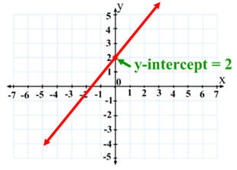
Y-Intercept
- It is the point where the graph intersects the y-axis
- It is the value of y, when x = 0
Investigation B:
- Clear your screen of all previous graphs.
- Enter the linear equation y = x.
- What is the value of y when x = 0? ______________
- What is the y-intercept of the equation y = x? _______________
- Under the first equation, enter the equation y = x + 2.
- What is the value of y when x = 0? _______________
- What is the y-intercept of the equation y = x + 2?
- Repeat for the following equations, recording your data in the table below.
Equation | Value of y when x = 0 | Y-Intercept
y = x + 3
y = x + 5
y = x - 2
y = x - 7
Clear all graphs, then continue with the following equations
y = -x
y = -x + 1
y = -x + 4
y = -x - 5

Findings:
- What can you conclude about the relationship between a linear equation in the form y = mx + b and its y-intercept?

CONCLUSION:
In a linear equation of the form y = mx + b, _____represents the ____________________(rate of change) and _____ represents the ________________________ (or initial value). The ______________________ the slope, the _______________________ the line.

