GRAPHING LINEAR RELATIONS - REVIEW
- A horizontal line has a slope value of what?

- A vertical line has what kind of slope?

- State the slope and y-intercept for the following equations:

- y = - $\frac{3}{4}$x + 2

- y = 2x

- Given the equation of the line y = 4x + 1,
- Write an equation that is parallel.

- Write an equation that is perpendicular.

- For the following equations, first state the m and b, THEN graph them on the grids below.
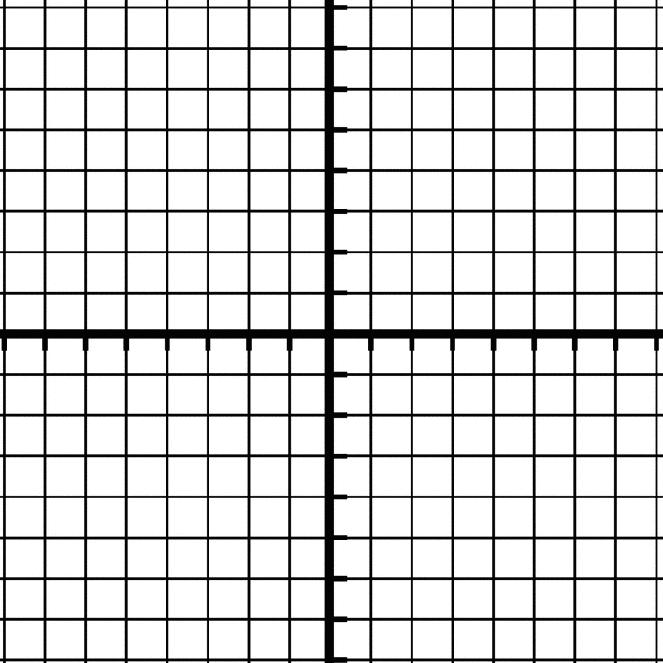
a) b)
y = - $\frac{1}{3}$x + 2
m =

b =
y = 2x - 6
m =

b =

- Write the equation of the line in the form y = mx + b given the following situations:
- Slope of $\frac{2}{3}$ and y-intercept of 1. b) Slope of -3 and y-intercept of 8.

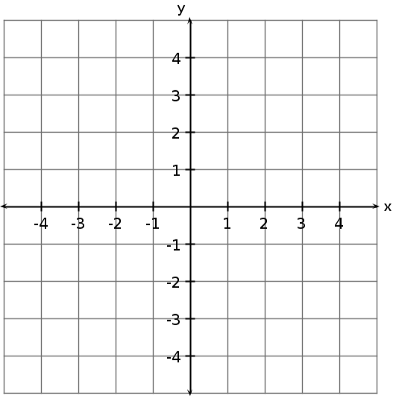
- State the slope, y-intercept, and equation in the form y = mx + b for the following graph:

slope:

y-int:

Equation:
Is the slope positive or negative?

- Determine the slope, y-intercept, and equation for the line represented by the following table of values.
x | y
0
2 | 4
4 | 8
6 | 12
x | y
0
1 | 4
2 | 6
3 | 8
- b)

slope: slope:
y-intercept: y-intercept
Equation: Equation:

- Write an equation in the form y = mx + b for the following graphs:
- b)

Equation: ______________ Equation: _________________

- Sarah earns $9 per hour babysitting the neighbour’s kids.
- Make a table of values showing Sarah’s total earnings for up to 5 hours of babysitting.

- Graph Sarah’s earnings.
40
Hours Worked | Total Earnings | Rate of Change  (y-values)  Total Earnings ($)  30
0
1 |  | 20
 |  | 10
0
4
2
5 |  | Hours Worked

- What is the equation that represents this relationship in the form y = mx + b?

- What do the slope and y-intercept represent in this question?
Slope:

y-intercept:

- Write the equation of the line in the form y = mx + b given the following situations:
- Passing through the point (5, 1) and a slope of -2.

- Passing through points (3, 0) and (6, 2).

- The linear equation is y = 3x + 2.
- Find the x and y-intercepts from the equation.

- Graph the line using the intercepts.

- Write the following equations in Standard Form:
- y = 2x – 3 b) y = - $\frac{2}{3}$ x - 7

- Write the following equation in y-intercept form:
- x – 3y + 9 = 0 b) 3x – 4y – 12 = 0

- A cell phone service provider charges $25.00 per month plus $0.25 per minute of use.
- What is the dependent variable?
What is the independent variable?

- Write an equation to model this relationship, where C is the cost and n is the number of minutes.

- How much would it cost to talk for 150 minutes per month?

