Some Terminology
Linear Relation: The relationship between two points on a straight line.
Slope: Measures the steepness of a straight line.
- It measures the “rate of change” from one point on the line with respect to another point.
- Ask, for every unit change in “x”, how much does “y” change?
Rise: The vertical distance between two points on a straight line. (eg. 1 unit)
Run: The horizontal distance between the two points on a straight line. (eg. 4 units)
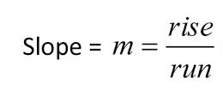
Calculating Slope
The variable used to represent slope is “m”.
To calculate slope, you can use the following equation:
Examples:
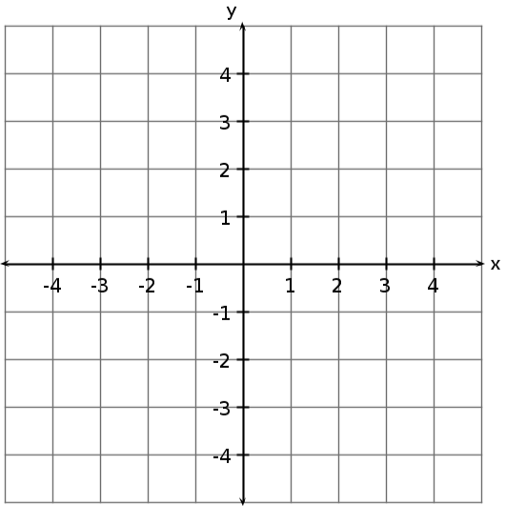
Calculate the slope between the two points.
a) b)

Slope = ____
Slope = ____

Positive Slope: Follow the line from left to right and the rise goes up.
Negative Slope: Follow the line from left to right and the rise goes down.

c) What is the slope between points d) What is the slope between points
(-4, 0) and (-1, 3)? (3, -2) and (-1, -4)?

e) What is the slope between points f) What is the slope between points
(-2, 1) and (-2, 4)? (1, 1) and (4, 1)?

Vertical Line: Has a slope that is undefined.
Horizontal Line: Has a slope of zero.

