Rate of Change:
Change in the y quantity (rise) relative to the change of one x unit (run).

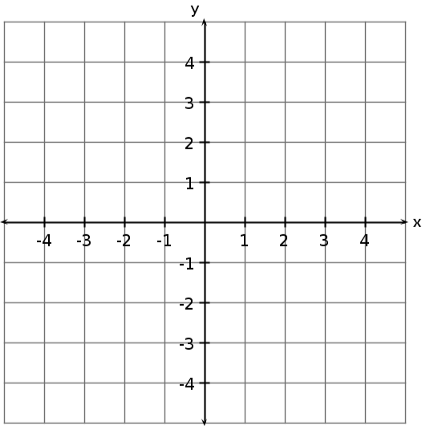
Calculate the slope (the rate of change) of the line:
Steps:
- Find any two points on the line.
- Count the rise and the run between the 2 points.
- Substitute rise and run into m = $\frac{rise}{run}$ formula.

Is the slope positive or negative? How do you know by just looking at it?
Negative. Looking at the line from left to right, the line slopes down.

ANOTHER EXAMPLE:
Calculate the slope (rate of change) of the line. Is the slope positive or negative?

PRACTICE QUESTIONS
Calculate the slope of the following lines. State whether the slope is positive or negative.
- b)

c) d)

