1. For each of the scenarios below fill in the appropriate values in the space provided.
Scenario | A banquet hall charges a flat rate of $300 plus $20 per person | Lindsay earns $10 per hour | A cell phone data plan charges a flat fee of $10 plus $0.40 per MB | 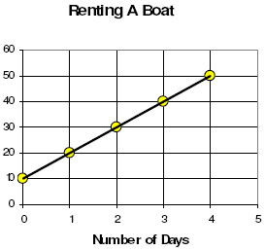 | 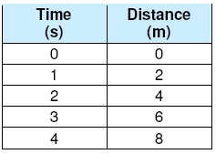
Dependent variable
Independent Variable
Initial Value
Rate
Equation (y = mx + b)
Partial or Direct

2. A gym membership costs a one-time fee of $99 plus $23 per month.
  - Write an equation to model this situation (remember to define your variables!).

  - How much would it cost to be a member for 2 years?

