SOLVING ALGEBRAIC EQUATIONS – TEST REVIEW

- Collect like terms and simplify.
- n – 10 + 9n -3 b) - 5n + 3 (6 + 7n) c) -7 (a + 3) – 8 (1 + 8a)

2. Solve the following equations using the given values.
a) xy - 5, when x = 3 and y = 7 b) 4n - 6, when n = -2 c) $\frac{x+y}{y-c}$ when x = 4, y = 8, c = 2

- Solve the following equations by isolating the variable. CHECK your answers using LS = RS.
a) x + 10 = -6 b) 45 = y – 8 c) -14 + a = 22

- Solve the following equations.
a) 4x = 12 b) -33 = -3y c) -6x = 24

d) $\frac{1}{2}$ x = 5 e) $\frac{1}{4}$ y = 6 f) $\frac{1}{3}$ x = $\frac{2}{3}$

g) 4x - 5 = 7 h) 11 = -5x + 6 i) $\frac{x}{6}$ - 3 = 8

5. Solve the following equations. (Hint: Pick a letter side and a number side first)
a) 7m – 8 = 5m + 2 b) 7x - 9x – 6 = 21 – 5 c) 22 – y + 5y – 3 = 5 – 3y

- 4(5n – 7) = 10n + 2 e) 2v + 18 = 16 – 4(v + 7) f) 9(11 – k) = 3(3k – 9)

6. Given the dimensions of the field,
a) Determine a simplified expression for the perimeter of the field.
(x + 6)
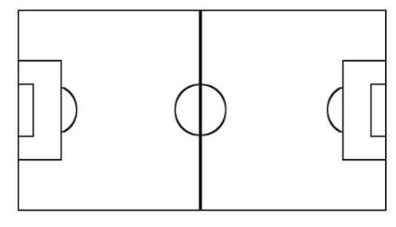
P =
(x – 3)

- Determine the value of x if the actual perimeter of the field is 78 metres.

- Solve the following equations with fractions.
- 7 = $\frac{1+m}{-3}$ b) $\frac{1(11+n)}{4}$ = 9 c) $\frac{m+1}{5}$ = $\frac{m}{6}$

8. Solve the following equations. (Hint: Find a common denominator!)
a) $\frac{x+3}{4}$ + $\frac{x+1}{3}$ = 3 b) $\frac{2}{5}$ + $\frac{4x}{3}$ = $\frac{10x}{6}$ + $\frac{11}{15}$

9. Rearrange each formula to isolate the indicated variable.
a) y = mx + b, solve for x b) I = Prt, solve for P

c) d = st, solve for t d) A = $\frac{bh}{2}$ , solve for b

10. Solve the following word problems by finding the value of the indicated variable.
- The formula for finding the volume of a rectangle is V = lwh, where V is volume, l is length, w is width, and h is the height. If the volume of a rectangle is 108 cm³, the length 4 cm, and the width is 3 cm, what is the height of the rectangle?

- The formula P = 2l + 2w is used to calculate the perimeter, P, of a rectangle. Length is represented by l and w represents the width. If the perimeter of a rectangle is 210 cm, and the length is 20 cm, calculate the width of the rectangle.

- Volcanoes and geysers illustrate that Earth’s interior is very hot. The formula T = 10d + 20 is used to estimate the temperature, T degrees Celsius, at a depth of d kilometers.
  - Determine the temperature in a mine shaft that is 0.5 km below the surface of the earth.
  - At what depth (d) is the temperature 100ºC?

