September 6, 2016
Dear Parents/Guardians,
Your child has brought home his or her agenda to share with you. In addition to helping your child develop organizational skills, the agenda promotes communication between home and school. In the agenda, your child will communicate with you what he or she needs to complete or to share with you that evening (e.g. homework, bring forms/library books to class, important events or dates, etc.). This will be our continuous and main form of communication this year. Therefore, it is important that it is checked nightly. Once the items have been completed, checked or packed, I am asking that you initial or sign in the box for the day.
When your child returns to class, I will then place a stamp, sticker, or checkmark beside the parent signature. This is an incentive for your child to show both you and me the agenda each day. This process will quickly become routine.
Your child will also receive a sticker or stamp in his/her agenda at the end of the day if they had a good day. If they had difficulties, there will be a brief note explaining the problem(s). I find that this is a quick and easy way of communication, keeping parents informed of daily events.
The agenda is a great organizational tool and gives your child a sense of responsibility. Your assistance in making this a smooth process is greatly appreciated.
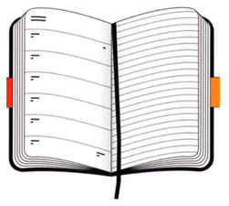
Thank you,
Mrs. Hall

