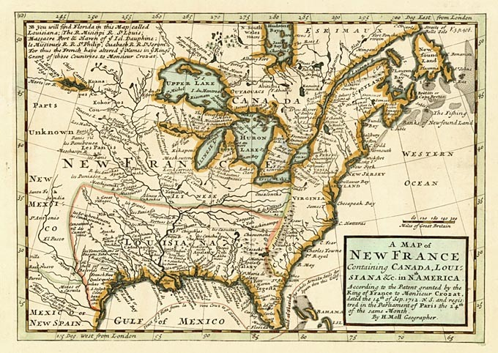
CHAPTER ONE – NEW FRANCE colony
For classes 74 and 75

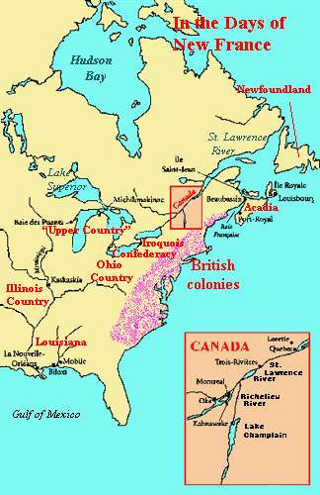
History Task 1: Read URSULINE NUNS (page 12) to FILLES DU ROI (page 17). Name__________
- In your own words, describe & draw the layout of a typical seigneurie.
(Pay particular attention to the shape of the fields.)

- Why were the filles du roi such an important force in helping to develop New France? Explain your answer.

Literacy cycle 75 | March 26 | March 27 | March 30 | March 31 | April 1
Wonder | English/Grammar sheet | Book task #10 | Book task #11 | Book task #12 | History Task #1
Wave | Book task #10 | English/Grammar sheet | Book task #11 | History Task #1 | Book task #12
Uglies | Catch Up class – tasks & comments | Book task #10 | English/Grammar sheet | Book task #11 | History Task #1
Fault in Our Stars | History Task #1 | Book task #10 | Book task #11 | English/Grammar sheet | Book task #12
Mazerunner | Book task #10 | History Task #1 | Book task #11 | Book task #12 | English/Grammar sheet
Brian’s Winter | Book task #10 | Book task #11 | History Task #1 | Book task #12 | English/Grammar sheet
Kind of a funny story | English/Grammar sheet | Book task #10 | Book task #11 | History Task #1 | Book task #12
Full Tilt | Book task #10 | English/Grammar sheet | History Task #1 | Book task #11 | Book task #12

Literacy cycle 74 | March 26 | March 27 | March 30 | March 31 | April 1
Wonder | English/Grammar sheet | Book task #11 | Book task #12 | Book task #13 | History Task #1
Wave | Book task #11 | English/Grammar sheet | Book task #12 | History Task #1 | Book task #13
Uglies | Book task #11 | Book task #12 | English/Grammar sheet | Book task #13 | History Task #1
Fault in Our Stars | History Task #1 | Book task #11 | Book task #12 | English/Grammar sheet | Book task #13
Stormbreaker | Book task #11 | History Task #1 | Book task #12 | Book task #13 | English/Grammar sheet
Brian’s Winter | Book task #11 | Book task #12 | History Task #1 | Book task #13 | English/Grammar sheet
Divergent/Mazerunner | Book task #11 | English/Grammar sheet | Book task #12 | History Task #1 | Book task #13

