Kinderkorner News
Volume 1, Issue 8 April 2015
Congratulations Mrs. James on the arrival of your beautiful baby boy Benson!
I would like to take this opportunity to introduce myself. My name is Miss. Capoferri. I will be your child’s Kindergarten teacher for the remainder of the school year. I have had the privilege of getting to know all the children during this past week. I look forward to the upcoming months as we will learn and grow together.
Thank you,
Miss. Capoferri
Don’t forget that every Wednesday is pizza day. The cost is $1 per slice. Please send the money in a bag or envelope with your child’s name on it. Milk is .75 cents (chocolate or white).
Please remember to visit our blog often to see what we are doing in the classroom. You can subscribe with your email address and be automatically updated when new blogs are posted. Come check us out at: http://kinderkorner.commons.hwdsb.on.ca/

A look back at March
In Language we reviewed the letters P, Q, R, and S. The children are really coming along in learning their letters and sounds. Way to go!!

During Literacy, we used our Easter theme to “Write the Room” We were on a word hunt!
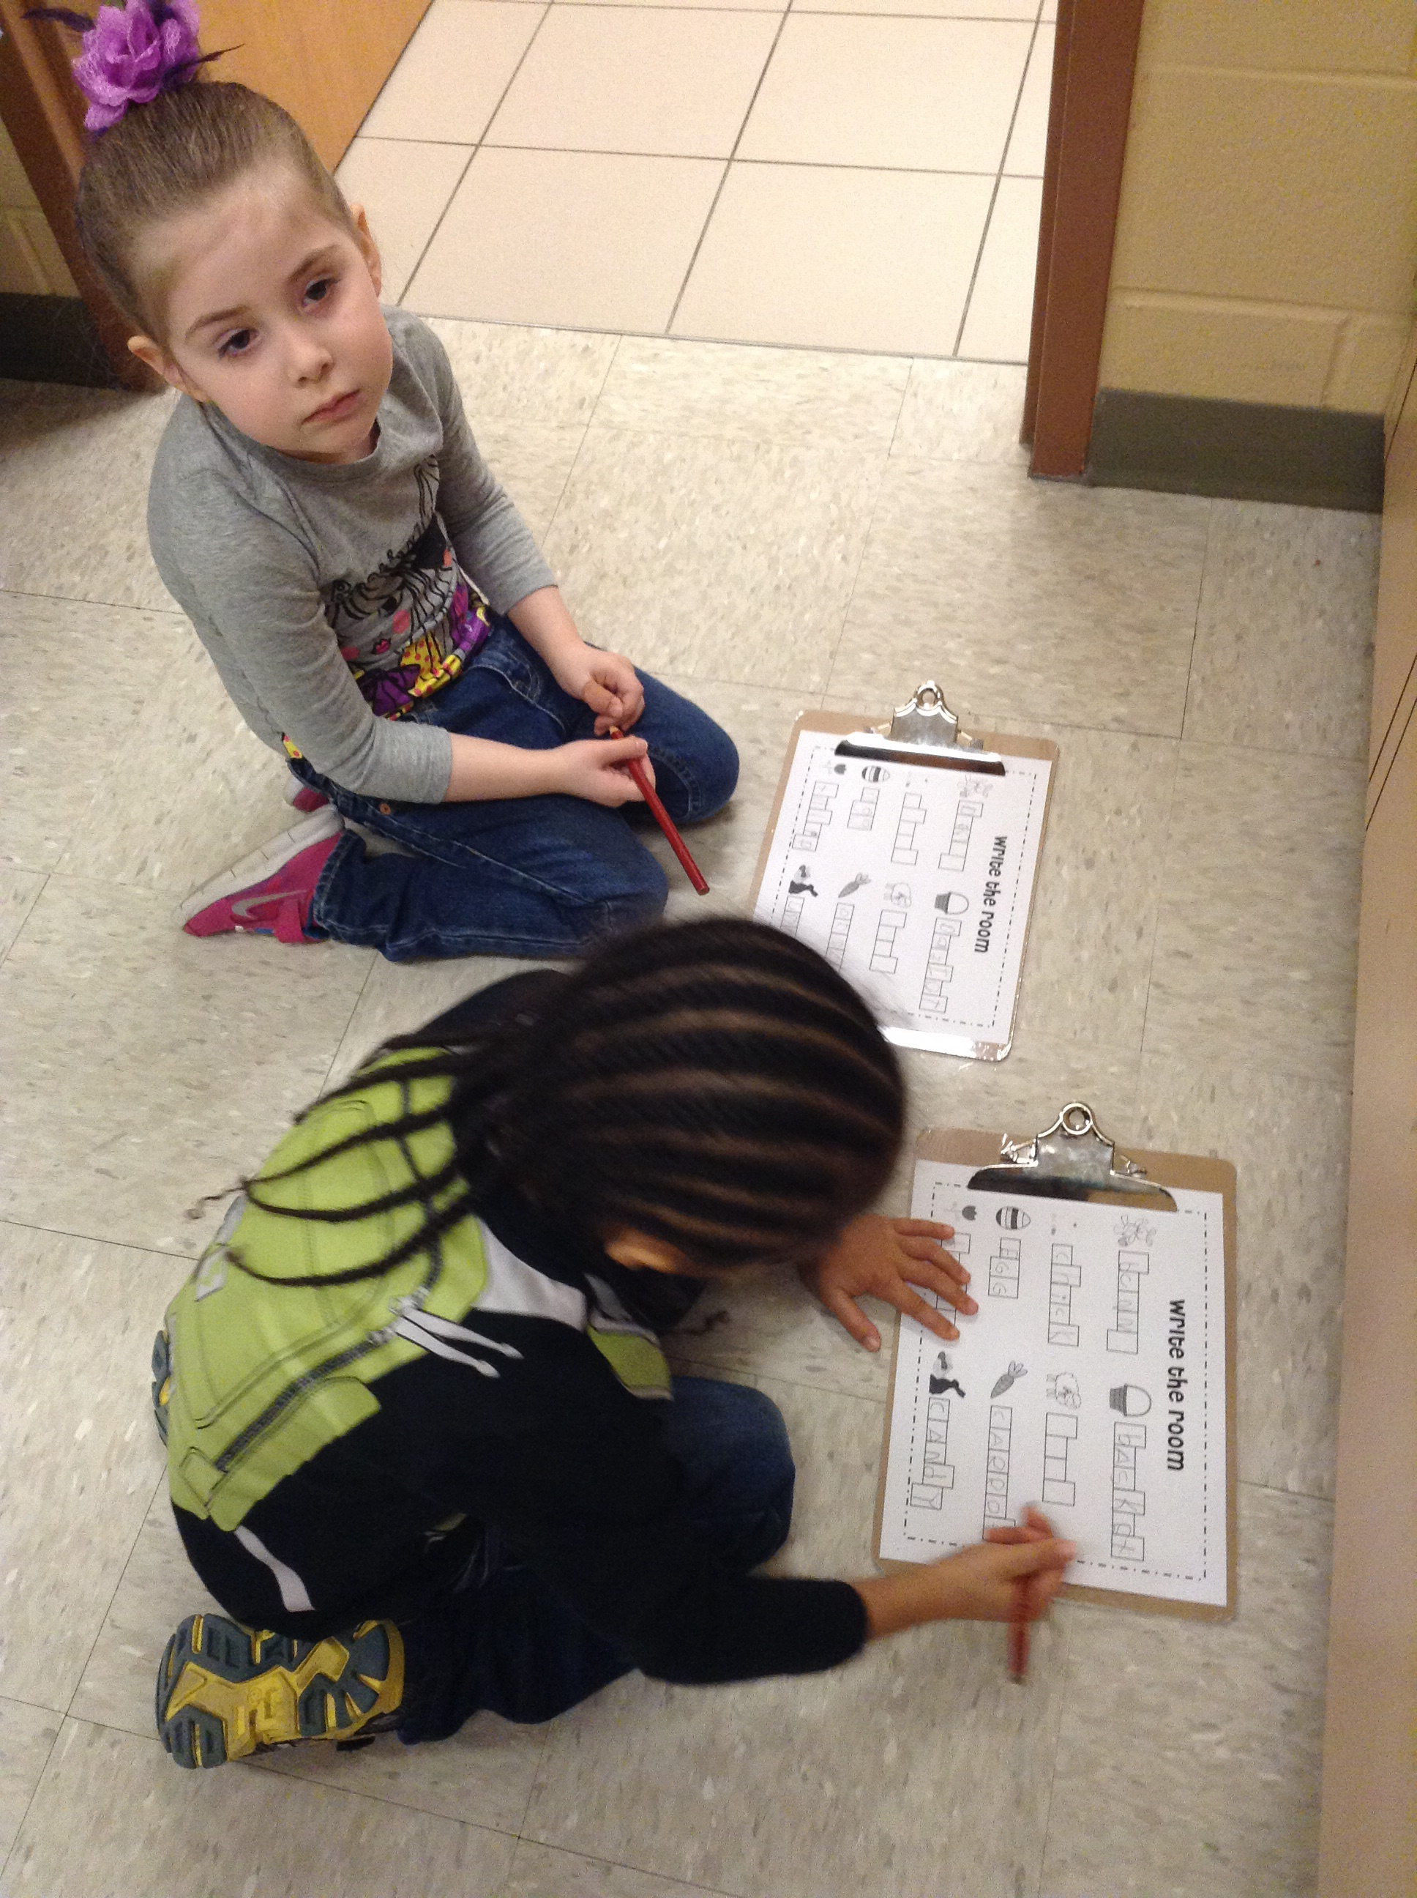
In Math we explored 2 dimensional shapes (circles, squares, triangles, rectangles). The children were quick to point out these shapes around the classroom and school. They also did a great job of using these shapes to create a picture.

This month we reviewed Graphing. Using our Easter theme, we made bar graphs and graphed how many different coloured jelly beans were in our eggs.
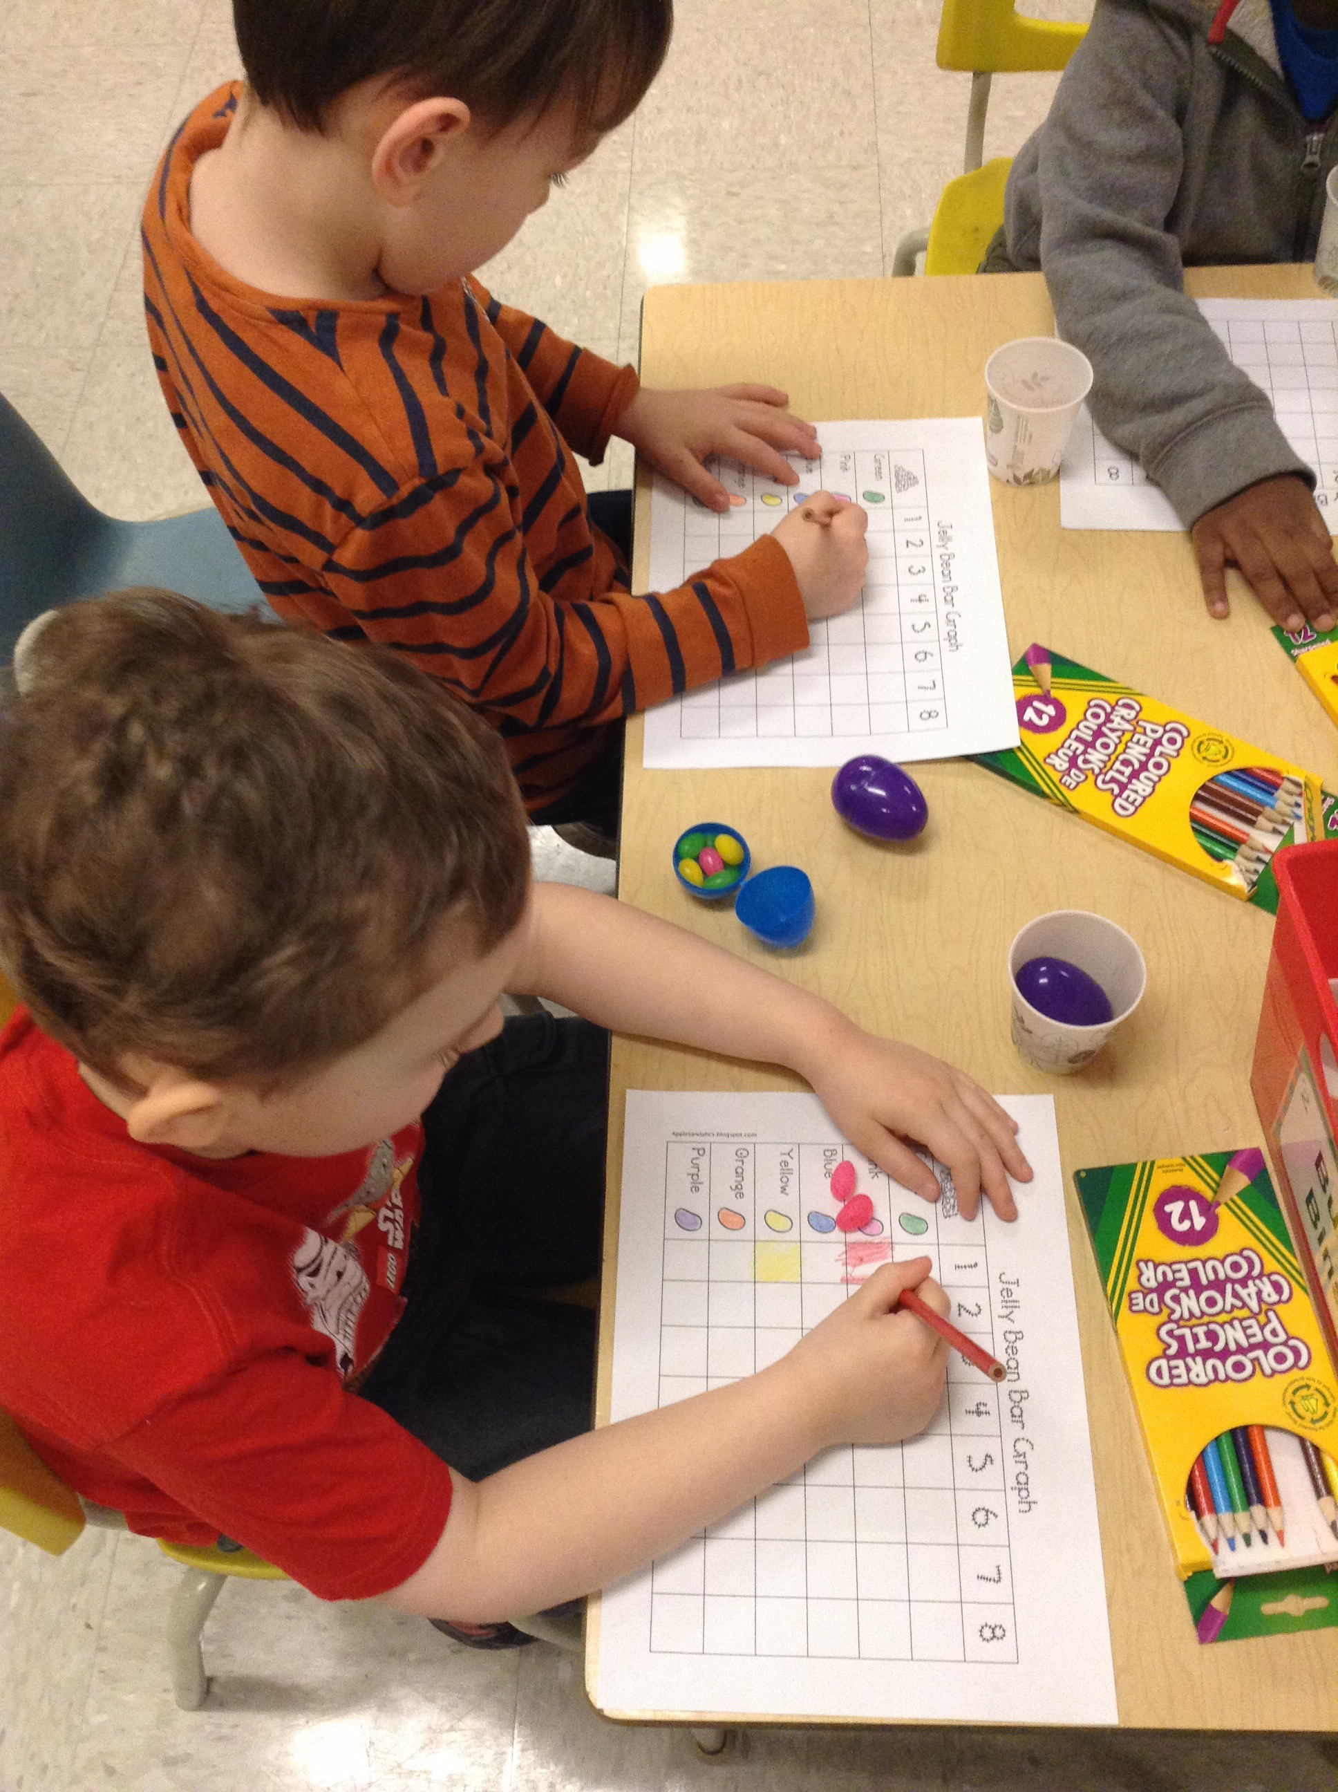
Congratulations to Xavier who won the Hamilton Bulldogs Tickets.
We had lots of fun Easter egg painting. We used lots of colours, designs, and patterns!
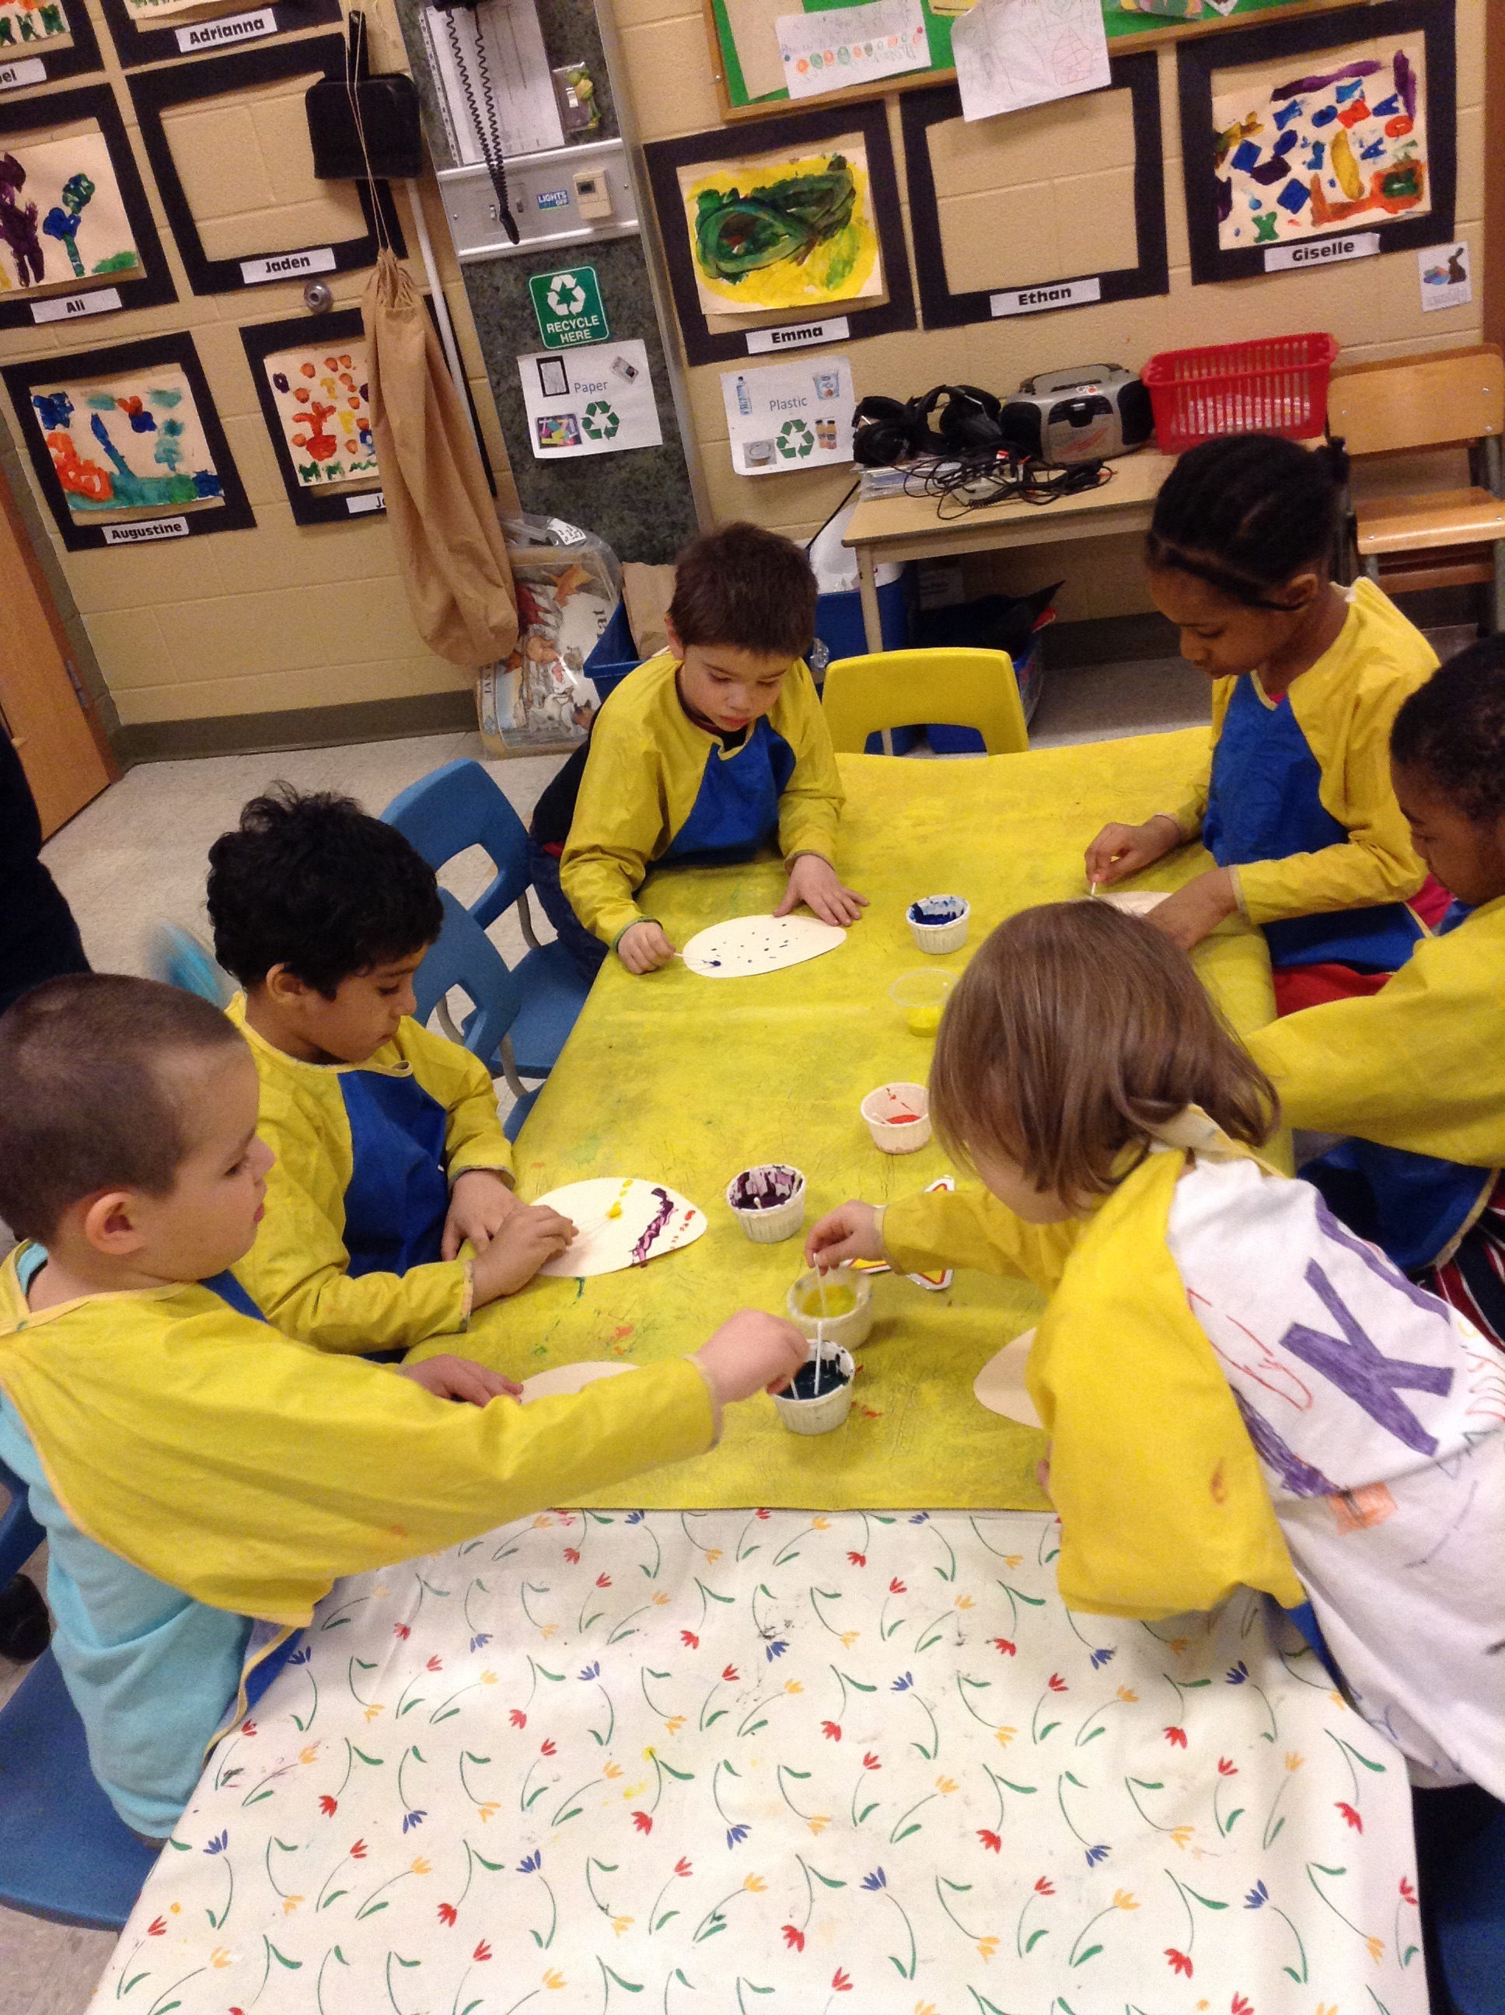

Dates to remember in April

 | 2  3  6  8  23  24  28  30 |  | Wednesday, April 2nd is our Autism Awareness Assembly  Good Friday. No School today.  Easter Monday. No School today.  Anti-Bullying Awareness Day – Wear Pink!  World Autism Day – Wear Blue today!  Sub Day! Enjoy  Student of the Month Assembly  French Cafe. Order forms will be sent home a few weeks before the date.

APRIL NEWS
Special Days
Wednesday, April 2nd is our Autism Awareness Assembly.

Friday, April 3rd is a Holiday. Good Friday. No school today.

Monday, April 6th is a Holiday. Easter Monday. No School today.

Wednesday, April 8th is Anti-Bullying Awareness Day. Wear Pink today to show your support.

Wednesday, April 22nd is Earth Day. We will be going out into our playgrounds to clean them up in honour of Earth Day.

Thursday, April 23rd is Autism Awareness Day. Wear blue today to show your support.

Friday, April 24th is Sub Day. More information to follow.

Thursday April, 30th is our Queen Victoria French Café. More information to follow.

Language

In April our “Letter of the Week” focus will be U, V, and W. We will continue to review the letter formations, letter names, actions and sounds using the Weekend Workbook.

We are beginning to work on various word families. This month our focus is the “at” family (cat, bat, fat, sat, rat, mat). At home play silly rhyming games with your child to practice changing the beginning letter/sound to create a list of rhyming “at” words.

Our Popcorn word focus this month will be on “no, me, said, go, my.”

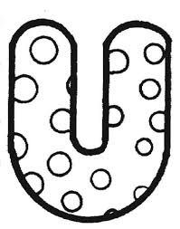


Math

This month the Kinders will begin exploring numbers beyond 10. We will learn to recognize, count, and add, double-digit numbers to 30. We will use a variety of hands on manipulatives (ten-frame, charts, linking cubes, counters and coins) to help work through various math activities and centres.

Our Math focus will also be to explore money (coins). Together, we will learn and be able to identfiy each coin as well as the coin value.



Science

Spring is still a science focus in April … since it doesn’t feel like it has started yet!! We will continue to discuss the changes that happen in Spring (temperature gets warmer, grass begins to grow, buds grow on tree branches, birds return, etc.). When out and about, point out the changes that you see or draw a picture when you get home.
We will also begin to learn about lifecycles of plants and animals, as well as how to care for plants and animals (food, water, fresh air, sunshine). The children will be able to participate in lots of hands on activities!! Check out our Kinderkorner blog regularly to see what is happening in the classroom!

Dramatic Play Centre

This month we are going to incorporate a store theme to our Dramatic Play to help reinforce math concepts taught in class. The children will enjoy taking on several roles as store cashiers as well as paying customers. We will incorporate play money, cash registrars, grocery fliers, price-tag items and other materials for dress up. The Kindergartens will make their own signs and labels that they would see in a grocery store.

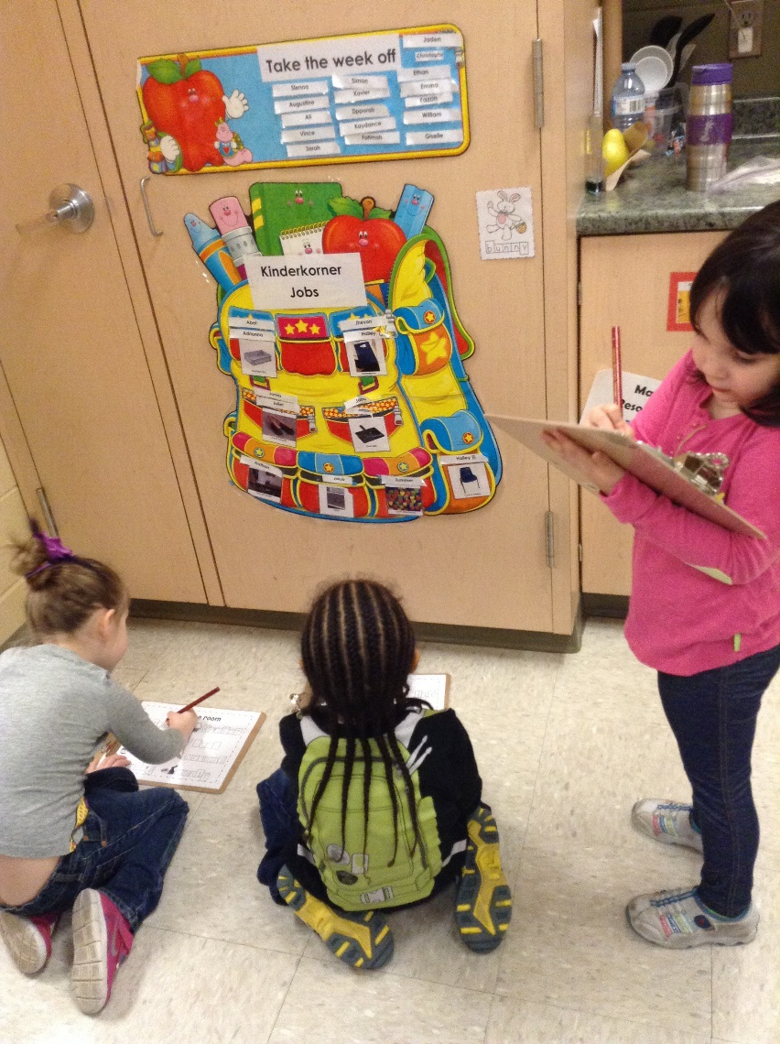

 |  | 