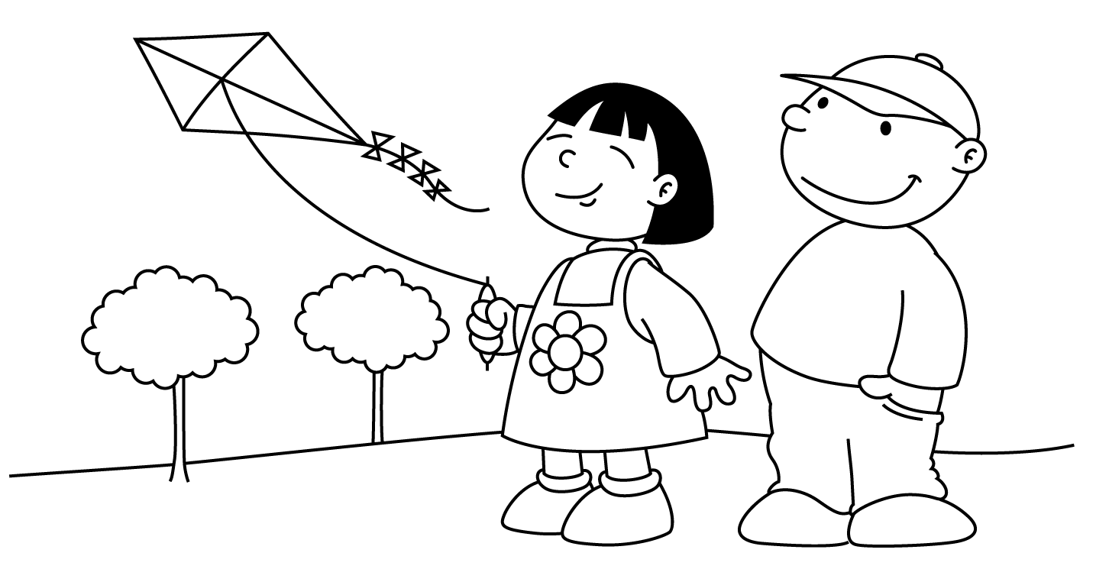

MONTH of MARCH
Sunday | Monday | Tuesday | Wednesday | Thursday | Friday | Saturday
1 | 2  Computers  Letter P  Show and Tell | 3  Gym  Show and Tell  (Kaydance, Abel & Vince) | 4 Pizza Day  Computers  Show and Tell  (Stanley & Ali) | 5  Gym  Show and Tell  (Nathan, Emma & Simon) | 6  Library  Show and Tell  (Juliet & Ethan) | 7
8 | 9  Computers  Letter Q  Show and Tell | 10  Gym  Show and Tell  (Giselle, Jonas & Triniti) | 11 Pizza Day  Computers  Show and Tell  (Adrianna & Zipporah) | 12  Gym  Show and Tell  (Summer & Hailey C.) | 13  Library  Show and Tell  (Sarah, Jakob & Yazan) | 14
15 | 16  MARCH BREAK! HAVE A SAFE AND HAPPY HOLIDAY!  Last day of school is Friday, March 13th and  school resumes on Monday, March 23rd. | 17 St. Patrick’s Day | 18 | 19 | 20 | 21
22 | 23  Computers  Letter R  Show and Tell | 24  Gym  Show and Tell  (Sienna & Fatimah) | 25 Pizza Day  Computers  Show and Tell  (Augustine & Xavier) | 26  Gym  Show and Tell  (William, Jana & Hailey B.) | 27 Sub Day  Library  Show and Tell  (Jahzara & Jhevon) | 28
29 | 30  Looking Ahead ……  Friday, April 3rd is Good Friday and Monday, April 6th is Easter Monday. There is NO SCHOOL on either of these days! | 31 | 1 | 2 | 3 | 4

