Kinderkorner News
Volume 1, Issue 7 March 2015
Please remember to complete, sign and return page 3 of your child’s report card.

We are so proud of our friends and how far they have come with dressing themselves for outdoor winter activities. They have improved fine motor skills by doing zippers and buttons. Way to go!!!

Pizza days are EVERY Wednesday. Please send your child with $1 per slice in a bag labelled with your child’s name. Don’t forget that milk is also available for .75 cents.

Please remember to visit our blog often to see what we are doing in the classroom. You can subscribe with your email address and be automatically updated when new blogs are posted. Come check us out at: http://kinderkorner.commons.hwdsb.on.ca/

A look back at February
In Language we reviewed the letters L, M, N and O. The children are doing a great job of learning the letters of the alphabet and the sounds they make!! Thanks to everyone who brings in the Letter of the Week Show and Tell. It’s a big hit every Monday and there are always some creative items! Way to go!
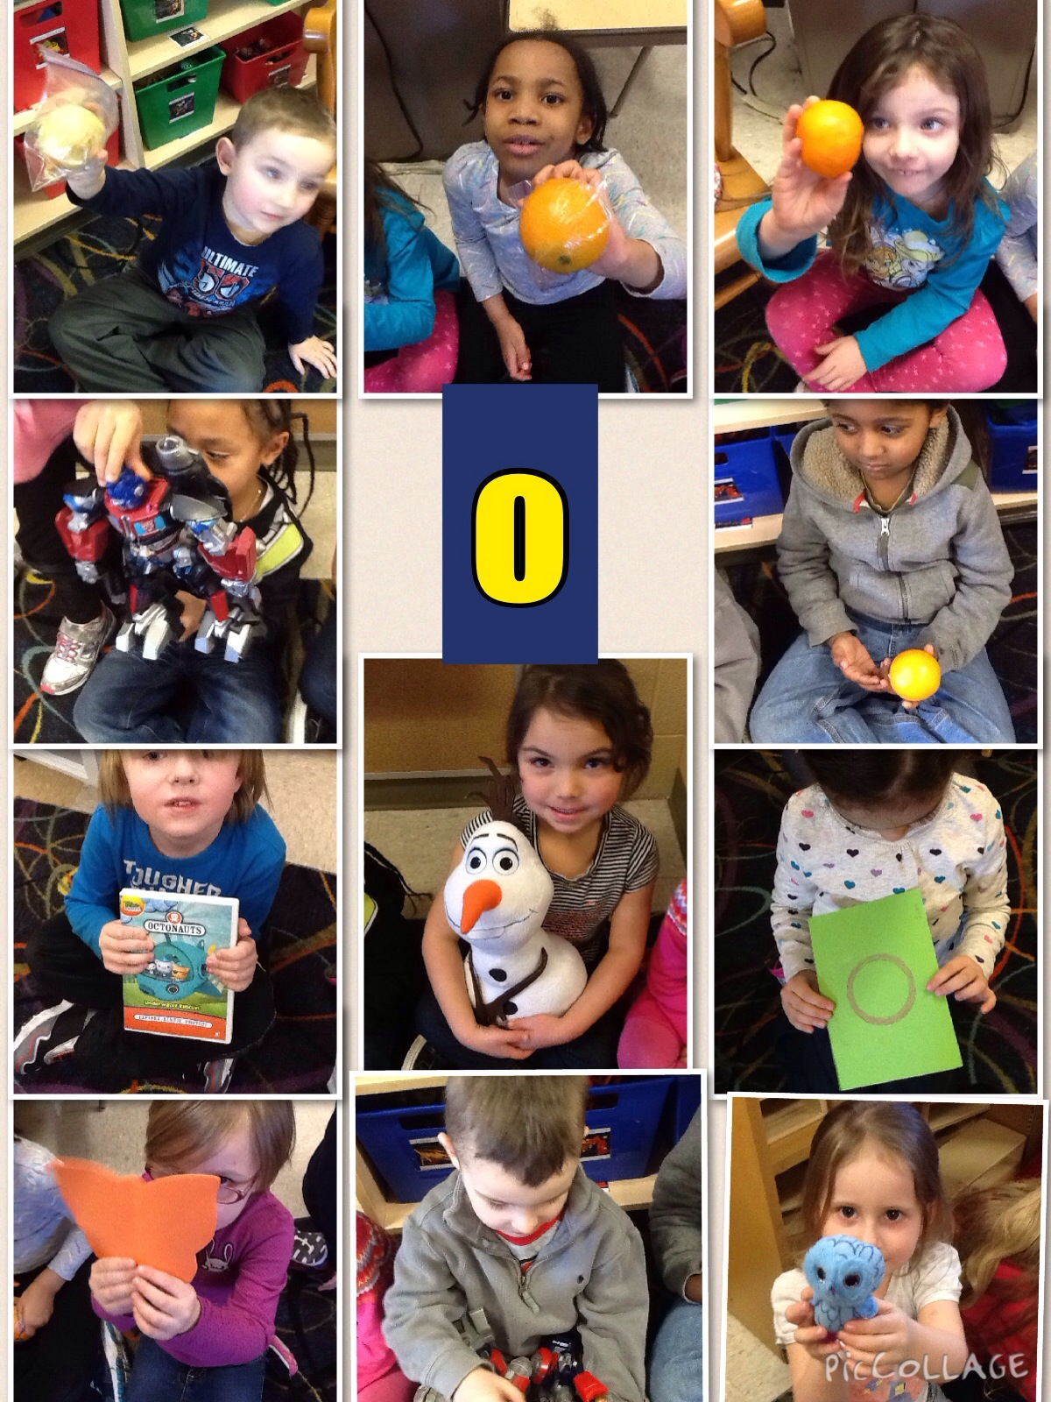
Every week in February the children have had a chance to help create different mixtures in our Sensory Bin. It’s been a great reinforcer of measurement skills, team work and science inquiry skills. The children really enjoy getting their hands dirty when mixing up the materials!!
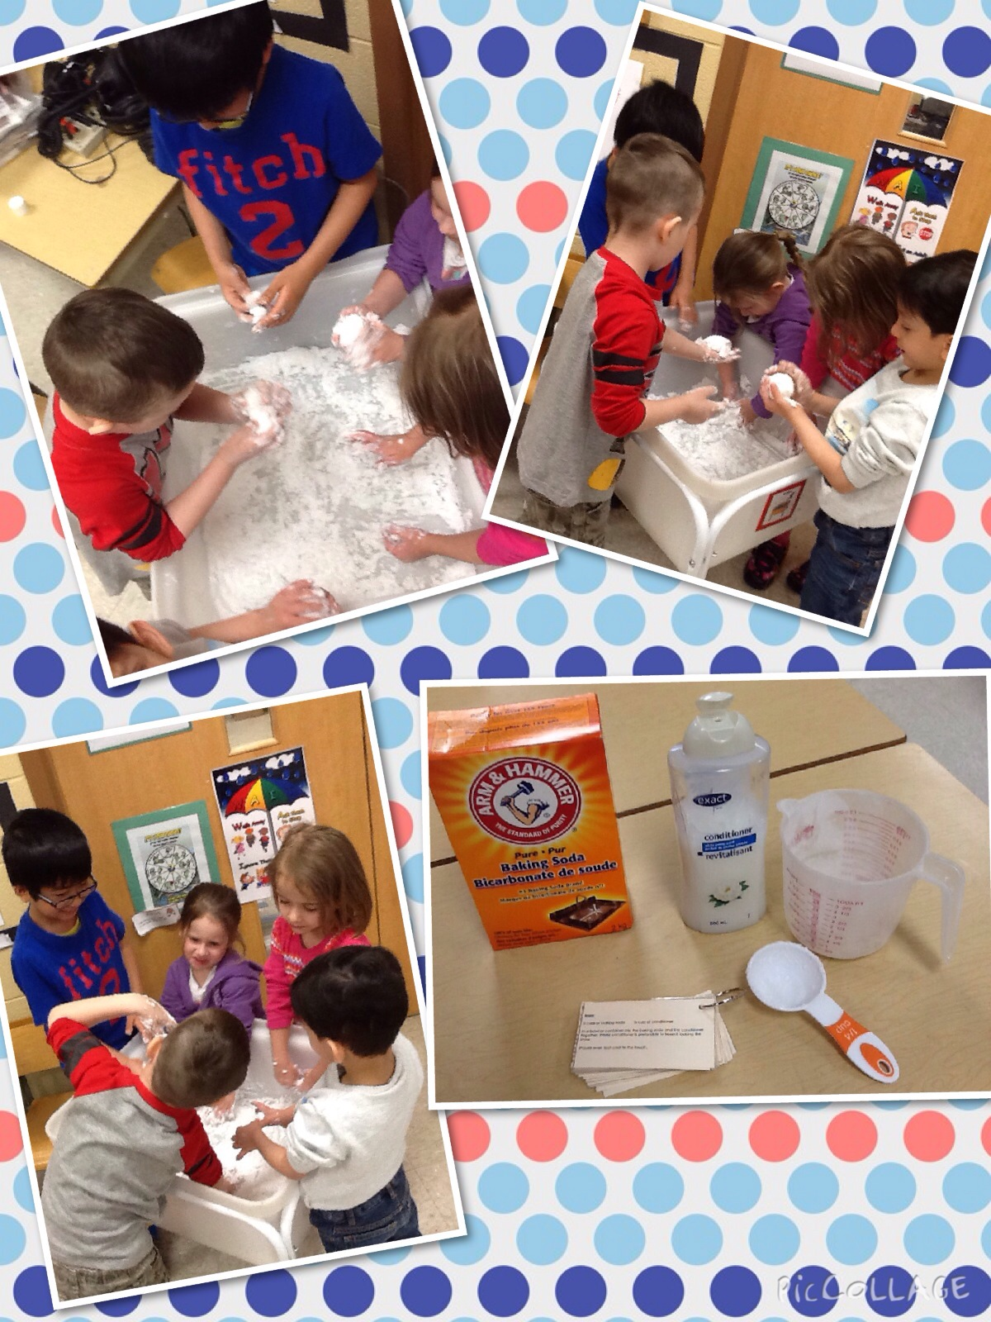
Some special events that were a huge hit in February were the Valentine’s Day celebration (thank you for all the yummy treats), participating in Jump Rope for Heart and an awards assembly for honesty with a special visit from Bruiser the mascot of the Bulldogs who presented an outstanding student award to one person from each class in the whole school!
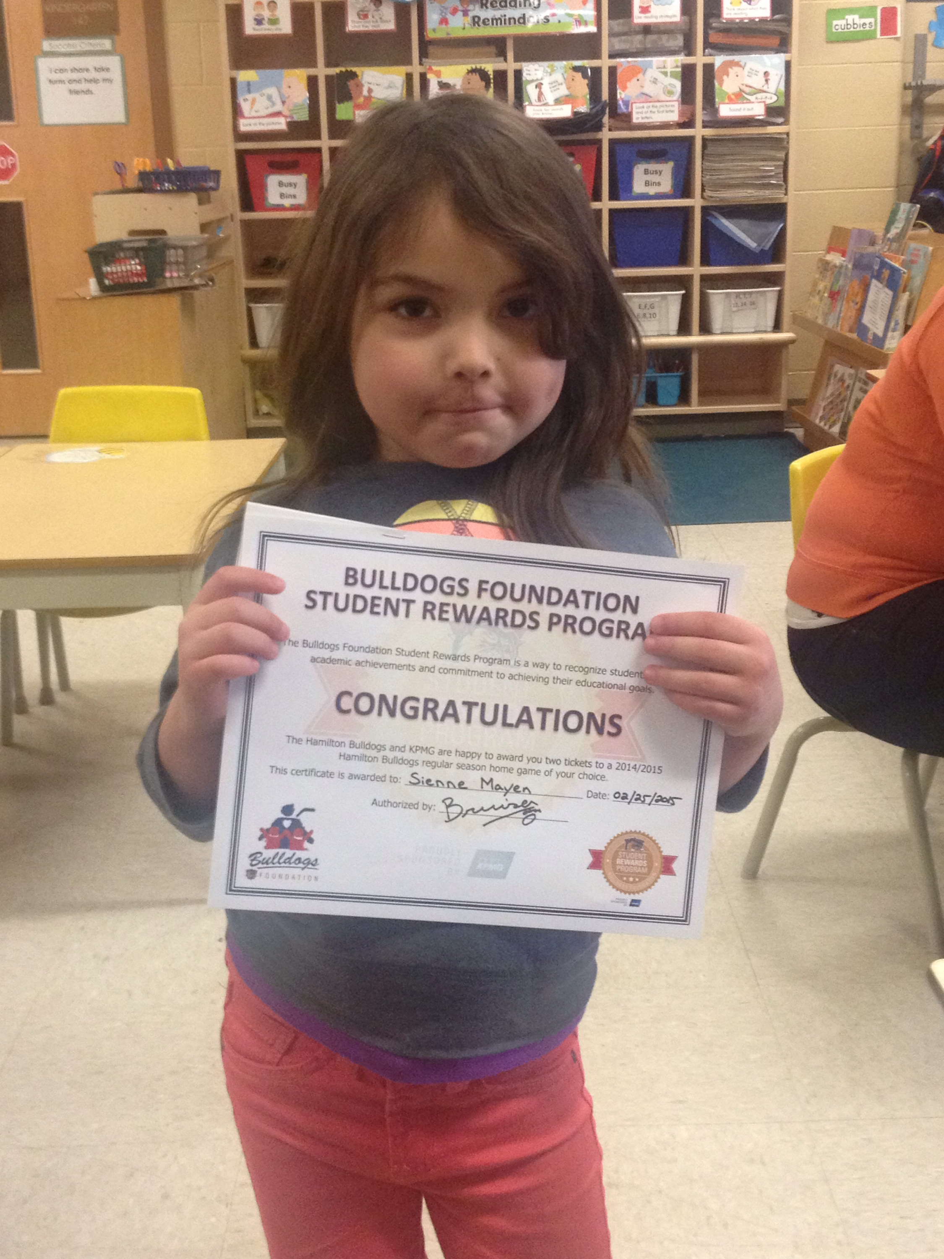

Dates to remember in March

 | 16 -20  23  27 | Monday, March 16th – Friday, March 20th is March Break – No School. Classes resume on Monday, March 23rd.  Monday, March 23rd school begins again.  Friday, March 27th is Sub Day.  Looking Ahead …  Friday, April 3rd is Good Friday and Monday, April 6th is Easter Monday. There is NO SCHOOL on either day.

MARCH NEWS

March Break
There is no school during the week of Monday, March 16th – Friday, March 20th for March Break. Enjoy the holiday and hopefully we will get some spring weather!

Language
In March our “Letter of the Week” focus will be P, Q and R. Continue to review the letter formations, letter names, actions and sounds using the Weekend Workbook. We are continuing with our word family focus. This month is the “ing” family (ring, sing, king). At home play silly rhyming games with your child to practice changing the beginning letter/sound to create a list of rhyming “ing” words.

We will also be focusing on books by the author Robert Munsch. The stories are always fun and make the children laugh!!

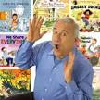

Math
We will continue our focus on 2 dimensional shapes (circle, square, triangle, rectangle, oval, etc.). We will review how many sides they have, examples we see in the real world (circle – cookie, rectangle – envelope, etc.) and look at pictures made up of using these shapes. Continue to encourage your child to look for these shapes in the world around them!!


Community Helpers
In March we are going to be focusing on the community helpers that help us (police officers, firefighters, mail carriers, nurses and doctors, dentists, vetranarians, etc.). The children will learn about the different community helpers, what their job is, what tools they use and the special buildings or vehicles they work in. We also have some costumes that the children can wear to incorporate into their play. It’s always a hit!! As part of this unit the children will be working on learning their last name, address and telephone number. Please review these things with your child.

Dramatic Play Centre
Since we are focusing on community helpers this month, we are going to make our dramatic play centre into various community helper work places (e.g. doctor’s office, police station, fire station, etc). The children will be encouraged to role play the various jobs of community helpers and the tools they use.
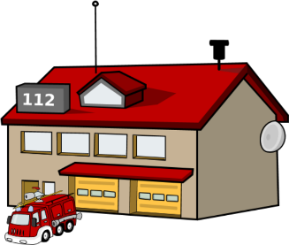

Science
Spring is coming at the end of March!! We will begin discussing the changes that happen in Spring (temperature gets warmer, grass begins to grow, buds grow on tree branches, birds return, etc.). When out and about, point out the changes that you see or draw a picture when you get home.

Mrs. James, Mrs. Dubeau and Mrs. P.

