Kinderkorner News
Volume 1, Issue 5 January 2015
A look back at December
In Language we reviewed the letters E, F and G. The children are getting much better at identifying words that begin with each letter. We love seeing what they bring in for show and tell. Keep up the great work!
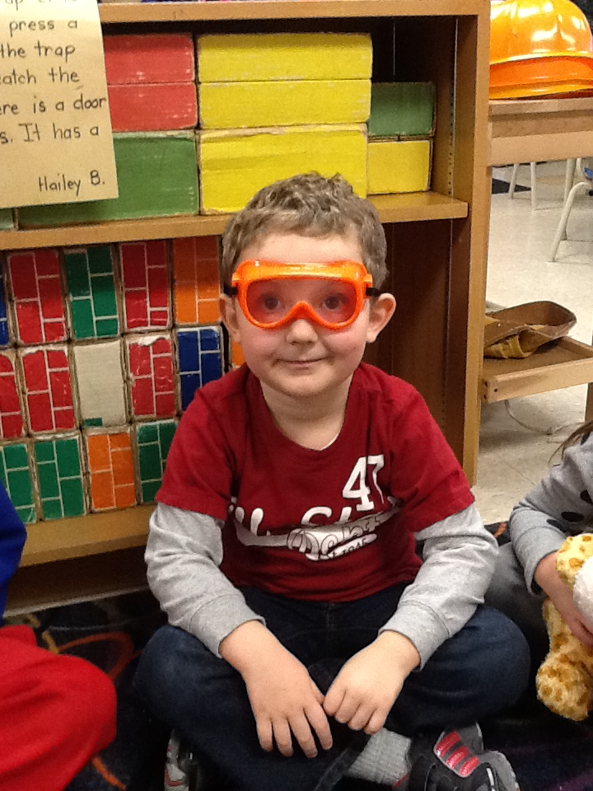
Our focus on the fairytale “The Gingerbread Man” was a hit!! We compared different versions of the story finding many similarities and differences in each. The class really enjoyed chiming in as the Gingerbread Man each time we read the story, as well as retelling the story by acting it out!
In Math we finished up measurement. They enjoyed measuring things in the classroom, especially themselves!! We also began graphing. The students collected information, placed objects onto graphs, coloured in graphs based on information gathered and interpreted the information from the graph.
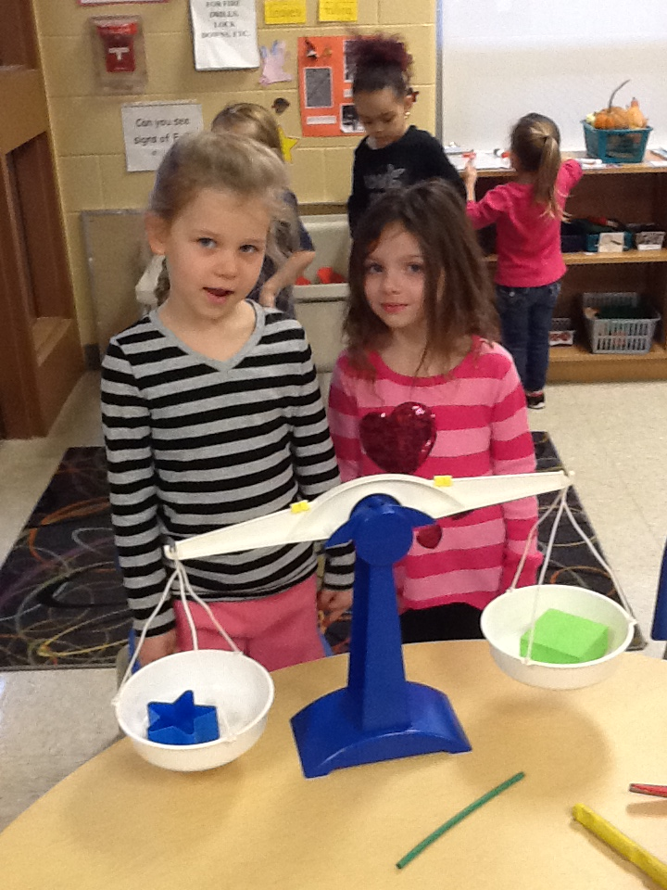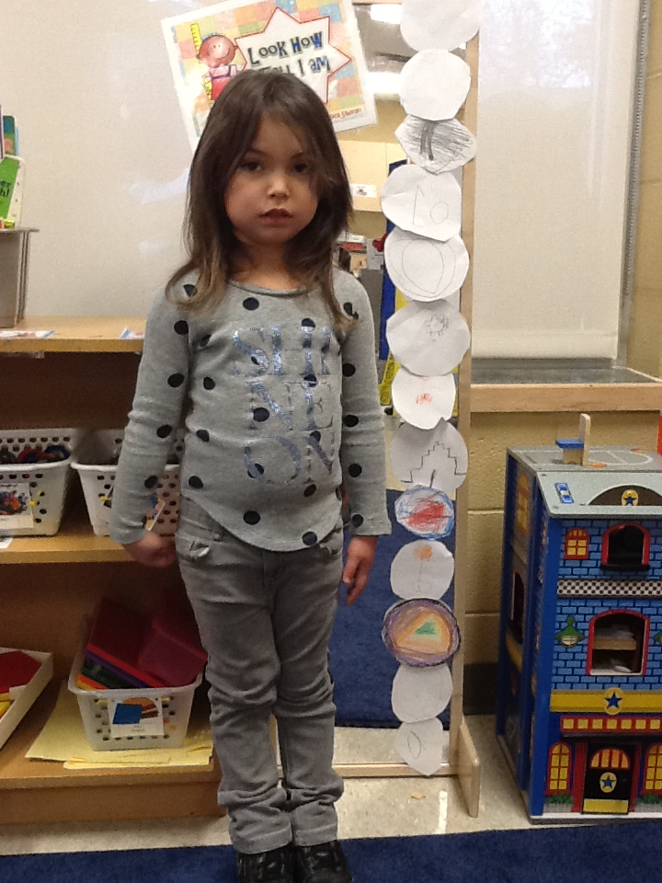
The Winter Concert, Pajama Day and our annual Turkey Lunch were so much fun!! The best was the visit from Santa!!
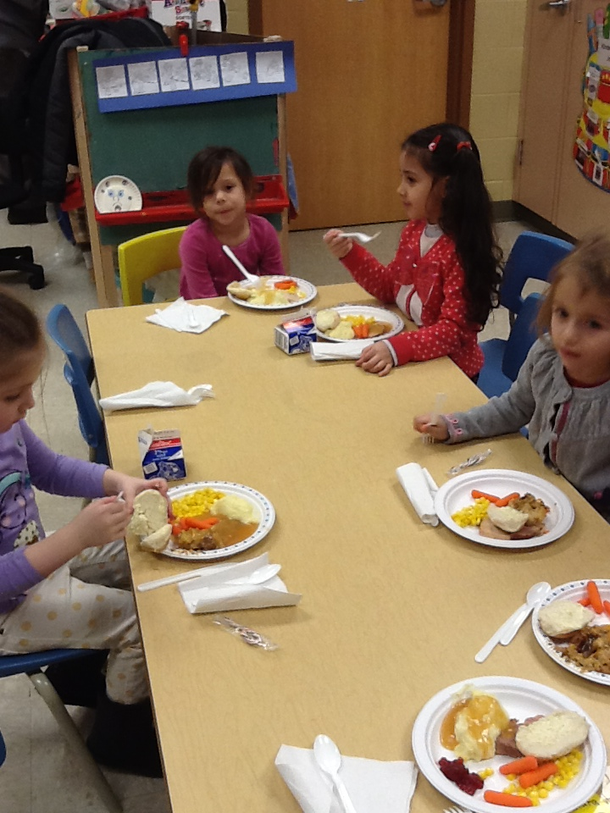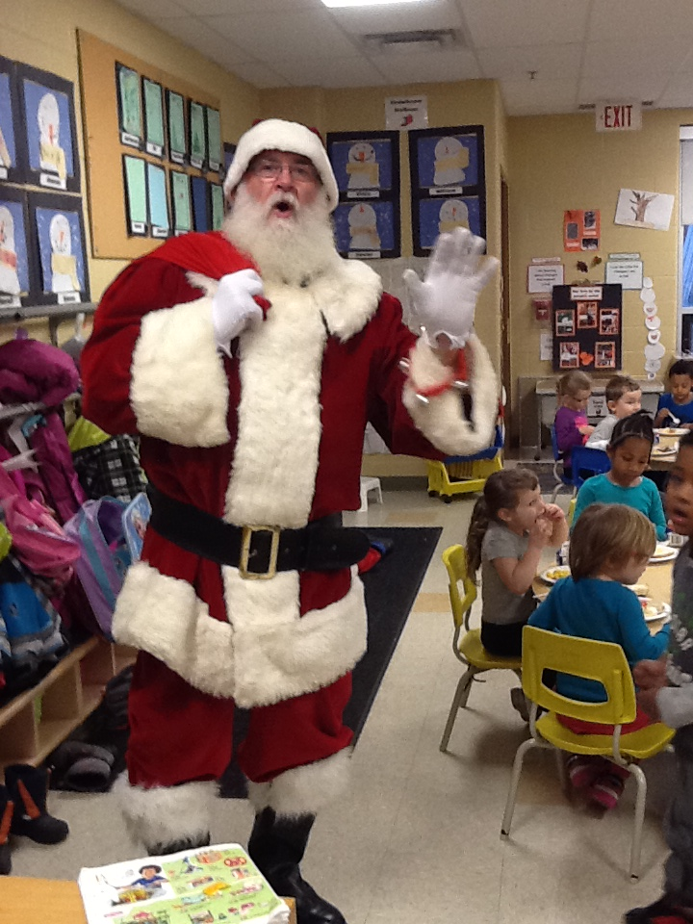

Remember to keep practicing putting on and doing up jackets and other outdoor clothes (snowpants, hats, scarves, mittens) to help your child further develop independence at school. Please label your child’s belongings to help us out and send a pair of indoor shoes if your child wears boots to school.

Also please send an extra pair of clothes in your child’s backpack incase accidents happen.

Don’t forget to complete and hand in your homework each week. It is a great way to introduce our letter of the week!!

Remember to return your child’s library book each week so that they can check out a new book.

We are looking for some 3D beautiful junk (boxes of various sizes, paper towel rolls, etc.). Please check your recycling bins and send them in with your child. Thank you!!

Dates to remember in January
Monday, January 5th is the first day back
after the holiday break.

Friday, January 23rd is a P.A. Day.
No School.

Friday, January 30th is Sub Day.
Every Wednesday is Pizza Day.
$1 a slice and .75 cents for milk.

JANUARY NEWS

Language
In January we will continue our “Letter of the Week”, focusing on the letters H, I, J and K. The class has done a great job of incorporating the letter of the week into their play, creating things at the art table, writing centre and building centre. Remember to complete the weekend homework with your child as an introduction to the letter, sound, words that begin with the letter and how to print the letter.
To help us with our reading and writing skills we will continue our word family focus. This month we will review the “ig” family (pig, wig, dig, etc). We will reinforce that by changing the beginning letter/sound to a “family”, we can create a list of rhyming words.
We will also be focusing on the fairy tale “The Three Little Pigs”. We will reinforce learning about 3D figures by building the three pig’s houses in the block centre and art centre using the beautiful junk that you have donated, as well as retelling the story through acting it out and various smartboard activities.
Math
We will continue to review graphing as well as start our focus on 3 dimensional shapes (cylinder, cone, cube, sphere). We will learn how to identify, compare and describe these 3-D shapes in the classroom and in the real world around us. If you have 3D beautiful junk (boxes, paper towel/toilet paper rolls, etc.) we would love to have them!! At home point out different 3D figures as well as the 2D shapes found in them (e.g. a cube has 6 square sides).

Dramatic Play Centre
This month we are going to turn our dramatic play centre into a snow castle/igloo. The children will wrap boxes with white paper which we will then use to build our structure. Any donations of boxes would be greatly appreciated.
Science
We will introduce and learn about the changes that happen in Winter through investigations. Hopefully we will get some snow to do some fun and exciting hands on experiments! We will focus on the scientific process of making predictions, conducting the experiment and making observations of what happened.
Social Skills
In January we are focusing on empathy for others and acknowledging and responding to each other’s feelings (e.g. telling an adult or helping when another child is hurt/sick/upset, role-play emotions with dolls and puppets). When reading with your child have them make connections to the story by asking questions like “Why is the main character scared/happy/sad? How would you feel? What do you think they could do to make themselves feel better?”.
Mrs. James, Mrs. Dubeau and Mrs. P.

