Kinderkorner News
Volume 1, Issue 6 February 2015
Remember to keep practicing putting on and doing up jackets and other outdoor clothes (snowpants, hats, scarves, mittens) to help your child further develop independence at school. Please label your child’s belongings to help us out and send a pair of indoor shoes if your child wears boots to school.
Our Valentine’s party is on Thursday, February 12th. Please have your child bring their Valentine’s cards that day (with only their name signed). We have 28 children in the class. Please feel free to send in some yummy red treats that day!! Remember to label any containers that need to go back home.
Report Cards go home on Thursday, February 12th for both JK and SK students. Please remember to sign and return page 3 of the report card.
There are many fun Family Day events throughout the city. Check the newspaper, library or community centre for more details and events in your neighbourbhood for some family fun.

A look back at January
In Language we reviewed the letters H, I, J and K. The children are becoming pros of finding the letters in our monthly poem and weekly letter song.
Our Snuggle Up and Read event was a big hit!! Author Aimee Reid read her story and the children enjoyed acting like elephants! They also loved wearing their pyjamas to school.
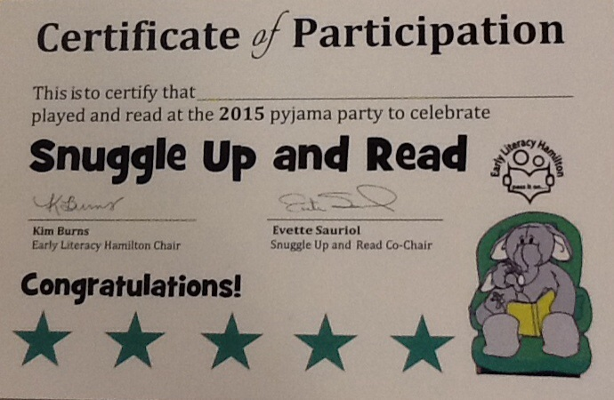
In Math we explored 3 dimensional shapes. During the nutrition breaks the children were excited to show us their water bottles (cylinders) and apples (spheres). They made the shapes with playdough, with marshmallows and toothpicks, made 3D sculptures with their friends using beautiful junk and used 3D shape terms when building with their friends.
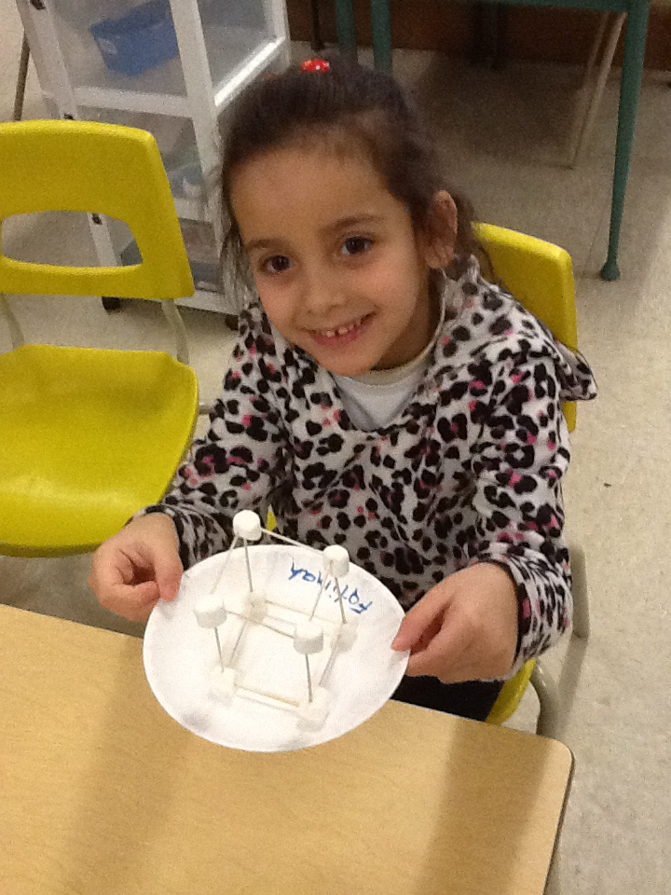
In January we were able to conduct many cool science experiments. We really focused on making predictions before all of our experiments. One of the experiments that really fascinated the children was our dirty/clean hands bread experiment. After a few weeks green mould was growing on the bread that was touched by the dirty hands.
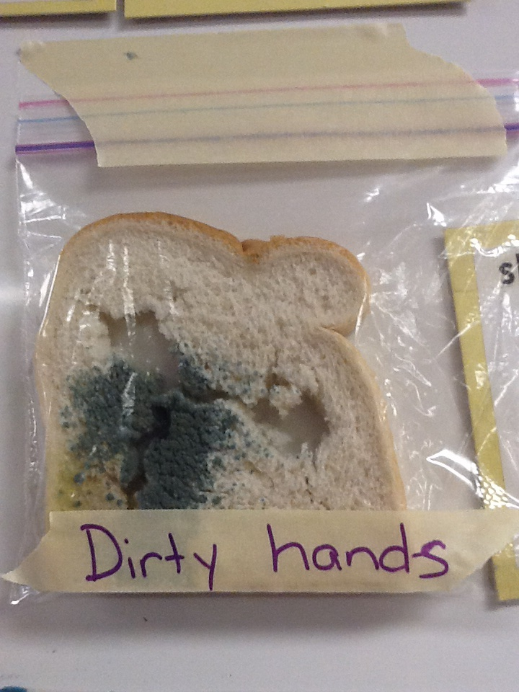

Dates to remember in February
Thursday, February 12th report cards go home and it’s also our Valentine’s Day Party!!

Friday, February 13th is a P.A. Day. No School

Monday, February 16th is Family Day! No School

Friday, February 27th is Sub Day

FEBRUARY NEWS

Please remember to visit our blog often to see what we are doing in the classroom. You can subscribe with your email address and be automatically updated when new blogs are posted. Come check us out at: http://kinderkorner.commons.hwdsb.on.ca/

Report Cards
Junior and Senior Kindergarten report cards go home on Thursday, February 12th. Don’t forget to sign and return page three once you have read the report card.
Valentine’s Day Party
We will be having our party on Thursday, February 12th. Please have your child sign only their name on their Valentine’s cards – no friend’s names. We have found that it can be very difficult for the children to hand out Valentine’s with names if they are unsure how to read it. We have 28 children in the class. If you would like to contribute a healthy red snack for the class to share we would love it!!
Language
In January we will continue our “Letter of the Week”, focusing on the letters L, M, N and O. Continue to review the letter formations, letter names, actions and sounds using the Weekend Workbook. We are continuing with our word family focus. This month is the “ake” family (rake, cake, snake). At home play silly rhyming games with your child to practice changing the beginning letter/sound to create a list of rhyming “ake” words.
Another language focus will be making connections to books being read aloud in class. There are three kinds of connections that we will work on: text to self (That made me think of the time I …), text to text (That story reminds me of the story …), and text to world (I remember seeing something like this on the news …).

Math
We will focus on 2 dimensional shapes (square, rectangle, circle, triangle, oval, etc). We will learn the shape names, how many sides they have, discuss what the shapes remind us of (circle – pizza, rectangle – chocolate bar, etc.) and create pictures using these shapes. Encourage your child to look for these shapes in the world around them!!

Dramatic Play Centre
This month we are going to let the children’s imagination run wild. We will let you know what they come up with and if we are in need of any supplies to help us create something special.
Science
We will continue to learn about the changes that happen in Winter (temperature gets colder, it snows, birds fly south, some animals hibernate). We are going to do some experiments with ice and salt and using borax to make snowflakes. Our focus is still the steps of the scientific process of making predictions, conducting the experiment and making observations of what happened – and of course having fun!!!.

Social Skills
In February we are going to really focus on how to be a good friend as well as how to tell how someone is feeling through facial expressions and body language. We will also review using our manners.

Mrs. James, Mrs. Dubeau and Mrs. P.

