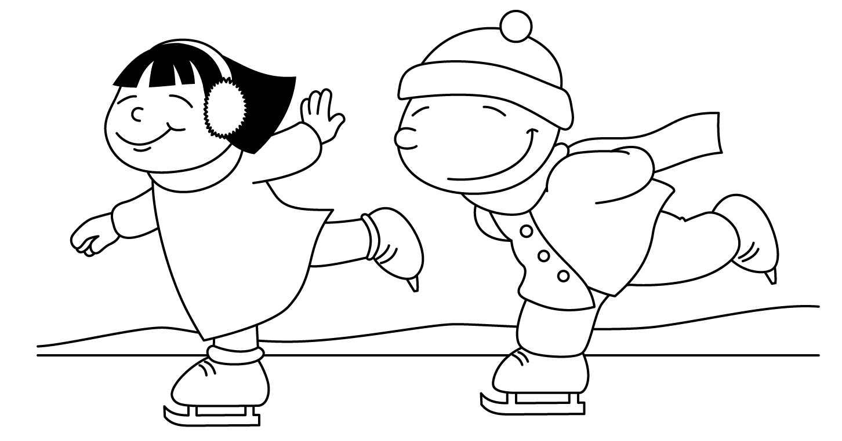

MONTH of JANUARY
Sunday | Monday | Tuesday | Wednesday | Thursday | Friday | Saturday
 | Welcome back!!  Report Cards will be going home in February  for all kindergartens. | 30 | 31 | 1 | 2 | 3
4 | 5  Gym  Show and Tell  Letter H | 6  Library  Show and Tell  (Vince & Abel) | 7 Pizza Day  Computers  Show and Tell  (Stanley & Zipporah) | 8  Gym  Show and Tell  (Ali & Nathan) | 9  Computers  Show and Tell  (Emma & Simon) | 10
11 | 12  Gym  Show and Tell  Letter I | 13  Library  Show and Tell  (Juliet & Mustafa) | 14 Pizza Day  Computers  Show and Tell  (Ethan & Giselle) | 15  Gym  Show and Tell  (Jonas & Adrianna) | 16  Computers  Show and Tell  (Summer & Hailey C.) | 17
18 | 19  Gym  Show and Tell  Letter J | 20  Library  Show and Tell  (Sarah) | 21 Pizza Day  Computers  Show and Tell  (Sienna) | 22  Gym  Show and Tell  (Augustine & Xavier) | 23  P.A. DAY  NO  SCHOOL | 24
25 | 26  Computers  Show and Tell  Letter K | 27  Gym  Show and Tell  (William) | 28 Pizza Day  Library  Show and Tell  (Fatimah) | 29  Computers  Show and Tell  (Jhevon) | 30 Sub Day  Gym  Show and Tell  (Hailey B.) | 31

