Kinderkorner News
Volume 1, Issue 4 December 2014
A big thank you to our parents for coming into the classroom for parent observations. The children really enjoyed having you in and showing off the different things they do at school.

The cold weather has arrived!! Don’t forget to dress appropriately for the weather (snowpants, sweaters, hats, scarves, mittens, boots). Continue to have your child practice putting on the clothing themselves as well as doing up zippers. Don’t forget to pack running shoes if your child wears boots to school.

Don’t forget that every Wednesday is pizza day. Each slice is $1 and milk is .75 cents. Please send the money in a plastic bag labelled with your child’s name.

Thanks for a great start to our homework program!! The children have been doing a great job each week. Way to go!!

A look back at November
As much as our little friends have enjoyed their Halloween candy, they have also had a lot of fun learning about healthy foods and habits in November. We have found healthy foods in flyers, sorted food pictures into “sometimes” and “always” groups, learned about germs and how to minimize the spread of them; but I think the best was when we made our friendship fruit salad. It was delicious and they ate it all up!!
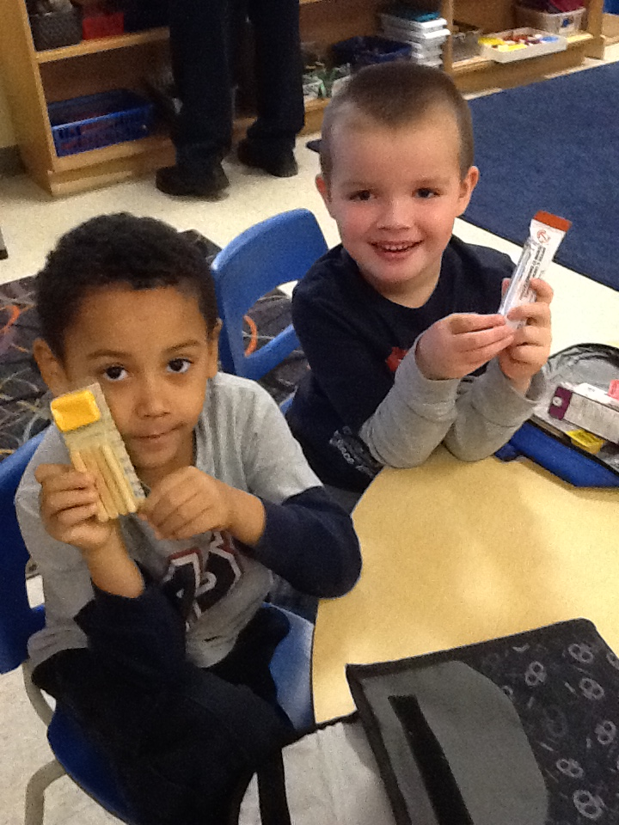
In Language we reviewed the letters A, B, C and D. The children enjoyed creating some awesome things that begin with each letter and did a super job bringing in items from home for show and tell! The class enjoyed retelling the story “The Three Billy Goats Gruff” through dramatic play, drew their favourite part of the story in their journal, as well as building bridges with blocks.
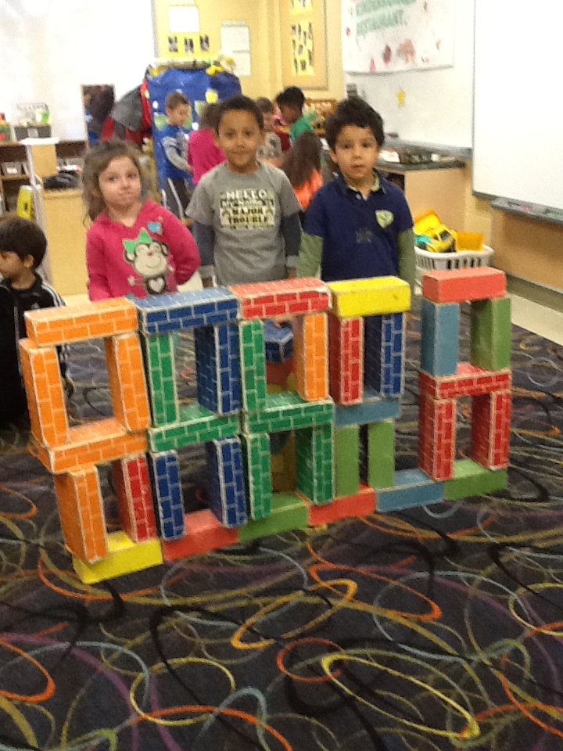
In Math we measured things around the classroom and practised our measurement terms. The children really enjoyed measuring their height with snowflakes and blocks, as well as exploring different measuring cups, spoons and beakers in the sensory bins with water and rice!!
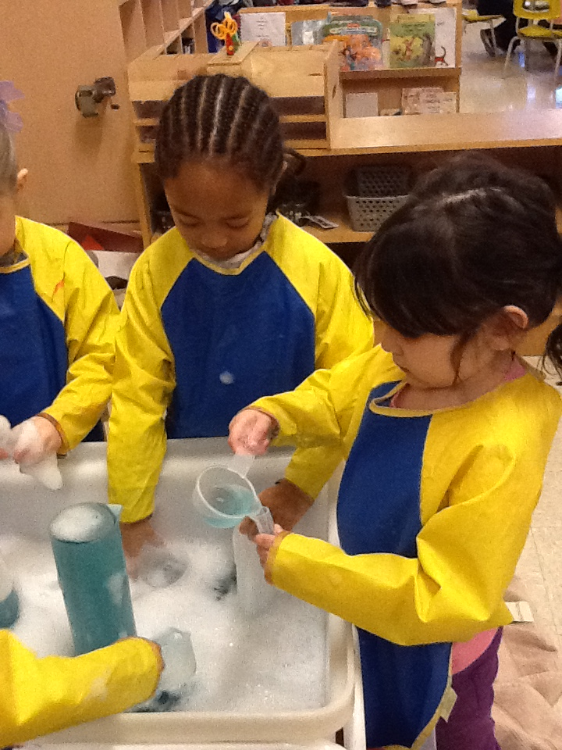

Dates to remember in december

Tuesday, December 9th is a special Craft Day. We will be doing lots of holiday crafts!!
Monday, December 15th is a Winter Concert.
Tuesday, December 16th is our annual Turkey Lunch.
Wednesday, December 17th is our Pajama Day.
Friday, December 19th is Sub Day, our Holiday Party and the last day of school before the holidays!!
(School begins on Monday, January 5th … see you then).

DECEMBER NEWS

Building 3 dimensional sculptures
We are looking for donations of your “beautiful junk” (cereal boxes, paper towel/toilet rolls, egg cartons, etc.) to help us in our quest to build some awesome 3-D structures. Once the children have completed their masterpieces they will be sharing it with the class. We can’t wait to see what their imaginations come up with!!
Language
In December we will continue our “Letter of the Week”, focusing on the letters E, F and G. The class has done a great job of incorporating the letter of the week into their play, creating things at the art table, writing centre and building centre, as well as bringing in the letter of the week show and tell.

To help us with our reading and writing skills we are continuing our word family focus. We will begin with the “ell” family (shell, well, bell, etc). We will practice that by changing the beginning letter/sound to a “family”, we can create a list of rhyming words.

We will also be focusing on the fairy tale “The Gingerbread Man”. We will practice retelling the story through puppets, sequencing pictures in correct order, and acting it out. At the end of the month we will be making and decorating gingerbread cookies!!

Math
We will be learning how to collect information, make a graph, and read information from simple graphs. We will also focus on describing everyday situations using probability language (sometimes, usually, never, always, might, etc.).

Dramatic Play Centre
It has taken us awhile to create all the things we would need for our Kinderkorner Restaurant (food, menus, etc.). Now that our friends have are getting the chance to use all things to act out the various roles, the have really enjoyed our Kinderkorner Restaurant. We will continue to keep the dramatic play centre as a restaurant for December.
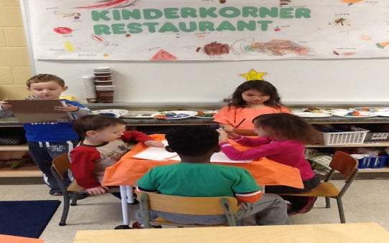
Craft Day
Craft Day is on Tuesday, December 9th . We will have lots of fun things going on in the classroom for the children to enjoy.
Winter Concert
The school is having a Winter Concert on Monday, December 15th . More details to follow.
Annual Turkey Lunch
Tuesday, December 16th is our annual turkey dinner. Due to the generosity of many organizations and volunteers, we are very pleased to be able to share a holiday meal together before the holidays!! I think Santa is also paying us a visit!!
Pajama Party
Don’t forget to wear your pajamas to school on Wednesday, December 17th for some holiday cheer.
Holiday Party/Sub Day
The last day of school before the break, Friday, December 19th we will have a holiday party to celebrate the season. It is a magical time of year! Please feel free to send snacks for the class to share, but remember to label any containers you would like sent back home. Don’t forget it is also Sub Day.

Mrs. James, Mrs. Dubeau and Mrs. P.

HAPPY HOLIDAYS AND HAVE
A
WONDERFUL NEW
YEAR!!

