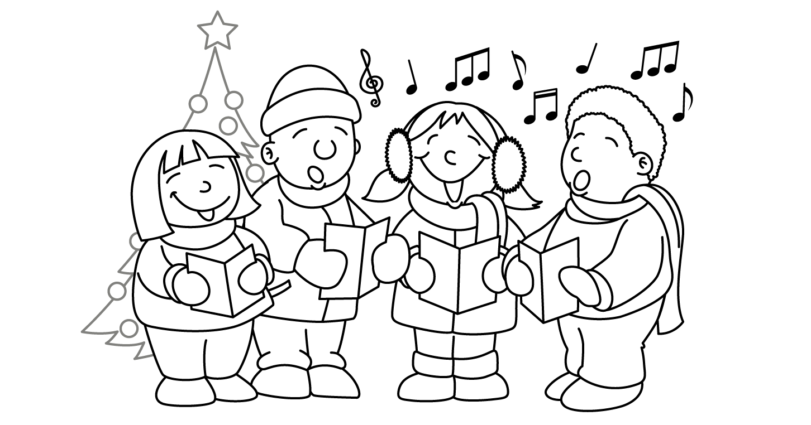

MONTH of DECEMBER
Sunday | Monday | Tuesday | Wednesday | Thursday | Friday | Saturday
30 | 1  Gym  Show and Tell  Letter E | 2  Library  Show and Tell  (Vince, Abel & Stanley) | 3 Pizza Day  Computers  Show and Tell  (Zipporah & Ali) | 4  Gym  Show and Tell  (Nathan & Emma) | 5  Computers  Show and Tell  (Juliet & Simon) | 6
7 | 8  Gym  Show and Tell  Letter F | 9 Craft Day  Library  Show and Tell  (Giselle, Ethan & Mustafa) | 10 Pizza Day  Computers  Show and Tell  (Adrianna & Syah) | 11  Gym  Show and Tell  (Summer & Hailey C.) | 12  Computers  Show and Tell  (Sarah & Jhevon) | 13
14 | 15 Winter Concert  Gym  Show and Tell  Letter G | 16 Turkey Lunch  Library  Show and Tell  (Hailey B. & Sienna) | 17 Pizza Day  Computers  Pajama  Day | 18  Gym  Show and Tell  (Augustine & Xavier) | 19 Sub Day  Computers  Show and Tell  (Summer & William) | 20
21 | 22  Last day of school is Friday, December 19, 2014.  School resumes on Monday, January 5, 2015. | 23 | 24 Christmas Eve | 25 Christmas Day | 26 | 27  
28 | 29  HAVE A SAFE AND HAPPY HOLIDAY!! | 30 | 31 New Year’s Eve | 1 | 2 | 3

