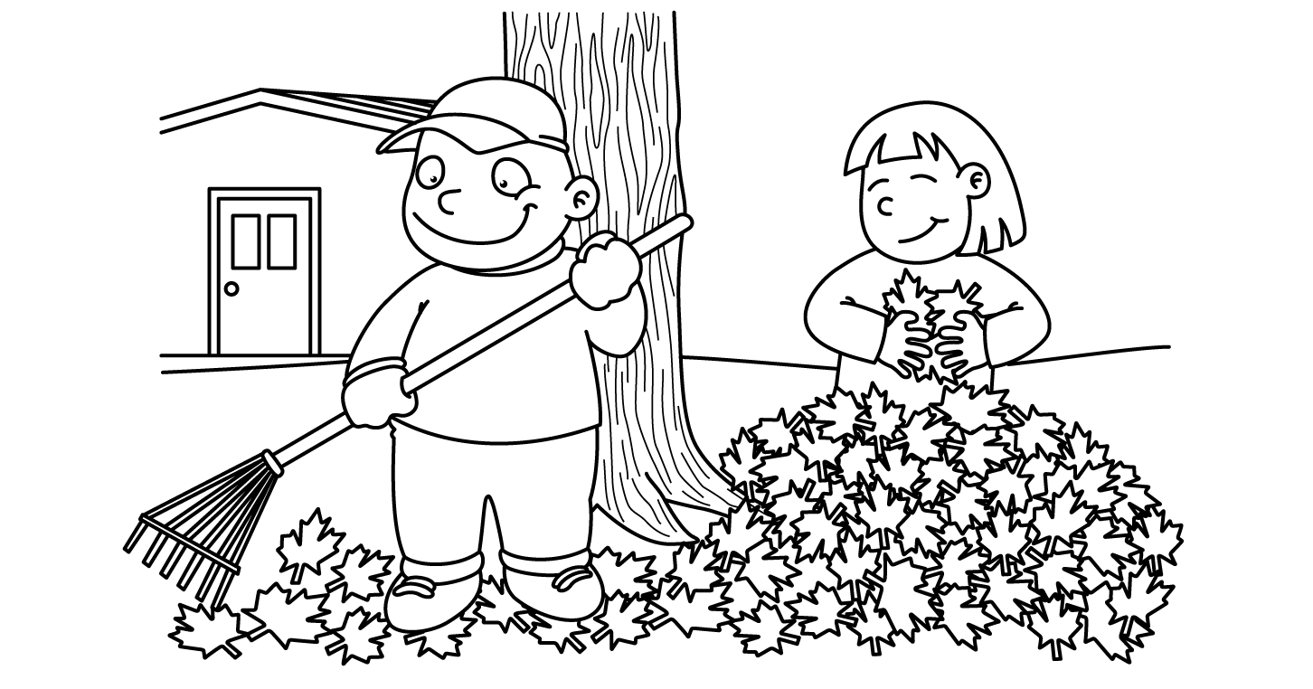

MONTH of NOVEMBER
Sunday | Monday | Tuesday | Wednesday | Thursday | Friday | Saturday
 | Parent observations are this month. We look forward to you visiting our classroom!  In November we are focusing on healthy snacks and healthy living.  Please send your child with healthy snacks everyday to help reinforce this concept ( e.g. fruits, veggies, cheese and crackers, popcorn, etc.). |  |  |  |  | 1
2 | 3  Library  Show and Tell  Letter A | 4  Computers  Show and Tell  (Vince & Abel) | 5 Pizza Day  Gym  Show and Tell  (Zipporah) | 6  Computers  Show and Tell  (Nathan & Ali) | 7  Gym  Show and Tell  (Juliet & Emma) | 8
9 | 10  Library  Show and Tell  Letter B | 11 Remembrance  Day  Computers  Show and Tell  (Giselle & Simon) | 12 Pizza Day  Gym  Show and Tell  (Adrianna) | 13 Photo Retakes  Computers  Show and Tell  (Ethan & Summer) | 14  Gym  Show and Tell  (Hailey C. & James) | 15
16 | 17  Library  Show and Tell  Letter C | 18  Computers  Show and Tell  (Jaden & Sarah) | 19 Pizza Day  Gym  Show and Tell  (Augustine & Jhevon) | 20 Sub Day  Computers  Show and Tell  (Mustafa & Sienna) | 21  P.A. DAY  NO  SCHOOL | 22
23 | 24  Gym  Show and Tell  Letter D | 24  Library  Show and Tell  (Hailey B. & Syah) | 26 Pizza Day  Computers  Show and Tell  (Kaydance) | 27  Gym  Show and Tell  (Hayder & Jahzara) | 28 Fruit Salad  Computers  Show and Tell  (William & Xavier) | 29

