Kinderkorner News
Volume 1, Issue 3 November 2014
A look back at October
October has been a busy and exciting month!! We had lots of fun making our delicious Thanksgiving soup; our trip to the pumpkin patch was great and we learned lots about a farm and how pumpkins grow; and our Hallowe’en parade, celebration and carving the pumpkin was a great hit!! Thank you for all the delicious treats!
In Language we reviewed the letters of the alphabet (names and sounds). We have begun to work on describing things with detail and have encouraged the children to use this skill when investigating things in the science centre and when we are investigating outside. We have also really encouraged the children to explore their writing skills on chalkboards, in journals, using stencils and letter stamps.
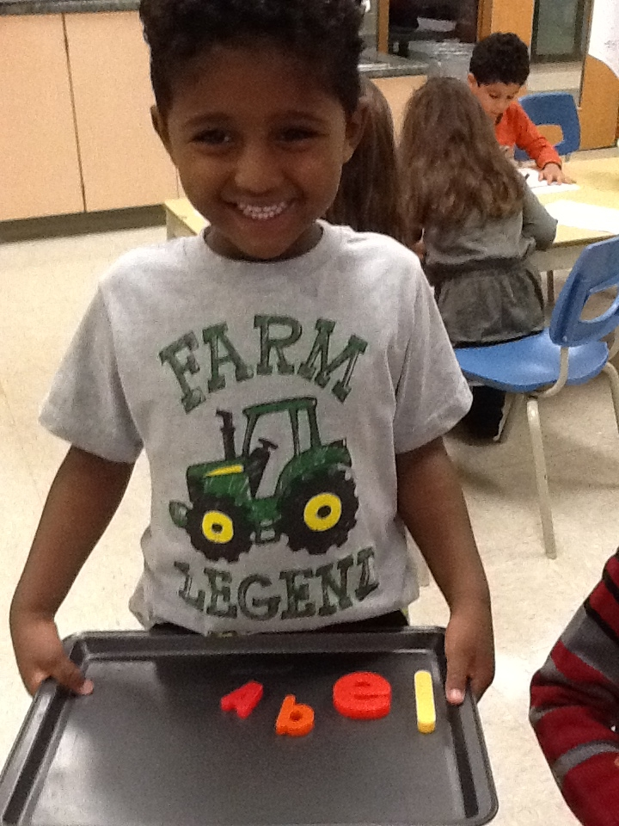
Our exploration of signs of Fall have been going very well!! The children have been investigating leaves, pinecones, gourds and pumpkins. They have also done a fantastic job of creating art about the different signs of fall!! Their favourite investigation this month was about the worms we saw on our pumpkin!
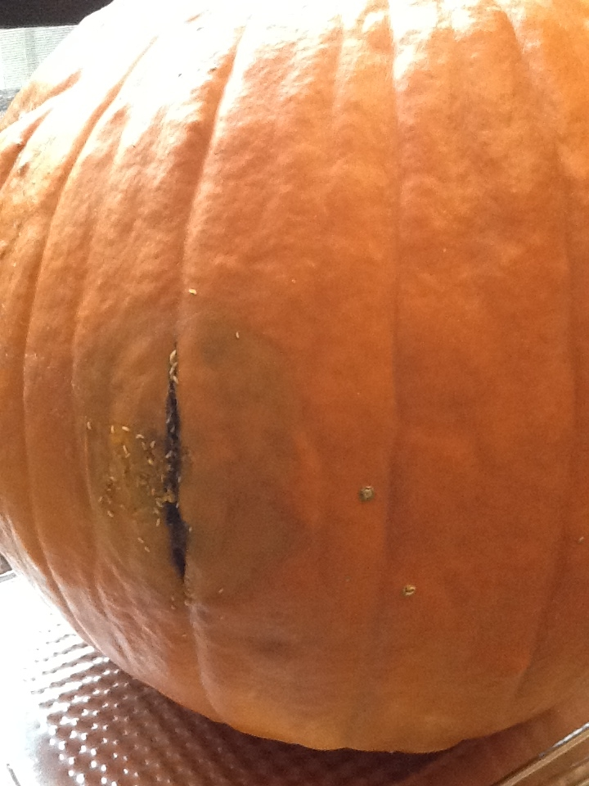
In Math we have been identifying, extending and making simple patterns. The children have really enjoyed this concept and are learning to identify if something is a pattern or not, what would come next in a pattern and are making progress in creating simple patterns using various things inside and outside the classroom. Keep practicing at home!
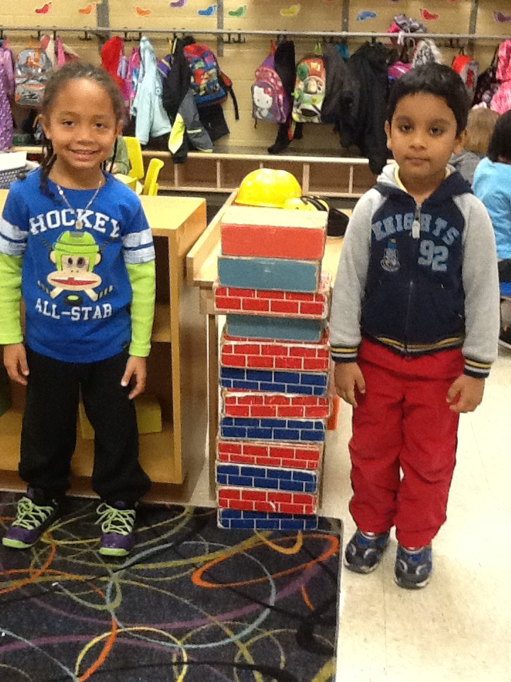

Parents, please remember to stay behind the fence when dropping off and picking up your child. With having almost 150 little kindergarteners in the playground it can get quite congested and confusing. Thank you for your attention to this matter.
Don’t forget to sign up for automatic updates to our blog by subscribing with your email address. This can be done directly on our blog at:
http://kinderkorner.commons.hwdsb.on.ca/
We go outside to play every day and with the cooler weather coming it is important to dress your child for that day’s weather (hats, mittens, scarves). We suggest dressing in layers … it is easier to take off a sweater if they are hot, than to be cold in just a shirt. At home, keep practicing putting on and doing up sweaters and jackets to help your child further develop independence at school.
Don’t forget to send a pair of indoor shoes if you wear boots to school!!
Remember to return your child’s library book each week so that they can check out a new book.

Dates to remember in november
 | 11 | Remembrance Day. Lest We Forget!!
 | 13 | Photo Retake Day
 | 20 | Sub Day. Don’t forget to hand in your forms.
21  28 |  | P.A. Day. No School Today!!  Making friendship fruit salad.  Don’t forget that every Wednesday is pizza day.  Milk is also available for 75 cents (chocolate or white).

NOVEMBER NEWS

Parent Observations
Parents have been invited to come into the class to observe and get a glimpse of what their child’s day is like in our Full Day Kindergarten program. Parents will also get a chance to briefly chat with the educators about how their child has adjusted to the school year. We look forward to seeing you!!
Show and Tell
Check the calendar for your child’s show and tell day. We have been working on describing things with detail. At home encourage your child to describe the item, asking them questions like “How does it feel?”, “Does it make any sound?”, “What colour it it?”. etc.
Every Monday will be a “letter of the week” show and tell, based on the previous weekend’s homework. All children are invited to bring in something that begins with the letter.
Language
In November we will begin our “Letter of the Week” focus, starting this weekend with the letter A – working our way to the letter D at the end of the month. Each weekend the children will be asked to create of find something around the house that begins with that letter. For the rest of the following week we will do lots of fun activities, songs and crafts based on the letter.

To help us with our reading and writing skills we are continuing with our word family focus. This month is the “ap” family (map, cap, nap). At home play silly rhyming games with your child to practice changing the beginning letter/sound to create a list of rhyming “ap” words.

Math
Our focus will be measurement. The children will be measuring and comparing the length, weight, capacity and temperature of various objects. Our goal is that they will learn to use simple measurement terms correctly (e.g. taller/shorter, bigger/smaller, heavier/lighter, empty/full, hotter/colder and use measuring devices appropriately (string, scoops, tape measure, balance scale, thermometer).
Science
We will continue to look for and learn about the changes that happen in Autumn (fall) through investigations. In October we put some pumpkin seeds in wet paper towel and we are waiting for them to sprout. We made predictions about which ones we think would grow first. We will also tie in math skills by measuring the growth of the plant. Our mouldy pumpkin sparked much interest from the students. In November we will conduct some experiments to further encourage their observation and prediction skills.
Dramatic Play Centre
In November we are focusing on Healthy Eating (sometimes and always foods) and Habits (washing hands, brushing teeth). To tie into this, we have decided to turn our house centre into a restaurant. We will be encouraging the children to make some menus and food to help create our Kinderkorner restaurant.
Homework Program
Congratulations on a great start to our homework program. As mentioned in the language section our homework will now focus on the letters of the alphabet – starting with A until we get all the way to Z. Remember to take time everyday to practice identifying the letter, the sound it make and words that begin with that letter. Keep up the great work!!
Making Friendship Fruit Salad
We will be making the fruit salad on Friday, November 28th. Watch for a note coming home about this event!!!

Mrs. James, Mrs. Dubeau and Mrs. P.

