Kinderkorner News
Volume 1, Issue 2 October 2014
A look back at September
We have really enjoyed getting to know each other in September! We learned that we have 11 SK’s and 17 JK’s as well as 14 boys and 14 girls.
In language we focused on the letters in our names. We practiced our names in shaving cream, on chalkboards and with stamps in playdough. It was awesome to hear the kids making observations about similarities and differences in their names!!
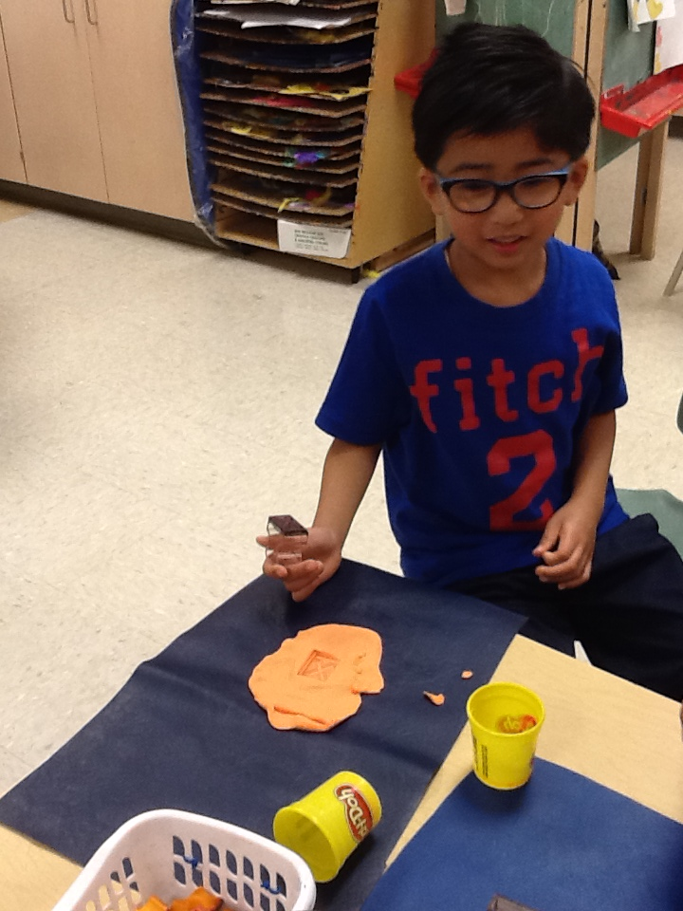
In math we practiced our sorting skills. We sorted our toys into their proper bins, sorted buttons and leaves of different colours, shapes and sizes. Their favourite activity was sorting themselves!! Keep practicing these skills with items around the house.
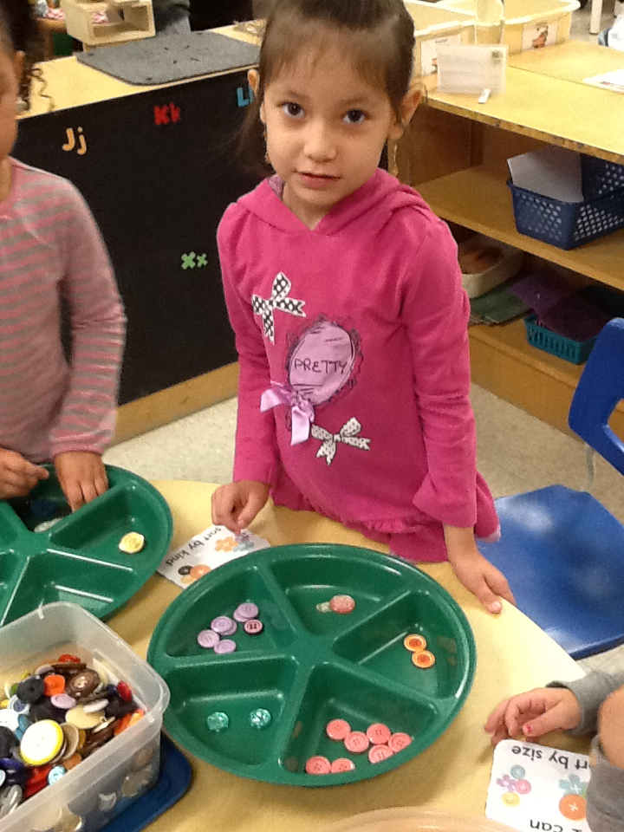
Our O.R.E.O cookie stacking challenge will take place the first week of October. The kids have loved practicing by stacking the blocks in our classroom. This activity has been great for practising skills such as communication, collaboration, cooperation, and problem solving. Way to go!!
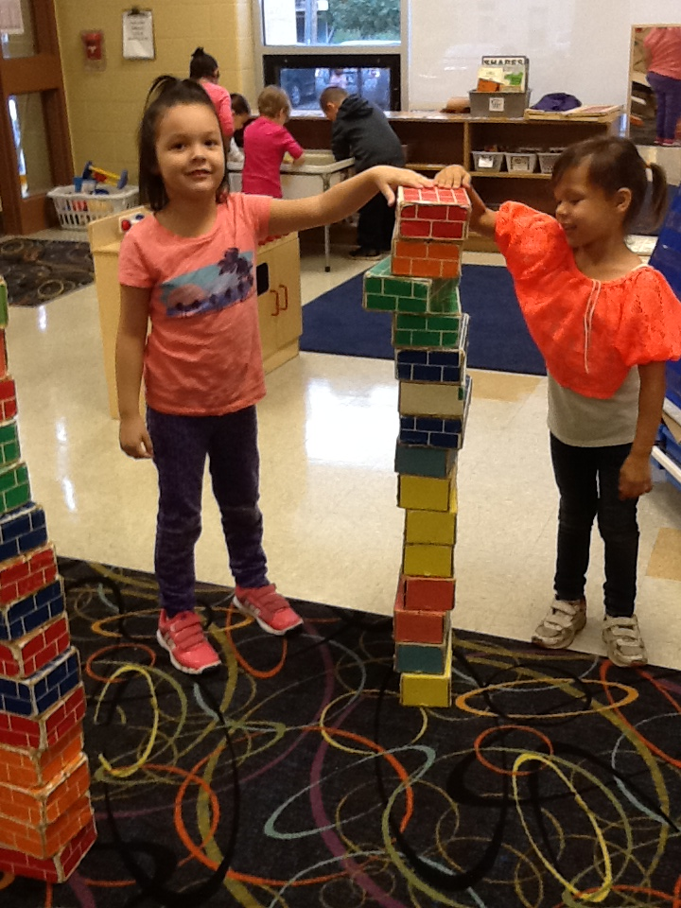
Thank you to everyone for a great start to the school year!!! Please remember to label your child’s belongings.
We go outside to play everyday and with the cooler weather coming it is important to dress your child for that days weather. We suggest dressing in layers … it is easier to take off a sweater if they are hot, than to be cold in just a shirt. At home, keep practicing putting on and doing up sweaters and jackets to help your child further develop independence at school.
Don’t forget that our school is a Peanut Sensitive zone. Please do not send any food that contains peanuts or tree nuts. Thank you for helping us keep everyone safe!

Dates to remember in October

Monday, September 29th – Friday, October 3rd is our OREO cookie stacking challenge!
Thursday, October 9th is Meet the Teacher Night from 5 – 6:30 pm.
Friday, October 10th we will be making vegetable soup to celebrate Thanksgiving.
Monday, October 13th is Thanksgiving. No School!!
Wednesday, October 15th is picture day. Don’t forget your smile!!
Friday, October 24th is Sub Day. Please remember to fill out and return the forms promptly.
Friday, October 31st is our Halloween party and parade.
Don’t forget that every Wednesday is Pizza Day ($1 per slice).

OCTOBER NEWS

Language
In October we will begin to explore the letters of the alphabet and the sounds they make. We have learned a song that reinforces these concepts using the Jolly Phonics program. Each letter is associated with an action to help the children remember the sound of that letter (e.g. D is pretending to hold drumsticks and hitting a drum while saying d,d,d). Please take the time to point out letters on signs, boxes, flyers and books.

To help us with our reading and writing skills we are beginning with our word family focus. This month is the “all” family (ball, fall, wall). At home play silly rhyming games with your child to practice changing the beginning letter/sound to create a list of rhyming “all” words.

We will also be introducing our Popcorn Words. Popcorn words are a list of 25 words that POP up in our reading and writing. You can find the list of Popcorn words under the “resources” section of our blog. Encourage your child to find some popcorn words in their home reading book and stories you read at home. Also have them practice pointing to one word at a time when reading, looking at the pictures for clues and counting the number of words in a sentence.

Math
Our focus will be identifying, reproducing and extending simple patterns using sounds, actions, colours and manipulatives. See if you can find patterns around the house on towels, sheets, clothing, etc. Remember to encourage your child to use their words to describe the pattern.

Science
We will be learning about the changes that happen in Autumn (fall). When you are at the park or on a walk, point out the changes that are happening outside. We are asking the children to bring in fall things (red, yellow and orange leaves, pine cones, maple keys). Please do not send in any nuts (acorns, walnuts, etc.) due to allergies. Thank you!

Dramatic Play Centre
The children have decided to turn our house centre into a coffee shop. They are quite excited to help create the centre with us!

Homework Program
Our homework program will begin this month. More details to follow shortly.

Making Vegetable Soup and Hallowe’en
Watch for notes coming home about these two events!!!

Mrs. James, Mrs. Dubeau and Mrs. P.

