History Task 4b
Task: When Sir Wilfrid Laurier, Prime Minister, boasted that the twentieth century belonged to Canada, he spoke for a nation buoyant with optimism about its future. After years of doubt and economic depression, wheat sales were booming, a frenzy of railway building was in progress, and the long-hoped-for settlers were at last pouring in to 'the last, best west'.
Create your own poster that focuses on encouraging immigrants to immigrate to Canada.
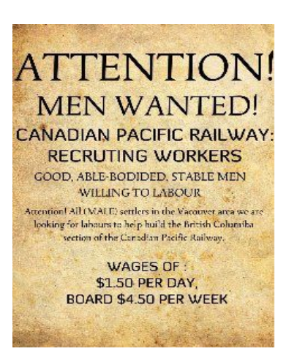
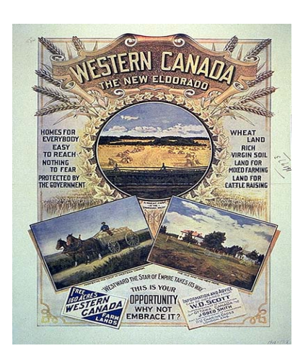
Some examples of Immigration posters 1900s

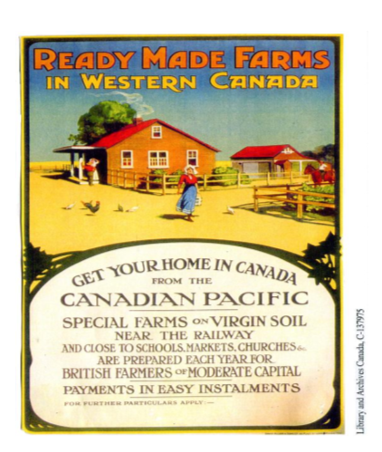
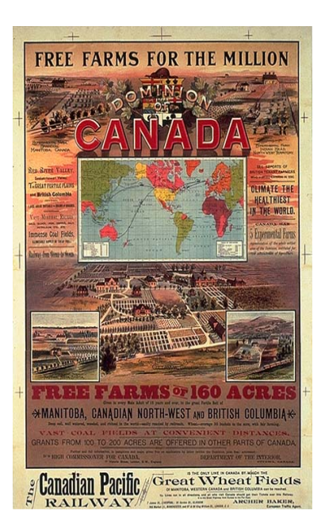

Think of the following 2 questions. Answer them and submit them along with your poster.

1. What are the challenges involved in reaching each of these groups (different races, cultures and gender). How can you appeal to all these groups in a single poster?

2. What are the important things you need to know about your audience when designing your poster?

Things to think about as well:
1. Who is your target audience?
2. What will your message be?
3. What will I put in my ad to catch people’s attention?

