Grade 8 Data Management Unit – Approx. 3 Weeks
Please see below the expectations that we will be covering throughout this unit.
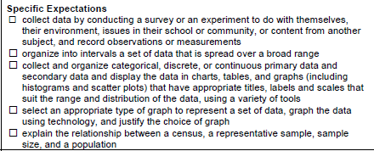

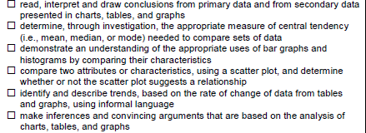

http://www.censusatschool.org.uk/images/curriculum_resources/datahandling/censusorsample-worksheet.pdf (difference between a population, census or sample
http://math.wonderhowto.com/how-to/grasp-differences-census-study-sample-survey-303057/ (explanation video of difference between census and sample)
http://www.mathsisfun.com/data/data-discrete-continuous.html (difference between discrete and continuous data
http://math.tutorvista.com/statistics/types-of-graph.html (explanation of types of graphs)
http://mste.illinois.edu/courses/ci330ms/youtsey/intro.html (types of graphs and explanation of the best situation to use them)
http://www.mathsisfun.com/data/scatter-xy-plots.html
http://www.mathsisfun.com/data/histograms.html
http://www.youtube.com/watch?v=KCH_ZDygrm4 (video on how to draw a histogram)
http://www.wikihow.com/Create-a-Histogram-in-Excel (how to use Excel to create a histogram)
http://www.icoachmath.com/math_dictionary/Measures_of_Central_Tendency.html (measures of central tendency)
http://worksheets.tutorvista.com/measures-of-central-tendency-worksheet.html (practice worksheet)
http://www.phschool.com/iText/math/sample_chapter/Ch02/02-07/PH_Alg1_ch02-07_Obj1.html (using measures of central tendency)
http://www.sophia.org/drawing-conclusions-based-on-data/drawing-conclusions-based-on-data--6-tutorial (drawing conclusions based on graphs)

