Math
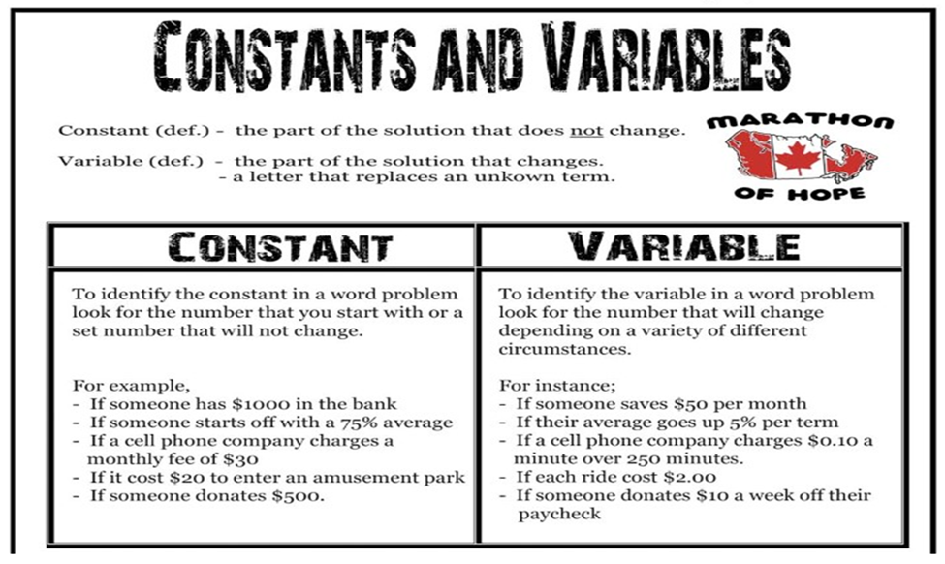
Examining how we use constants and variables in real life.
Can we think of some other constants and variables that we use in real life?

