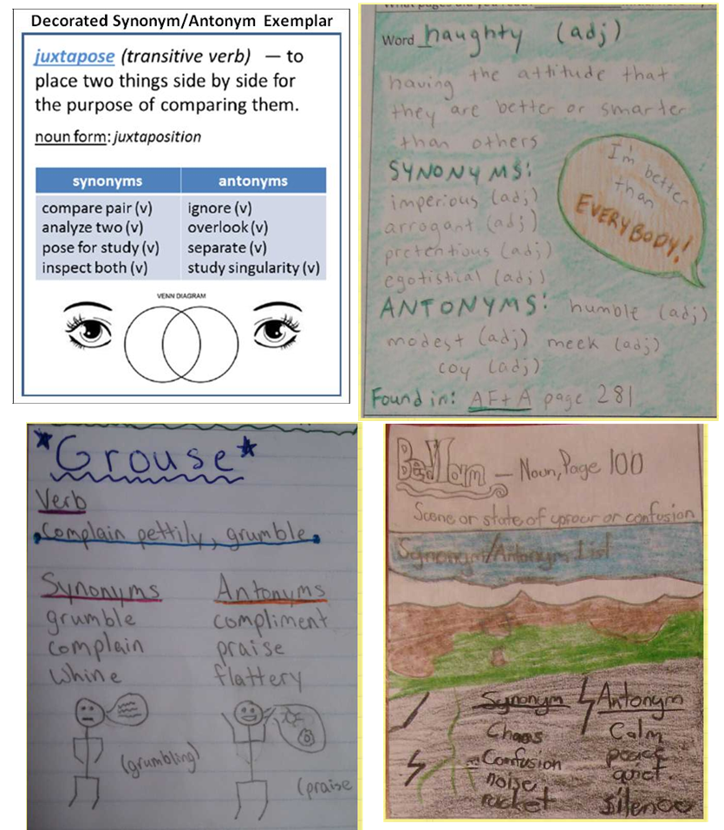
Vocabulary Building – Using the synonym/antonym method to show 25c words.

