Vocab Building
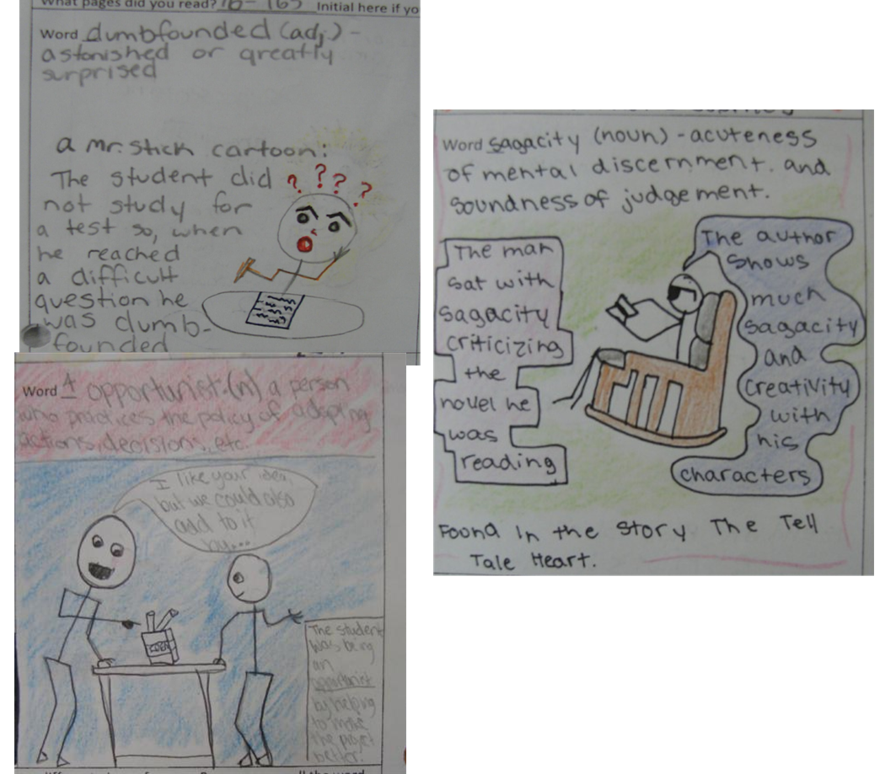
Choose 5 words from your reading book, or that you have heard or from another subject area. Use 2 of your words to create Mr. Stick vocabulary. A well-designed Mr. Stick Vocabulary Cartoon puts the vocabulary word you are collecting into an interesting context that can be captured in a simple cartoon. In the caption or in the dialogue bubble, you must use the word well and correctly.

