Cube Sticker Problem
A company makes coloured rods by joining cubes in a row and using a sticker machine to put “smiley” stickers on the rods. The machine places exactly 1 sticker on each exposed face of each cube. Every exposed face of each cube has to have a sticker. This rod of length 2 (2 cubes) would need 10 stickers.
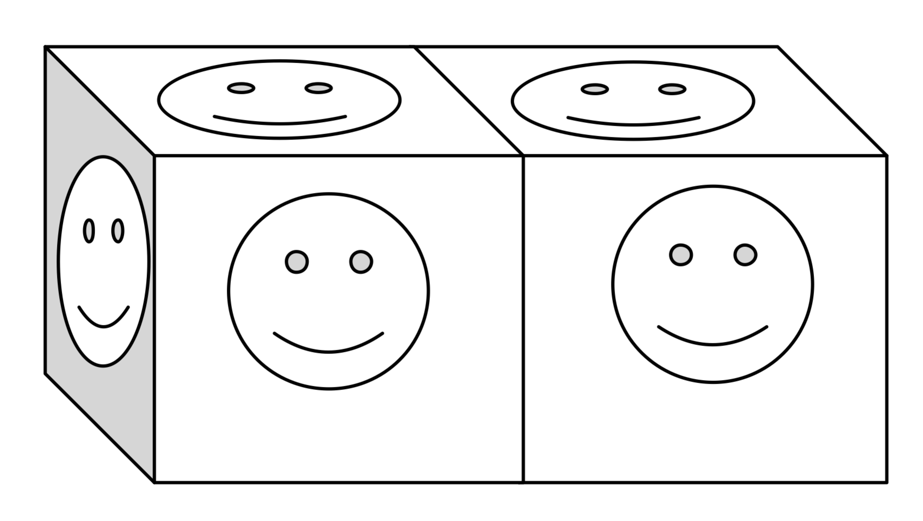
How many stickers would you need for:
A rod of 4 cubes? How do you know?
A rod of 10 cubes? How do you know?
How many stickers would you need for a rod of 20 cubes?
How many stickers would you need for a rod of 56 cubes?
Is there a rule that would allow you to predict the number of stickers that would be needed for any number of cubes?

Border Problem
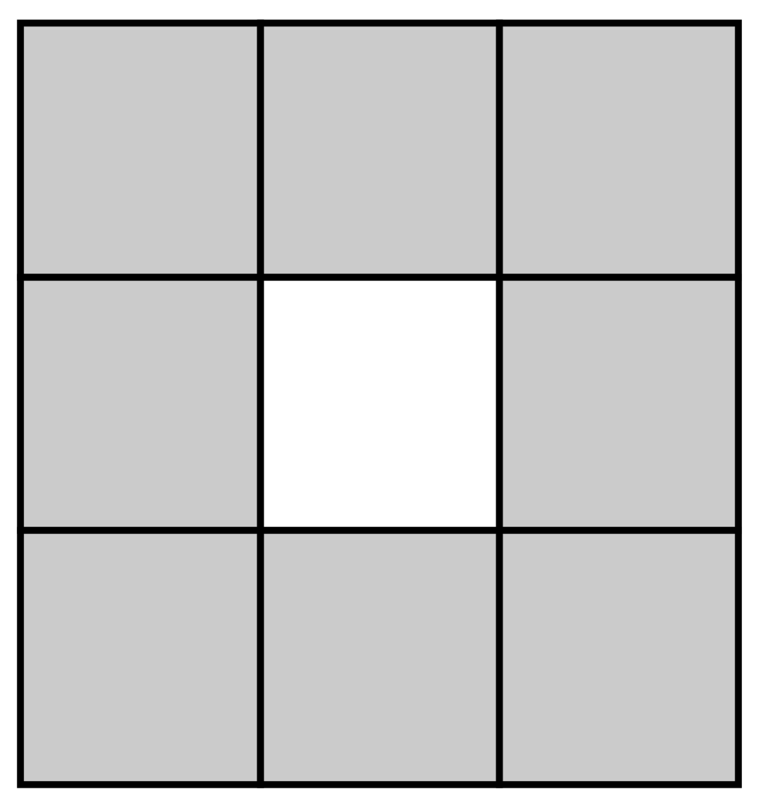

This is a 3x3 grid of squares with only the outside edge shaded.
If you had a 5x5 grid of squares where only the outside edge of squares is shaded, how many squares would be shaded?
If you had a 17x17 grid of squares with only the outside edge of squares shaded, how many squares would be shaded?
If you had a grid of 100x100 squares, how many would be shaded?
Is there a rule that would allow you to predict the number of squares that would be shaded in any size square grid?

