Human Body Systems Test Review
The test will be a combination of multiple choice, labeling, and open response answers.
This review is for informational purposes only the worksheet review will be used in class
The Digestive System
- Label the following on the diagram
  - Mouth, Esophagus, Stomach, Liver, Pancreas, Small Intestine, Large Intestine, Rectum
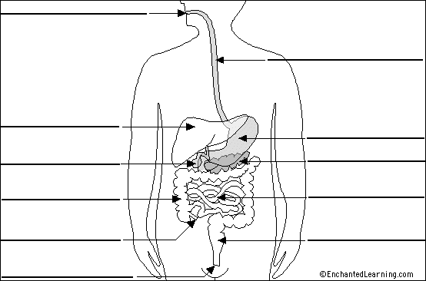
Appendix
Gall Bladder
- Identify the purpose and function of these parts within the digestive system.
- Identify how what you eat affects your digestive system. Including the importance of nutrients.
- Identify the path a piece of food would take to work its way through the digestive system.

The Circulatory System
- Identify the purpose and function of the following parts of the heart.
  - Right Atrium, Right Ventricle, Left Atrium, Left Ventricle, Veins, Arteries,
- Identify the pathway blood takes through the heart.
- Identify how the heart works with the other two systems of the heart.
The Respiratory System
- Label the Respiratory System
  - Mouth, Windpipe, Trachea, Bronchus, bronchioles and alveoli
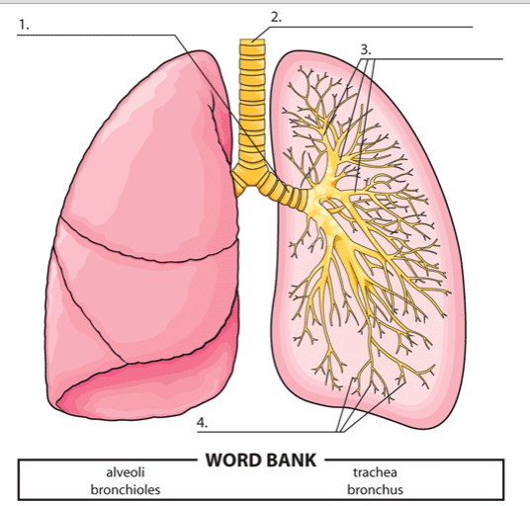
- Identify the function and purpose of each of the above parts
- Explain why it is important to keep the lungs healthy
- Explain how the Respiratory system works with the other systems in the body.

