Ink-blot
By Maria Eugenia
Lesson 1
Introduce Ink-blot by Maria Eugenia
Before Reading
If you just look at the picture on the cover, what do you think? What are your wonderings?
Prompt/Sentence Starter – “I wonder……”
ASR (anticipated student responses)
- I wonder if she is running away from the dog
- I wonder if she’s angry b/c of her facial expression
- I wonder why the dog is in colour and she is in black and white.
- I wonder what the title has to do with the character
- I wonder if she is smiling or scared?

Lesson 2
Read the story.
ORQ (Open Response Questions)
Why do people say that Ink-blot is badly drawn?
How would you feel if you were Ink-blot?
Explain why it does not bother Ink-blot that people say that she “really is badly drawn”.
What does the author mean when she says, “Some worry about everything”?

POV Questions – can be used as discussion/t-p-s/small group
How might the story have been different if the main character had been a boy instead of a girl?
Appendix 1 – POV Checklist
Lesson 3 – 2 options
Option 1 -
Book Jacket – create a new book jacket where the main character is you. Give the book a new name.
Appendix 2 – Book Jacket Rubric
Option 2 -
ART - Self-portraits – using charcoal and white paper
http://inchmark.squarespace.com/inchmark/2011/2/11/valentines-2011.html
*connect to Picasso/Line/Colour etc.
Gallery Walk – to look at all the portraits (don’t need to put names on it)
*Assessment – check-in based on POV question; have students pair up and listen to/make general observations on comments (use checklist for observations)
Return as a whole group and ask question again – referring to checklist to continue observational notes

Appendix 1 –
POV Question Checklist
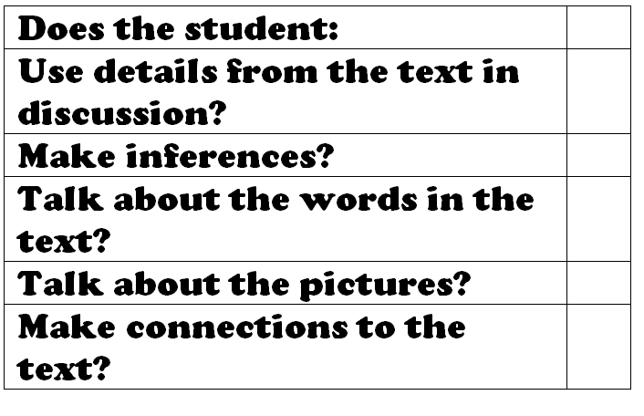

Appendix 2 – Book Jacket Rubric

Characteristics of Book Covers Rubric

Name: Date:

CRITERIA | LEVEL 1 | LEVEL 2 | LEVEL 3 | LEVEL 4
Book cover includes an interesting design that attracts an audience | • includes an interesting design that attracts an audience, with limited effectiveness | •includes an interesting design that attracts an audience, with some effectiveness | • includes an interesting design that attracts an audience, with considerable effectiveness | • includes an interesting design that attracts an audience, with a high degree of effectiveness
Book cover includes a strong image engages an audience | • includes a strong image that engages an audience, with limited effectiveness | • includes a strong image that engages an audience, with some effectiveness | • includes a strong image that engages an audience, with considerable effectiveness | • includes a strong image that engages an audience, with a high degree of effectiveness
Book cover creates a mood that is fitting for the story | • creates a mood that is fitting for the story, with limited effectiveness | • creates a mood that is fitting for the story, with some effectiveness | • creates a mood that is fitting for the story, with considerable effectiveness | • creates a mood that is fitting for the story, with a high degree of effectiveness

