Name:
Problem of the Week
Friday, January 17, 2014

A valentine is constructed by pasting two white semi-circles, each with radius 3 cm, and a white triangle onto a 12 cm square sheet of red paper as shown below. (The dashed line and the right angle symbols will not actually be on the finished card.)
You are going to write your valentine a message in red ink on the white region of the card.
Determine the total amount of area available for your special valentine greeting.
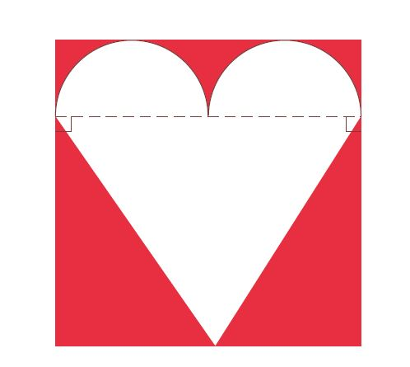

• demonstrates a very good, complete strategy to correctly solve the problem.  • uses best math vocabulary to clearly explain how to solve the problem and explanation was complete, well organized and logical.  • demonstrates the ability to correctly solve the problem.  • uses numbers, words, symbols or pictures (or a combination of them) to show how the problem was solved | 1 2 3 4  1 2 3 4  1 2 3 4  1 2 3 4

